**Project- Cart Theme**

Environment- Prod

**Dynamic Cart template (1-66)**

**Bug Report-**

1. The user can enter and save only special characters in the title.

**Priority-** Medium

**Severity**- Medium

Status- Open

Assigned By- Imran

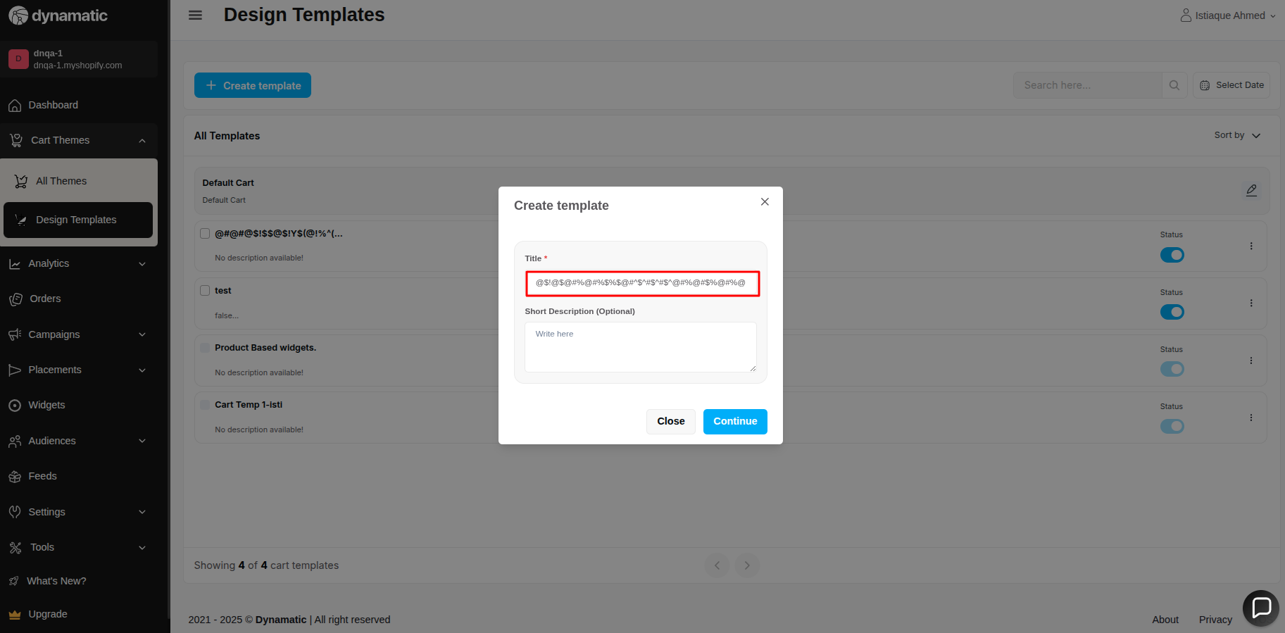

1. There is no maximum character validation in this title input field

**Priority-** Medium

**Severity**- Major

Status- Open

Assigned By- Imran

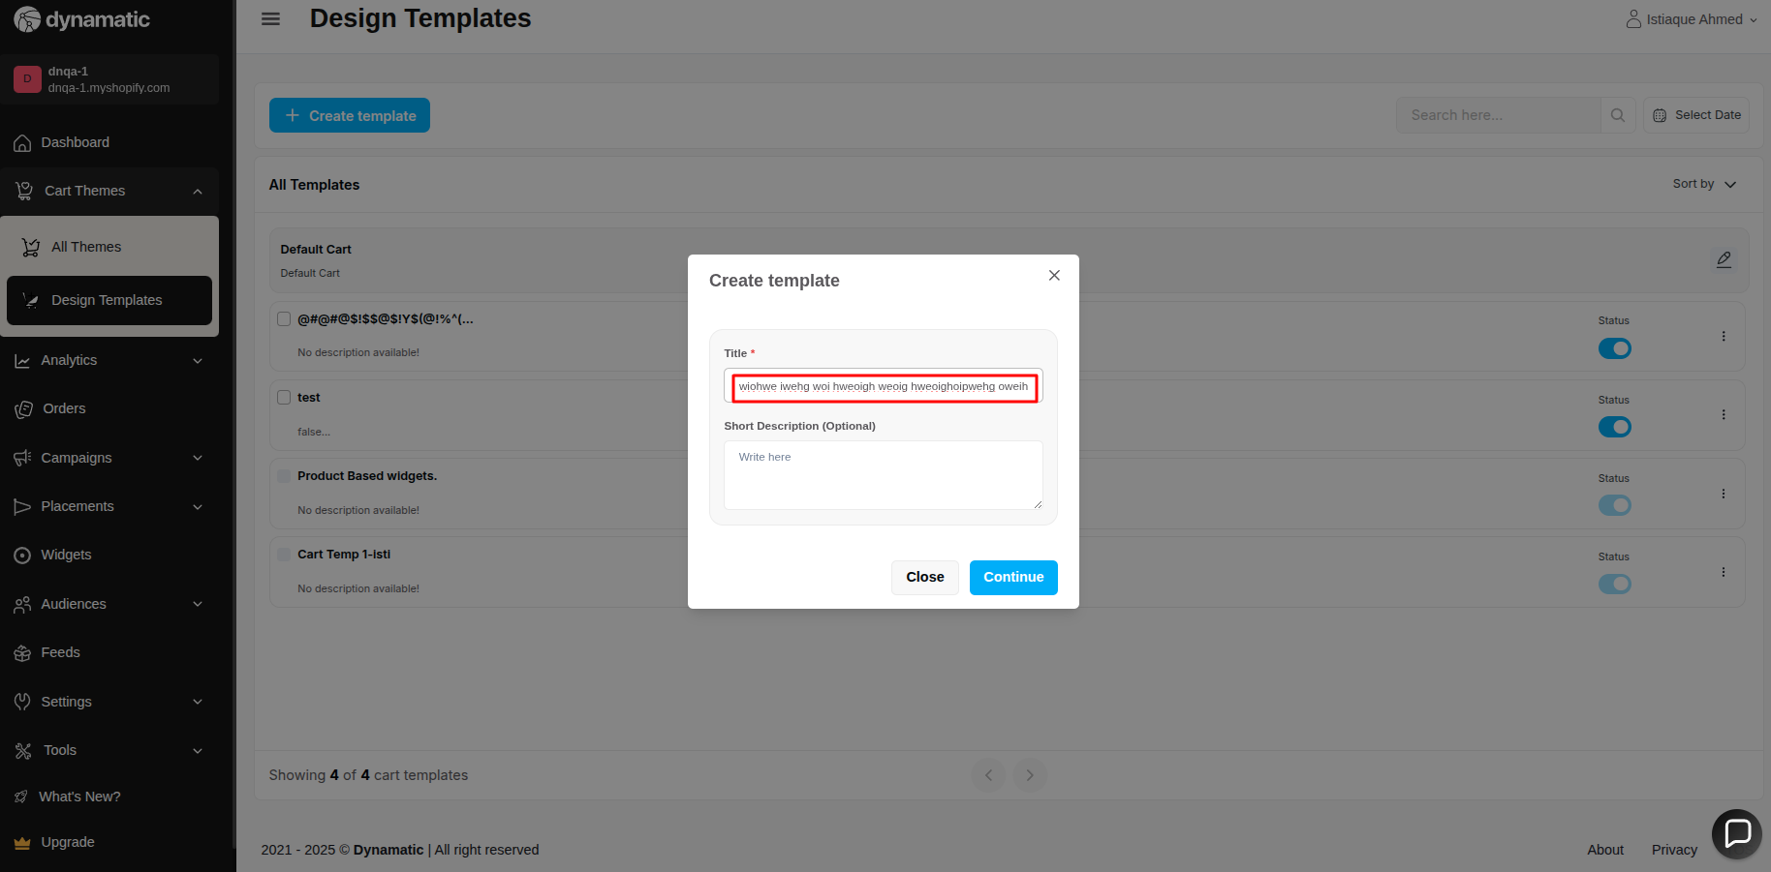

1. The continue button is enabled if the user enters only a single space in the title input field

**Priority-** High

**Severity**- Major

Status- Open

Assigned By- Imran

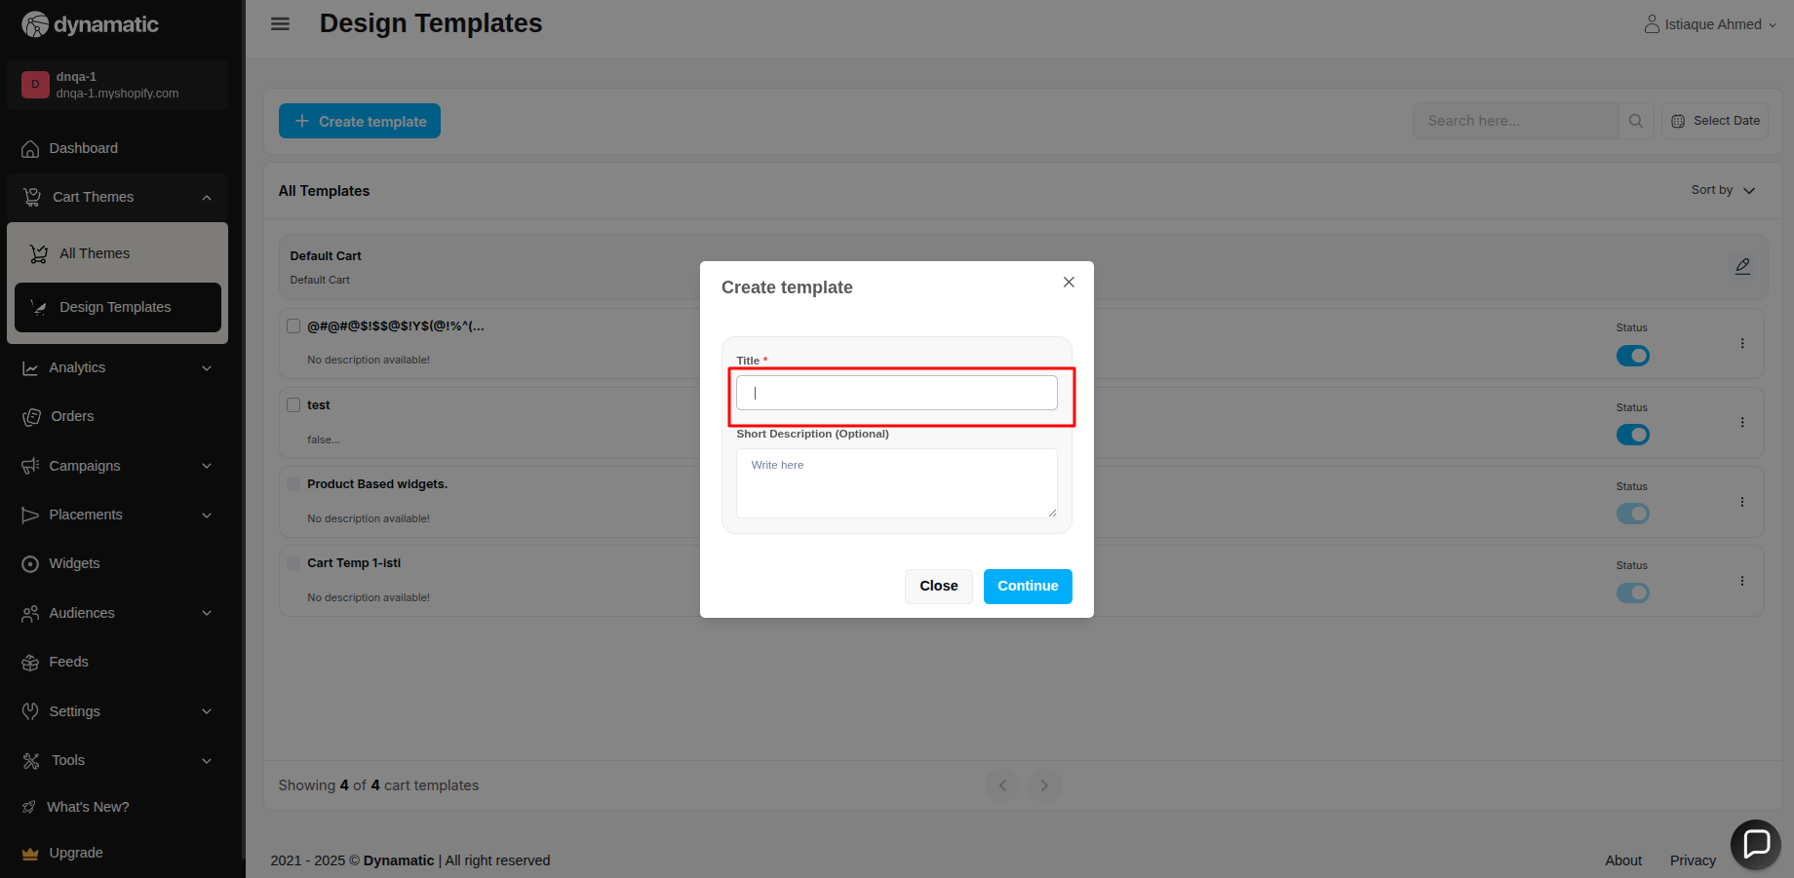

1. There is no maximum character validation in this Short Description(Optional) input field

**Priority-** Medium

**Severity**- Major

Status- Open

Assigned By- Imran

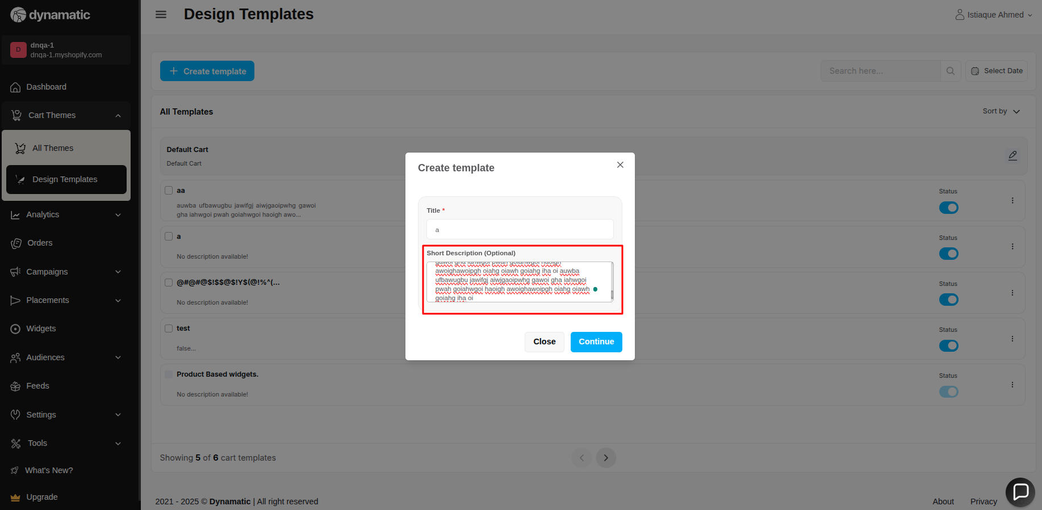

1. The user is unable to provide the End date

**Priority-** High

**Severity**- Major

Status- Open

Assigned By- Imran

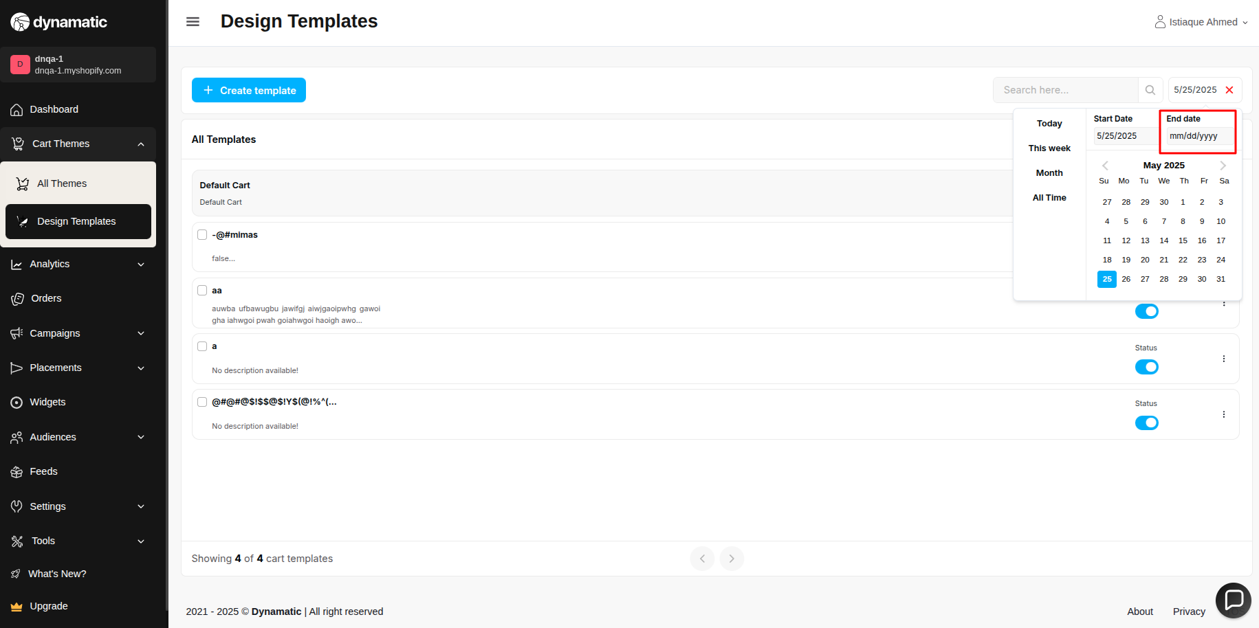

6. There is no maximum character validation in this title input field (left and right title)

**Priority-** High

**Severity**- Medium

Status- Open

Assigned By- Imran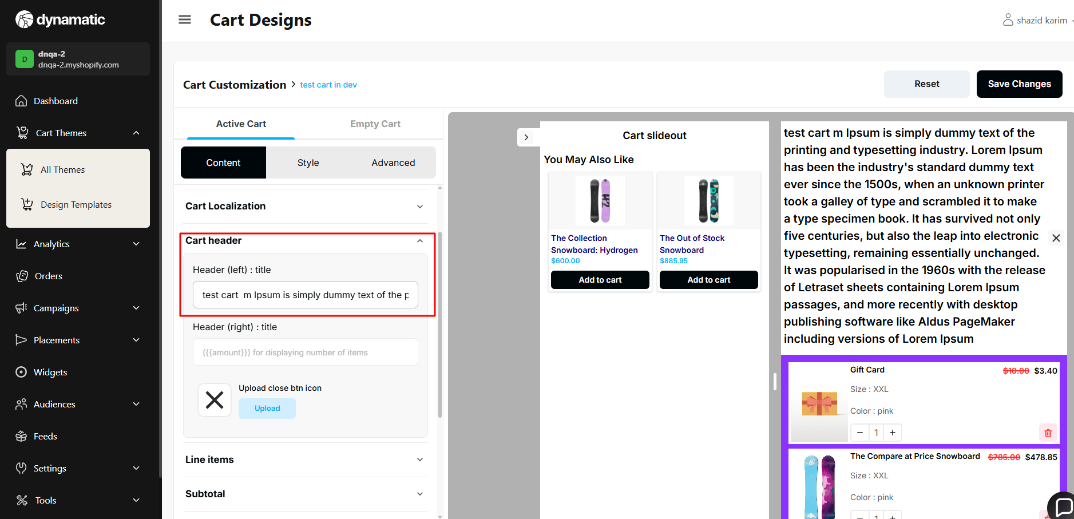

7. The user can select any future date.

**Priority-** High

**Severity**- Major

Status- Open

Assigned By- Imran

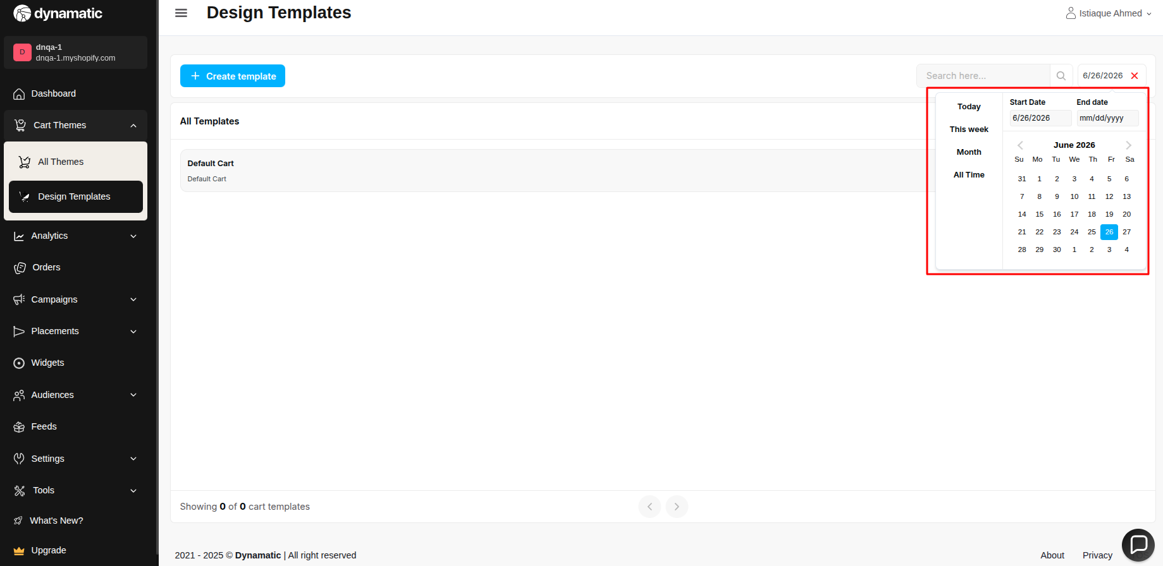

8. Cart design breaks when the header title is long.

**Priority-** High

**Severity**- Major

Status- Open

Assigned By- Imran

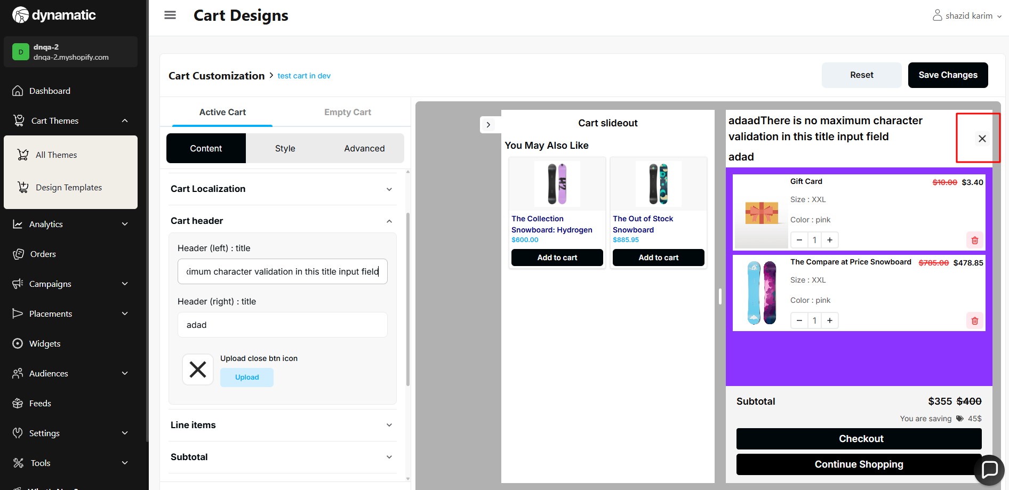

9.When the header is empty, a validation error message appears. However, the cart can still be saved, which should not happen

**Priority-** High

**Severity**- Major

Status- Open

Assigned By- Imran

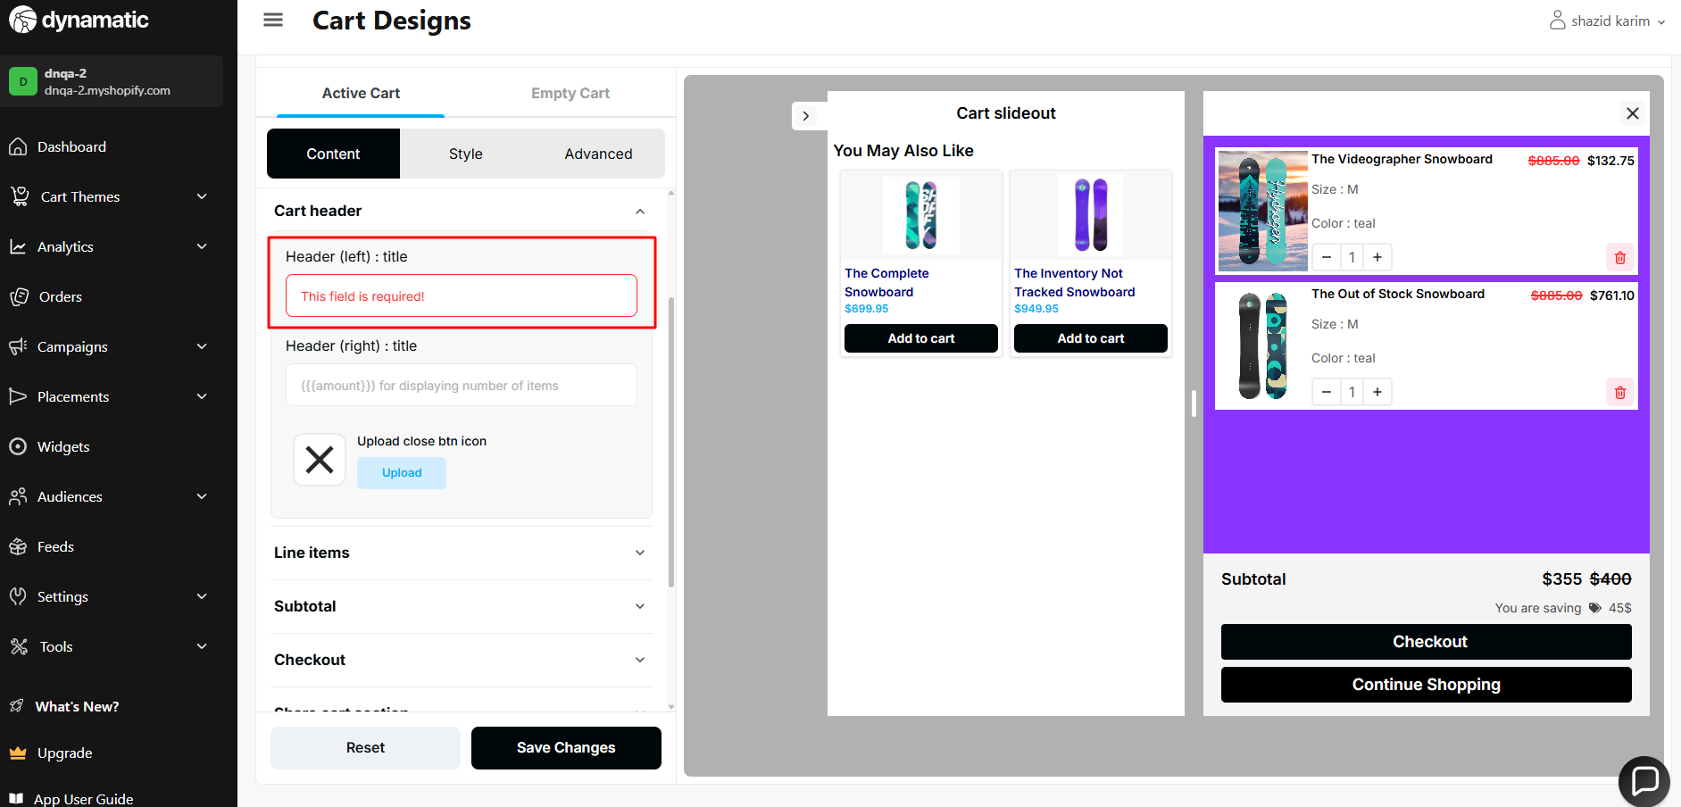

10. Sort → Sort is not working on the 1st page

If a user visits the 2nd page and sorts on that page, the sort is not working.

**Priority-** High

**Severity**- Major

Status- Open

Assigned By- Imran

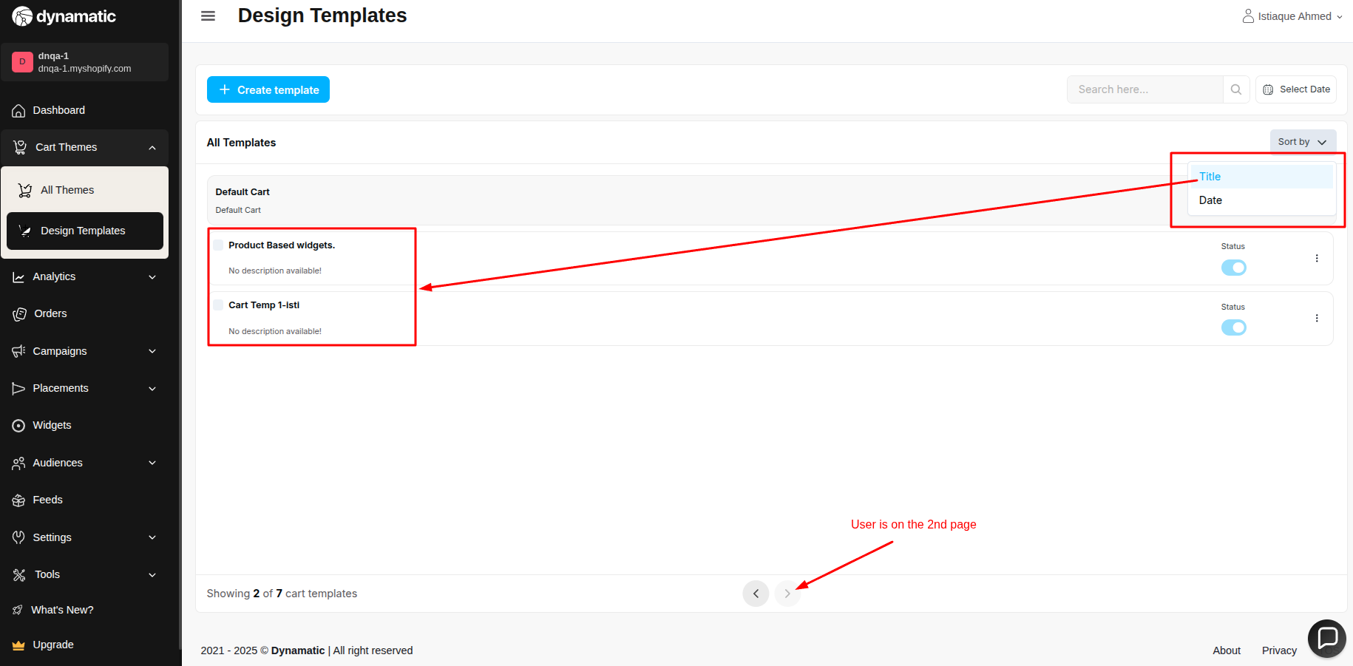

11. There is no validation in line item image size.

**Priority-** High

**Severity**- Major

Status- Open

Assigned By- Imran

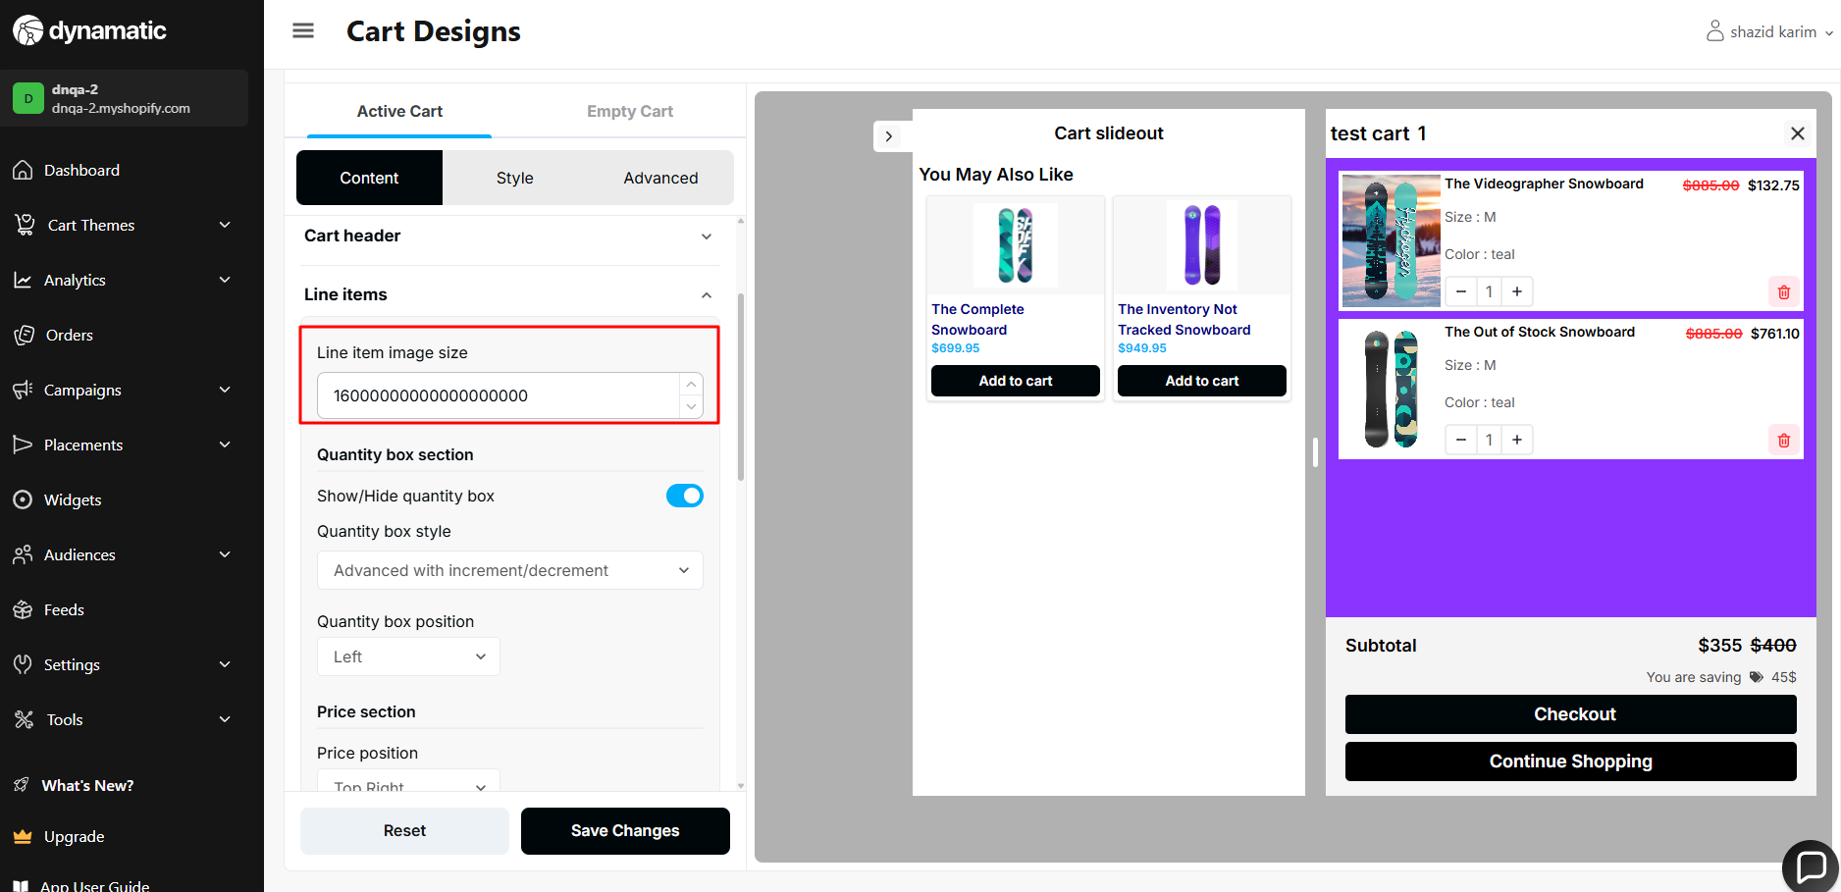

12. Checkout button text → By inserting only a space, the user can save the cart.

**Priority-** High

**Severity**- Major

Status- Open

Assigned By- Imran

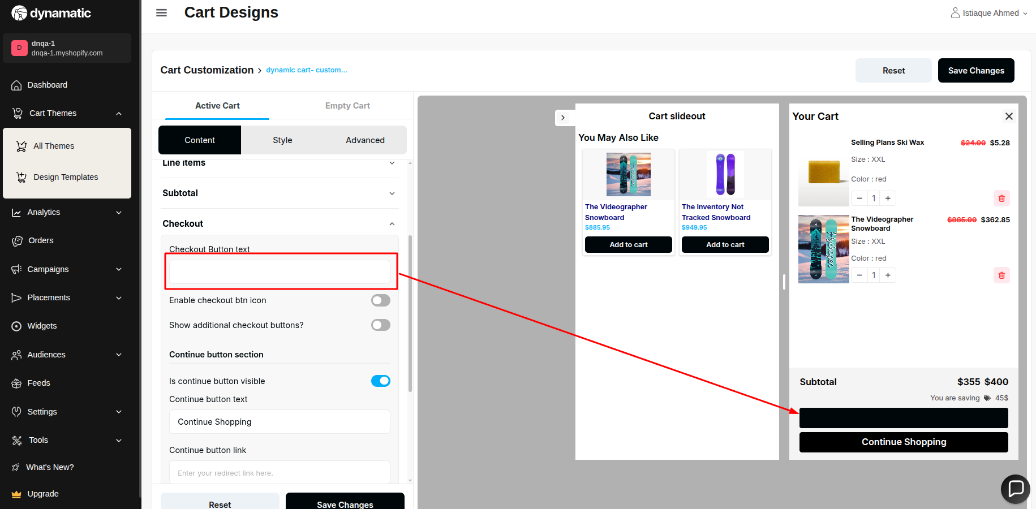

13. Line item image size must not be 0.

**Priority-** High

**Severity**- Major

Status- Open

Assigned By- Imran

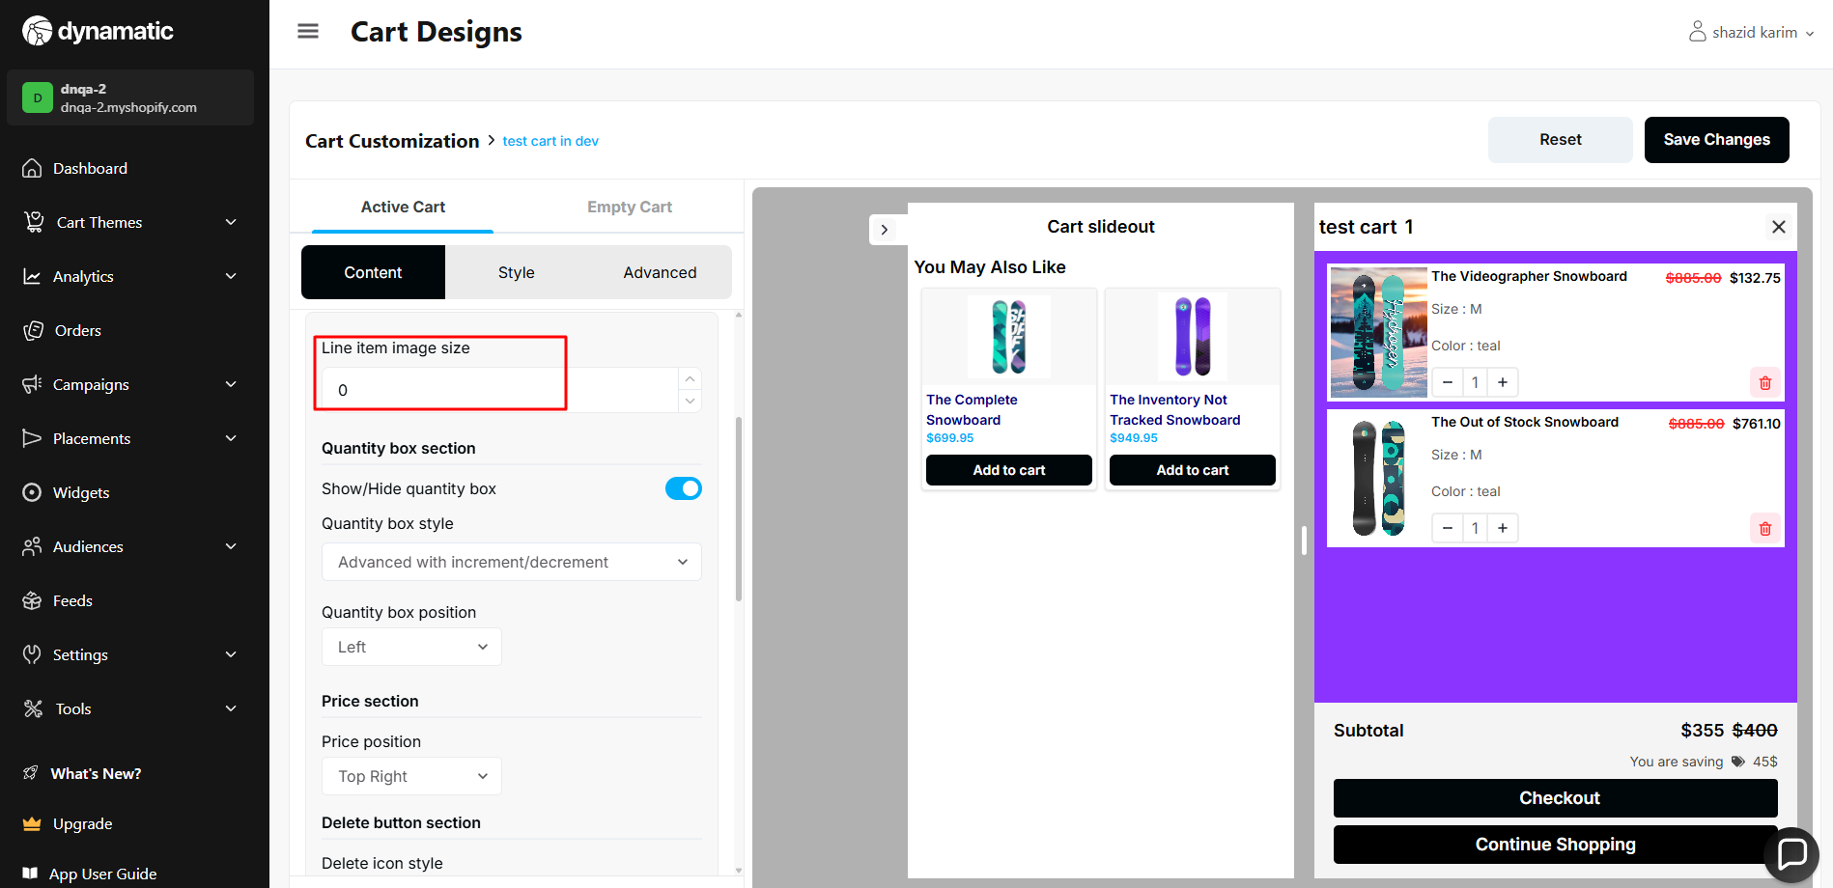

14. line item image size must not be a negative value.

**Priority-** High

**Severity**- Major

Status- Open

Assigned By- Imran

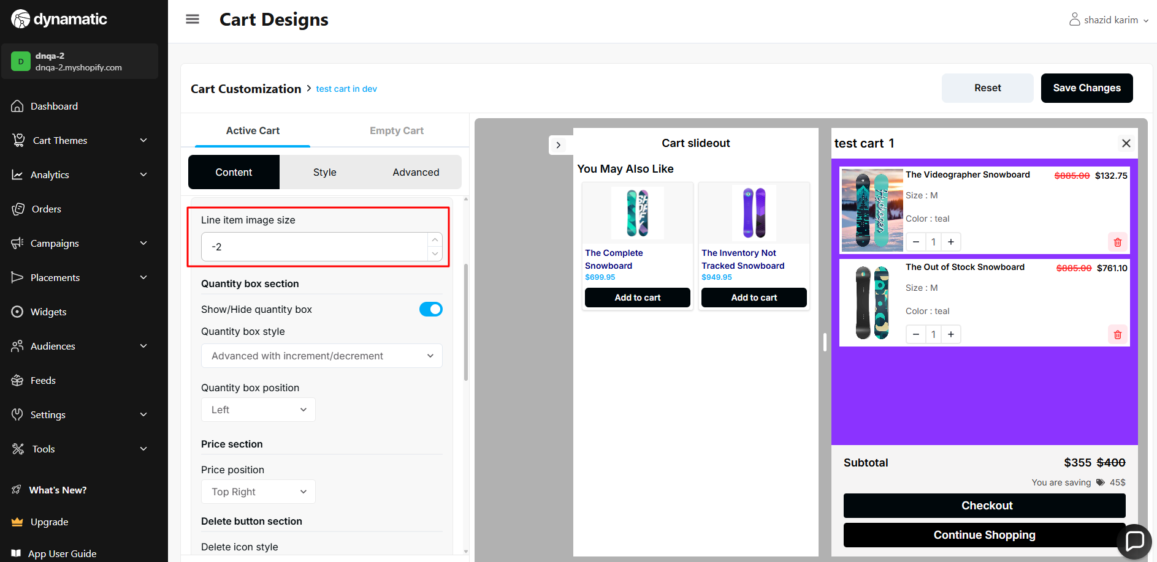

15. line item quantity box does not work.

**Priority-** High

**Severity**- Major

Status- Open

Assigned By- Imran

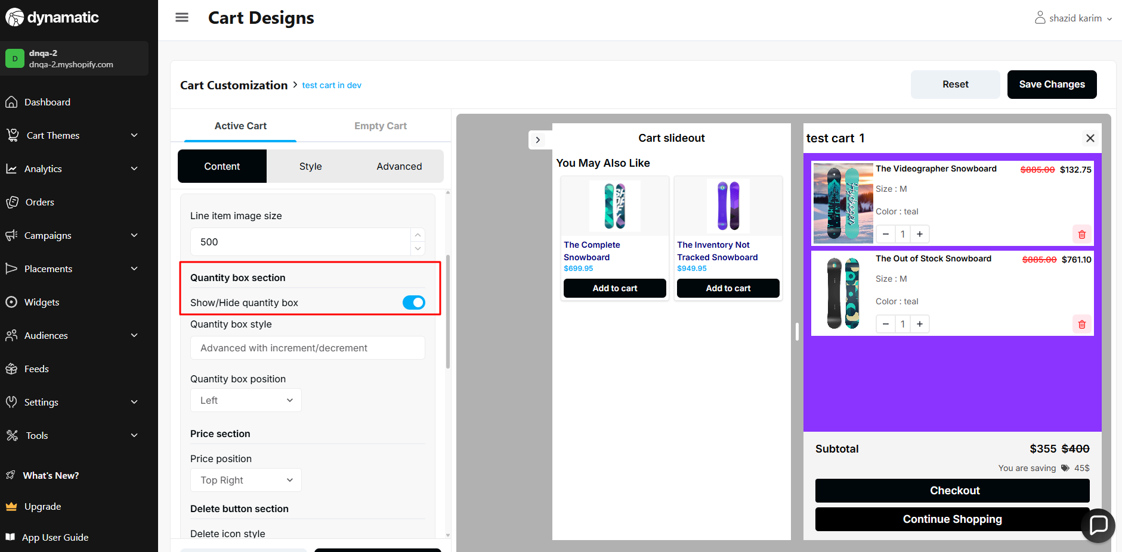

16. Checkout button icon size → Able to enter a negative number using keyboard

**Priority-** Medium

**Severity**- Major

Status- Open

Assigned By- Imran

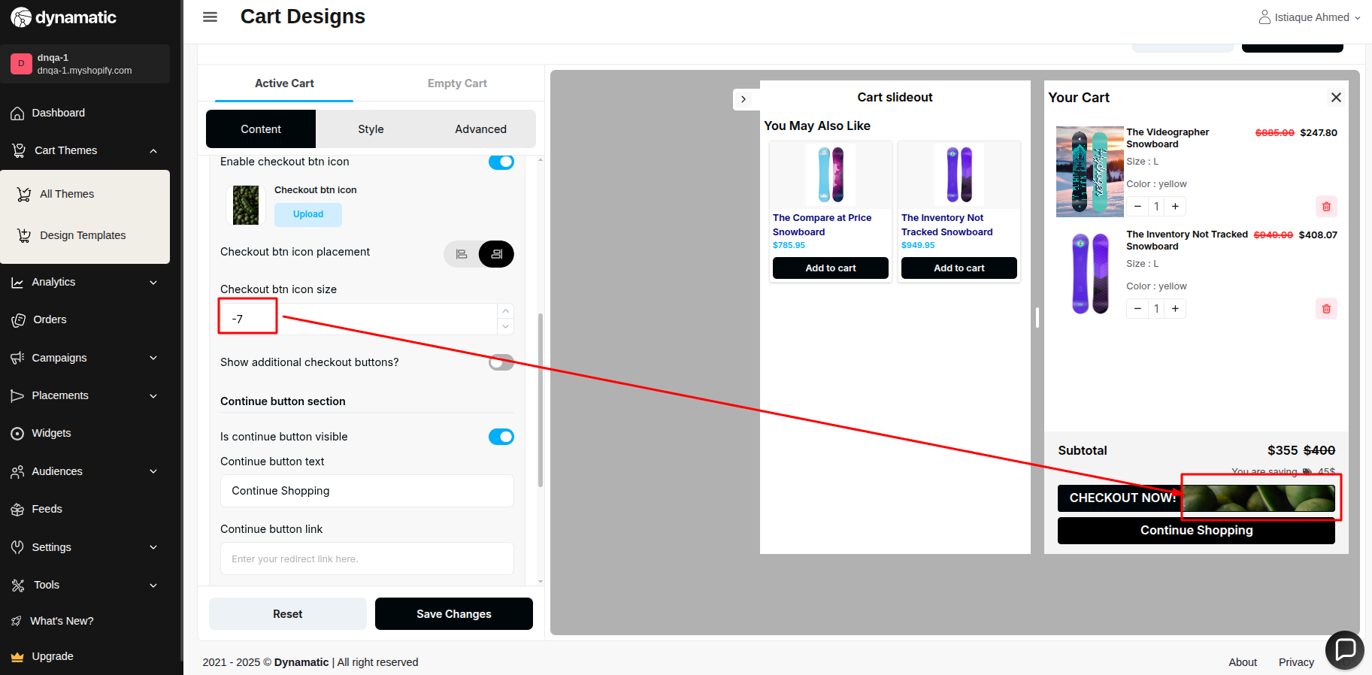

17. When I try to increase the product quantity, the cart automatically closes, and the slideout cart is still open.

**Priority-** High

**Severity**- Major

Status- Open

Assigned By- Imran

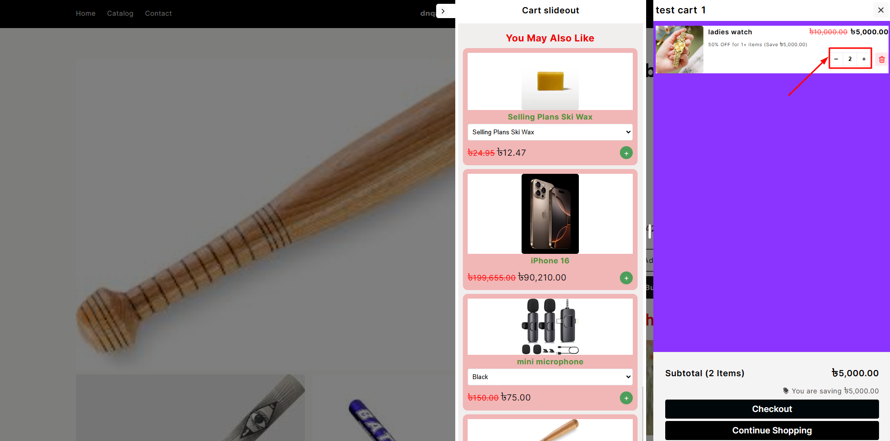

After increased quantity :

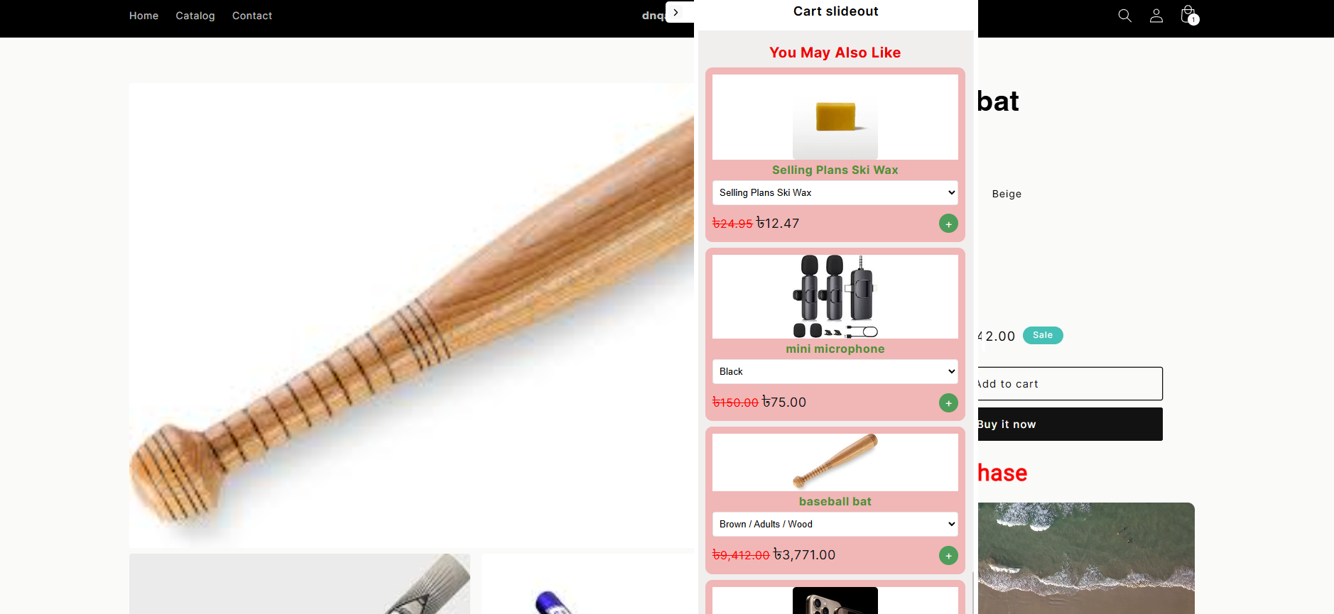

18. Checkout button icon size → The user can enter 0

**Priority-** High

**Severity**- Major

Status- Open

Assigned By- Imran

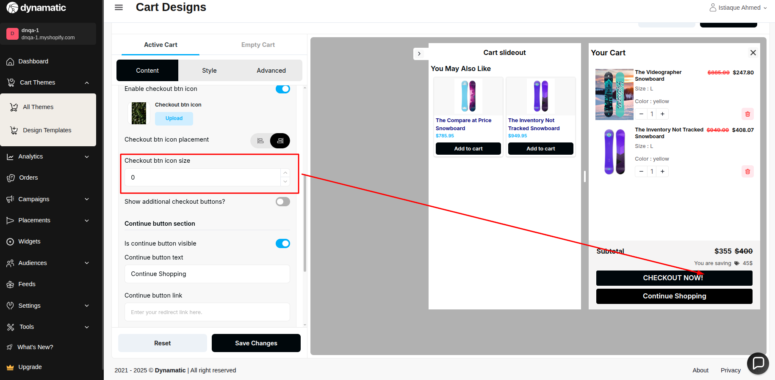

19. There is no maximum validation in this field.

**Priority-** High

**Severity**- Major

Status- Open

Assigned By- Imran

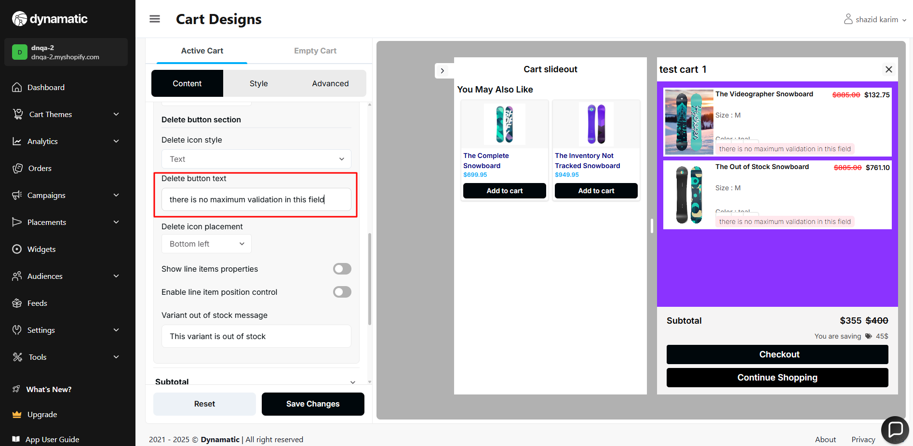

20. Checkout btn icon size → There is no maximum validation.

**Priority-** High

**Severity**- Major

Status- Open

Assigned By- Imran

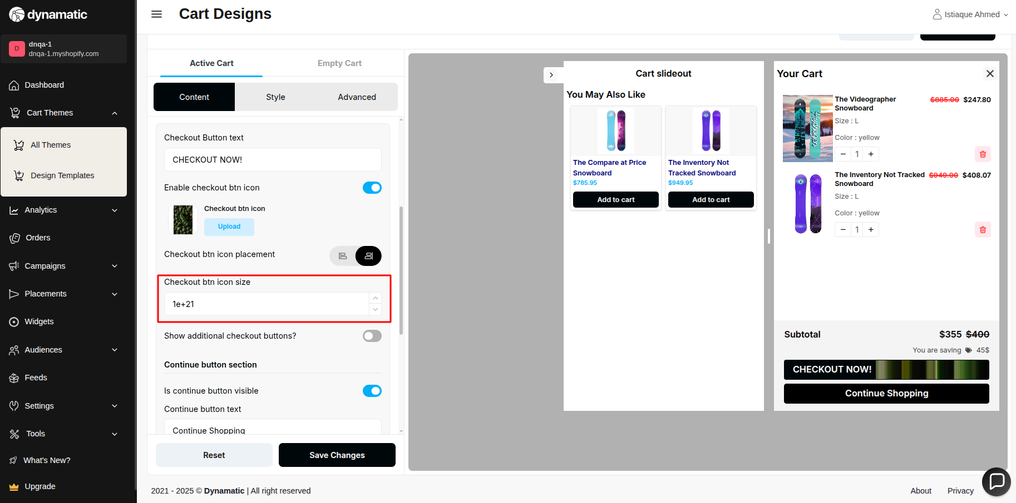

21. There is no maximum validation in this field.

**Priority-** High

**Severity**- Major

Status- Open

Assigned By- Imran

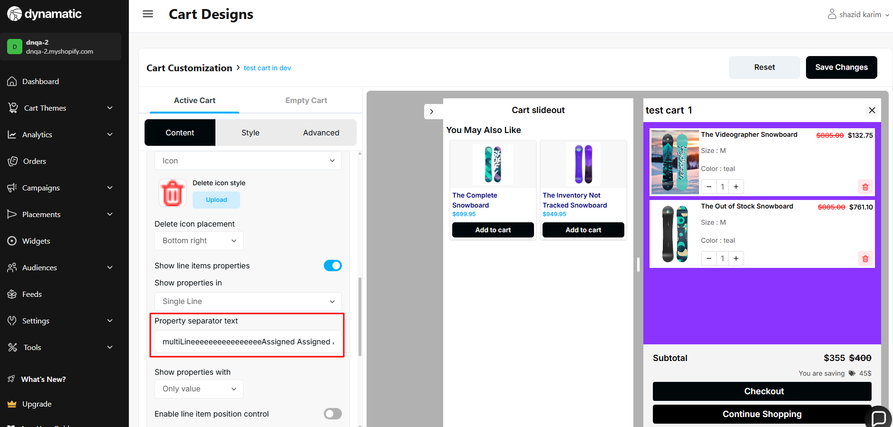

22. Accelerate Checkout Icons → Apple payment option is not showing.

**Priority-** High

**Severity**- Major

Status- Open

Assigned By- Imran

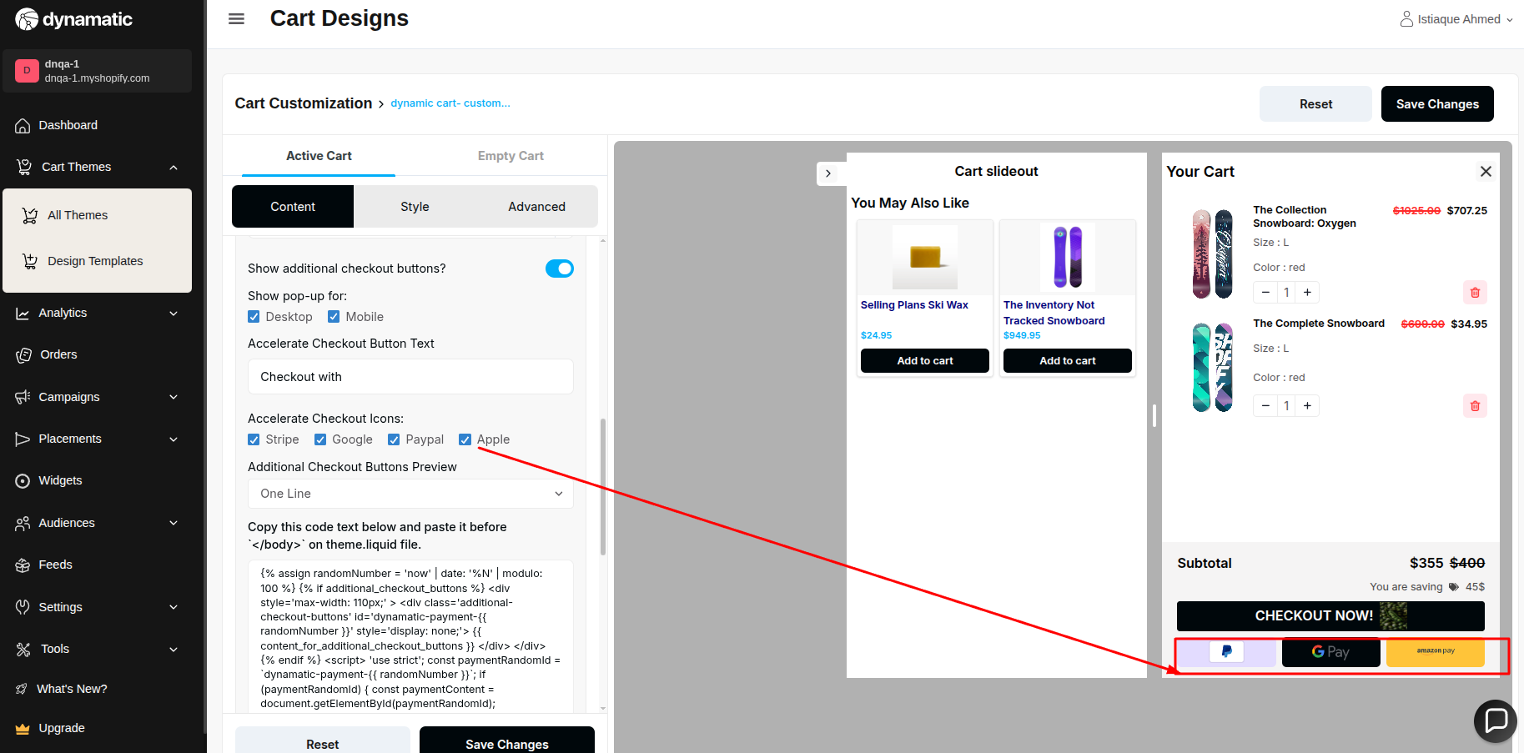

23. Additional Checkout Buttons Preview dropdown -> arrow is not showing after selecting any option from the dropdown.

**Priority-** Medium

**Severity**- Medium

Status- Open

Assigned By- Imran

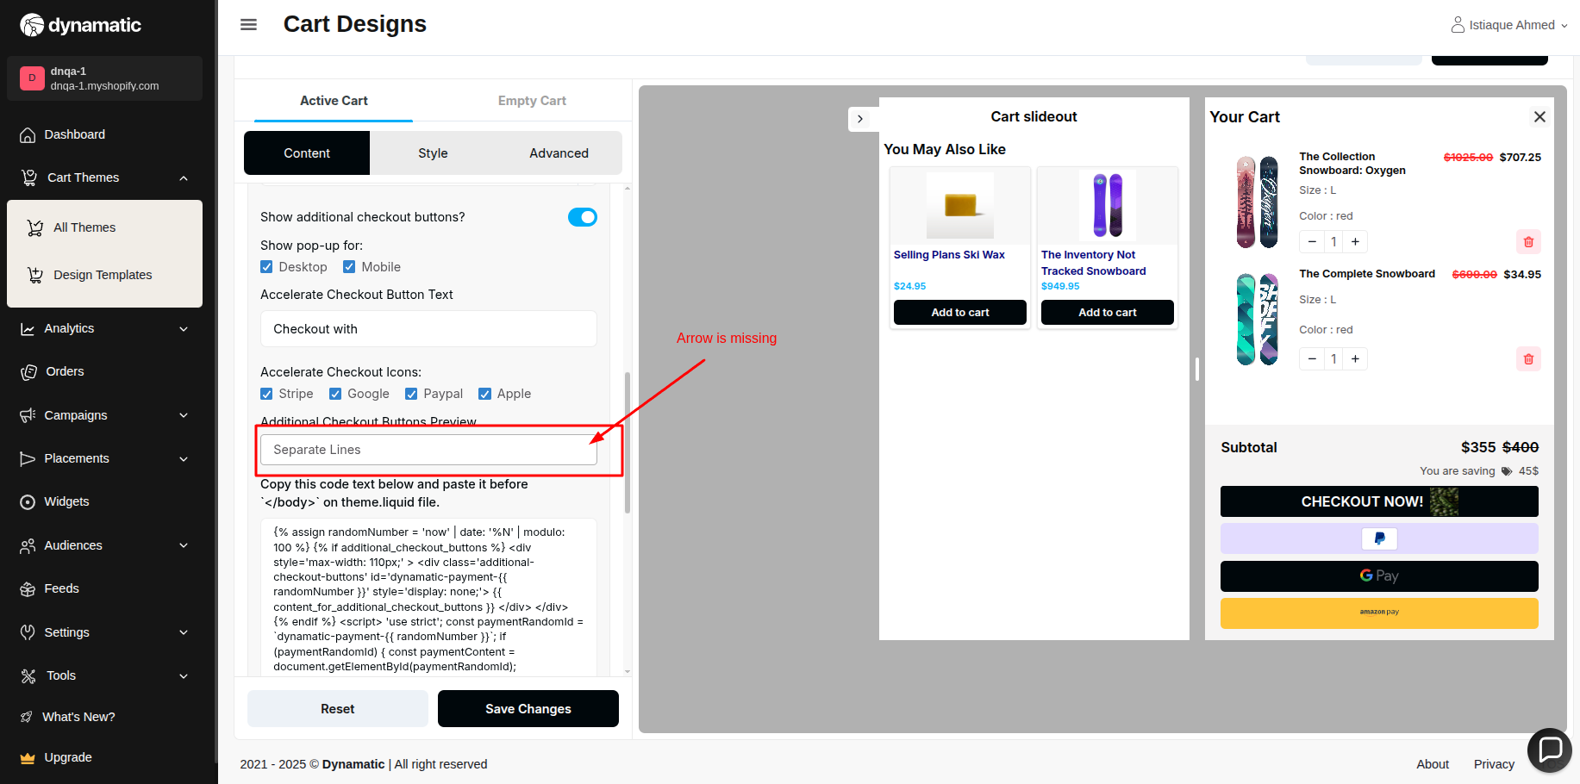

24. There is no maximum validation in this field(variant out of stock message).

**Priority-** High

**Severity**- Major

Status- Open

Assigned By- Imran

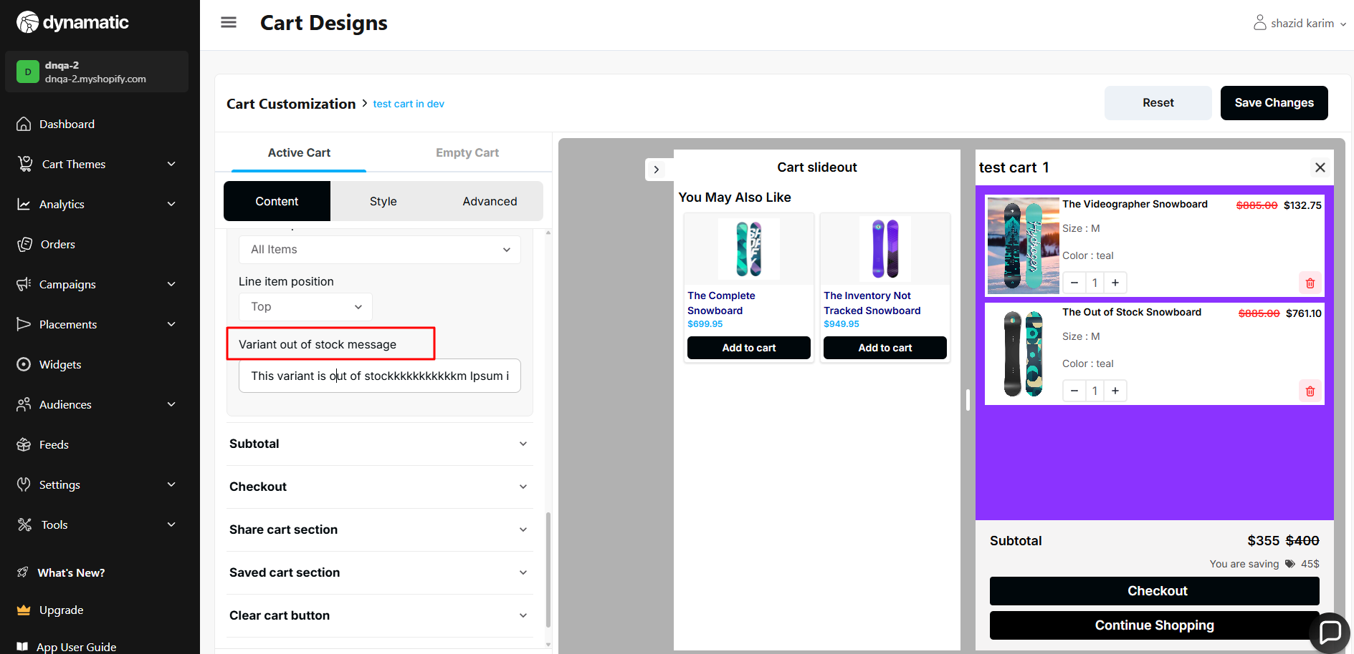

25. Line item position does not work.

**Priority-** High

**Severity**- Major

Status- Open

Assigned By- Imran

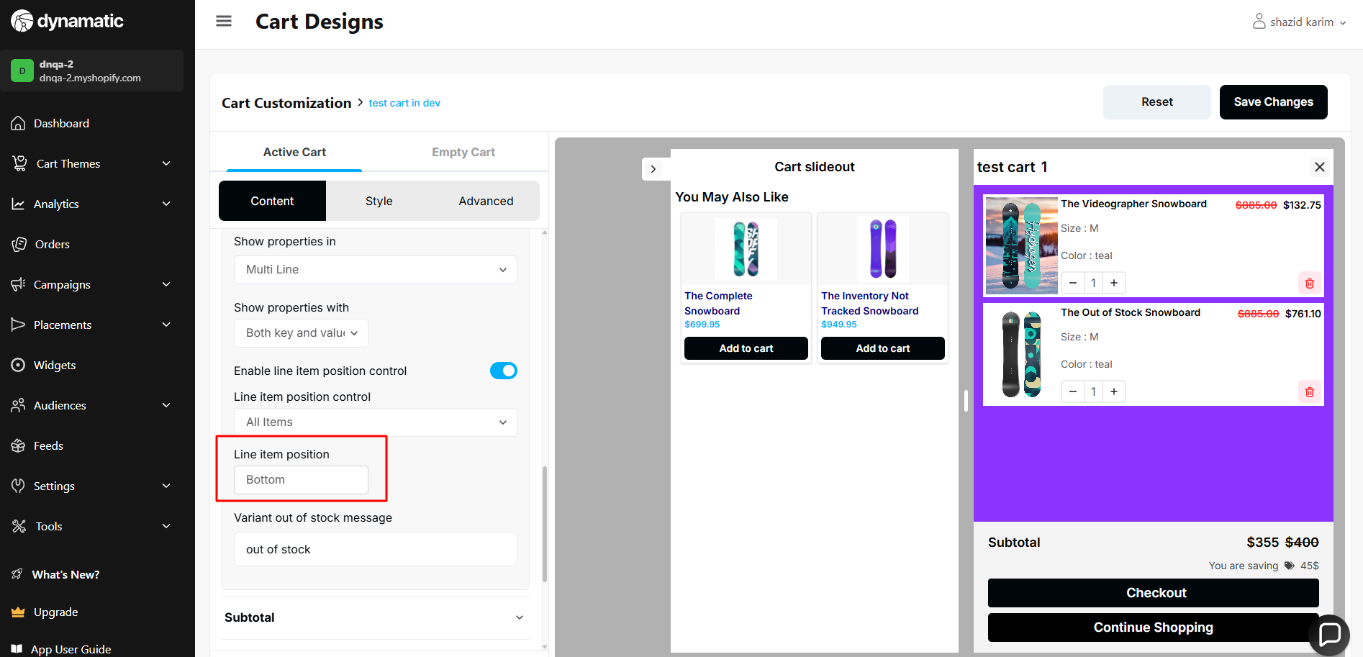

26. Subtotal text- there is no maximum text limit.

**Priority-** Medium

**Severity**- Medium

Status- Open

Assigned By- Imran

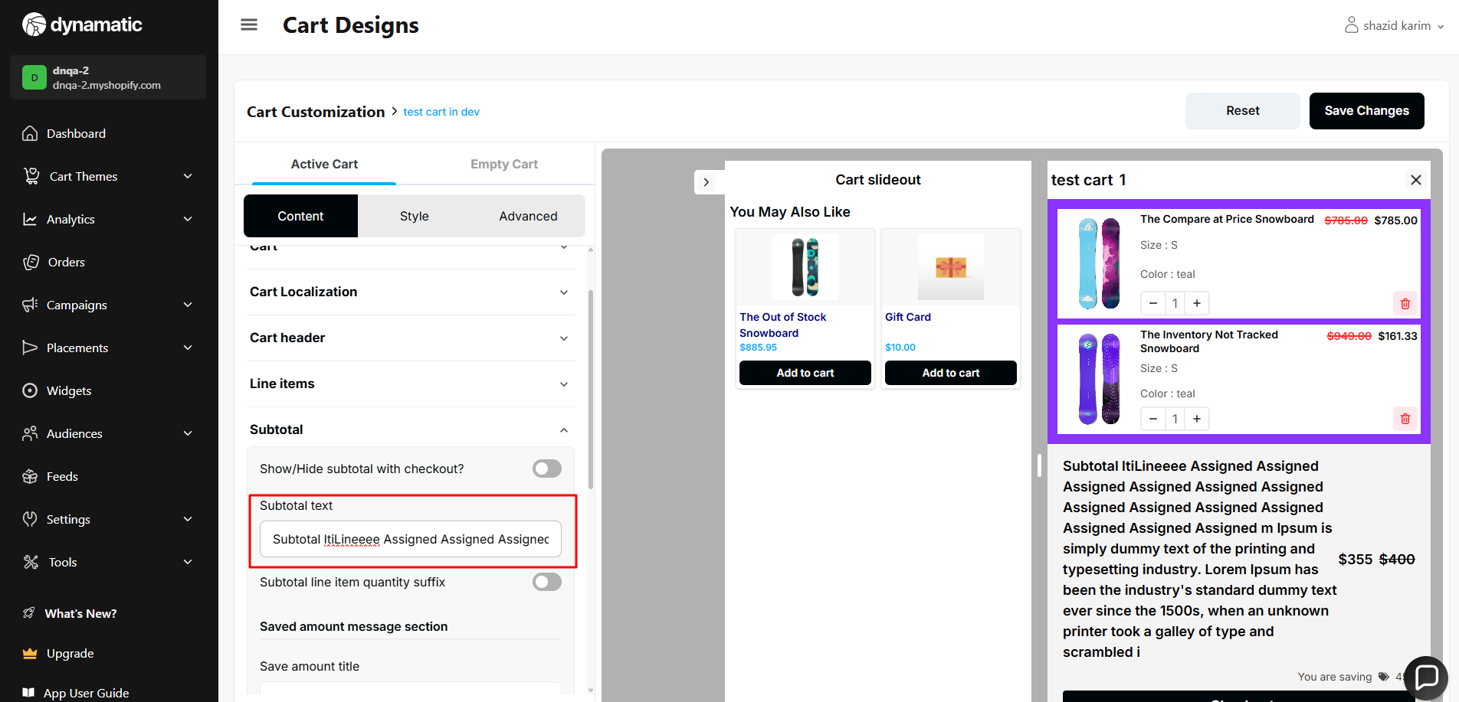

27. Subtotal line item quantity suffix ->Toggle does not work.

**Priority-** Medium

**Severity**- Medium

Status- Open

Assigned By- Imran

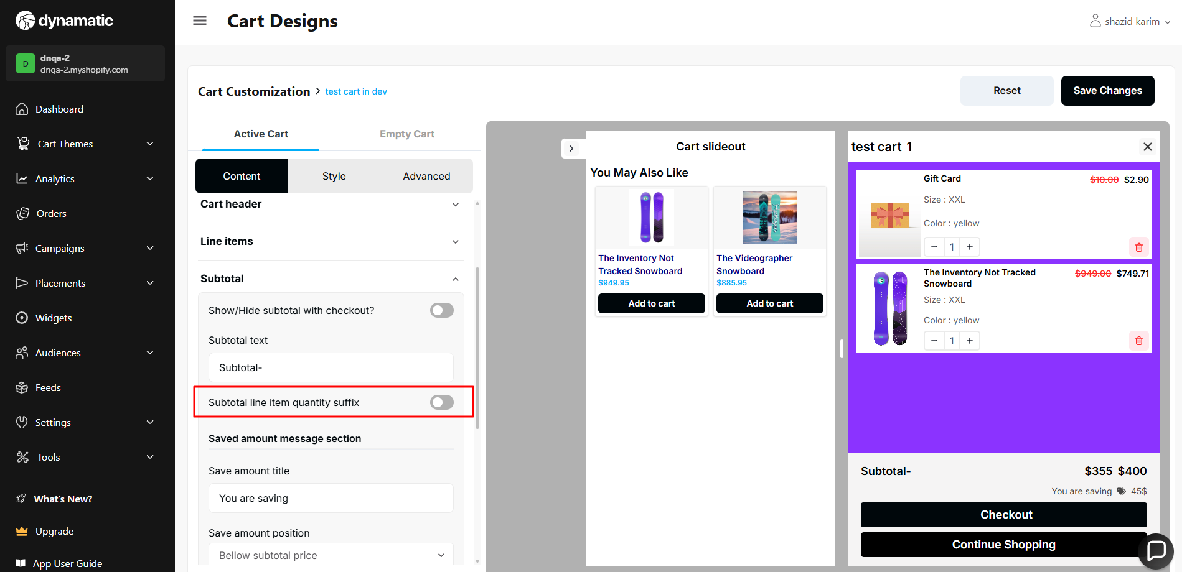

28. Subtotal title => there is no maximum text limit.

**Priority-** Medium

**Severity**- Medium

Status- Open

Assigned By- Imran

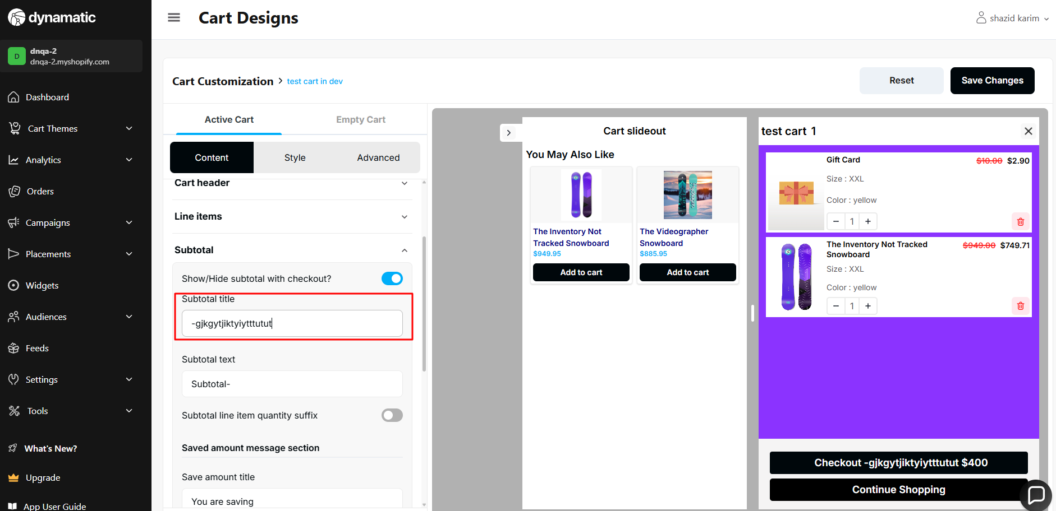

29. Continue button link → This field needs validation.

1. If this field is empty, after clicking the continue shopping button user will go to the products page
2. If the field is not empty, the user will go to that particular product URL which is provided by the merchant.

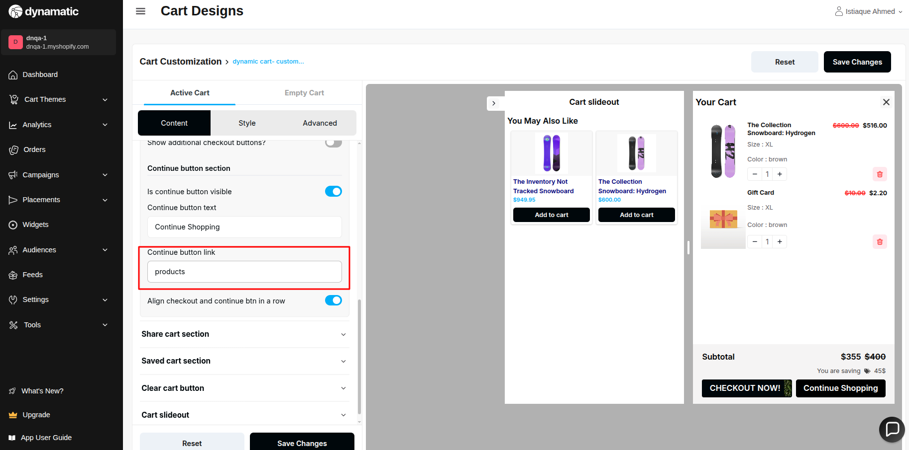

30. Quantity suffix both singular and plural=> there is no maximum text validation.

**Priority-** Medium

**Severity**- Medium

Status- Open

Assigned By- Imran

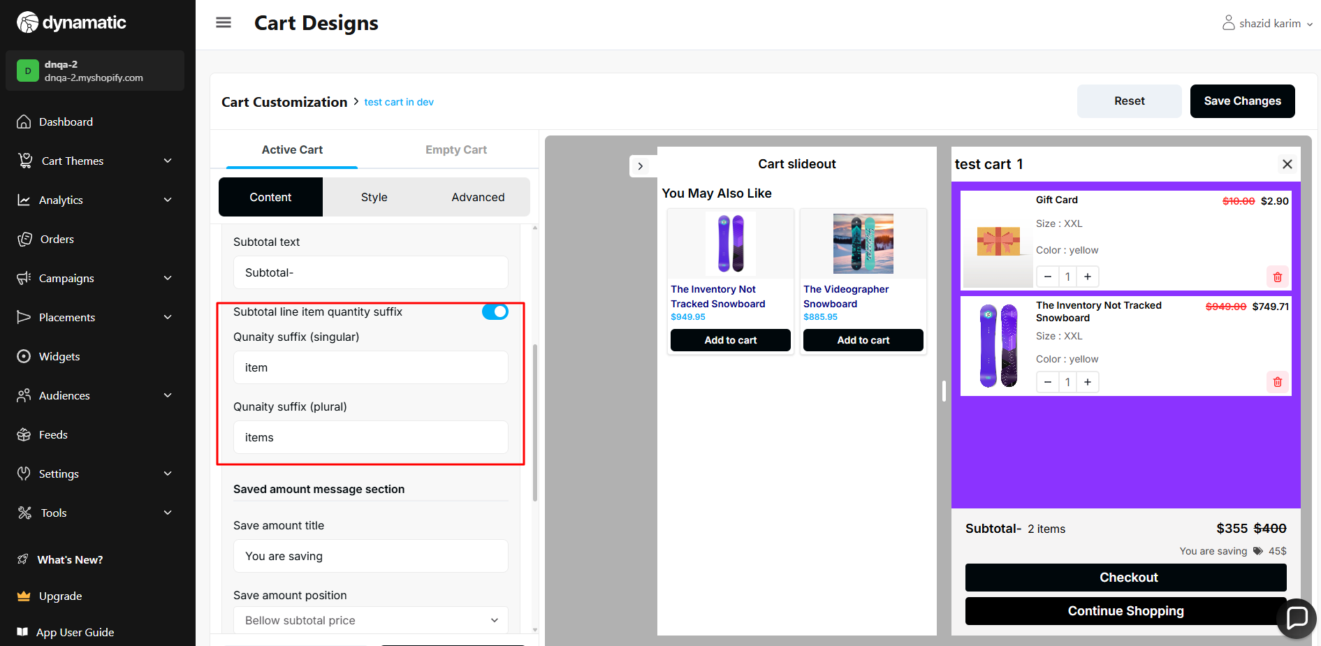

31. Quantity suffixes both singular and plural => does not work.

**Priority-** Medium

**Severity**- Medium

Status- Open

Assigned By- Imran

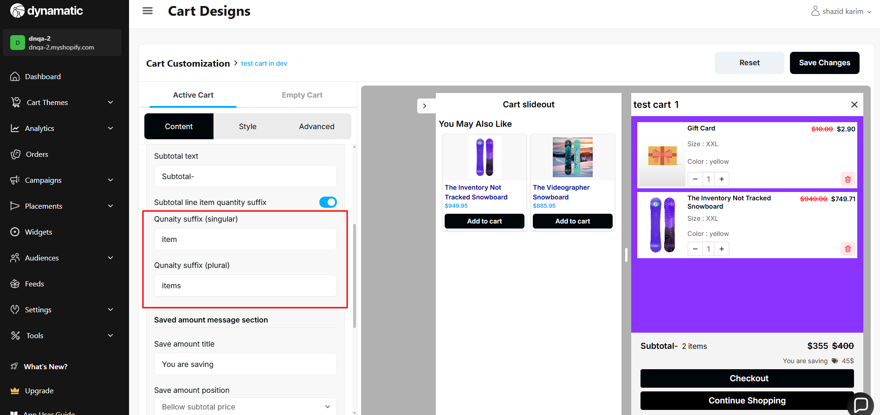

32. Save amount position => does not work.

**Priority-** Medium

**Severity**- Medium

Status- Open

Assigned By- Imran

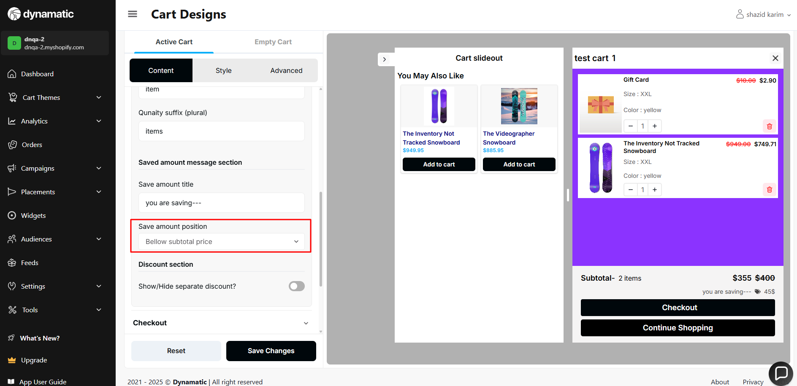

33. Share Cart → The count is not showing.

**Priority-** Medium

**Severity**- Major

Status- Open

Assigned By- Imran

Steps-

1. Add to cart a product
2. Click the Share icon/text from the cart
3. Paste the link in a different browser.

The count is not showing beside the cart icon.

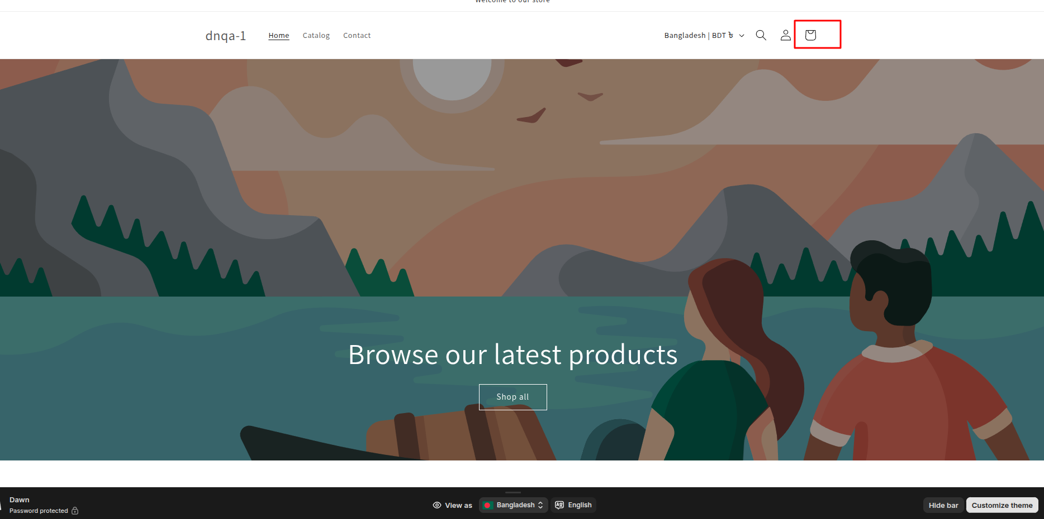

34. Discount collapse title=> There is no maximum text validation.

**Priority-** Medium

**Severity**- Medium

Status- Open

Assigned By- Imran

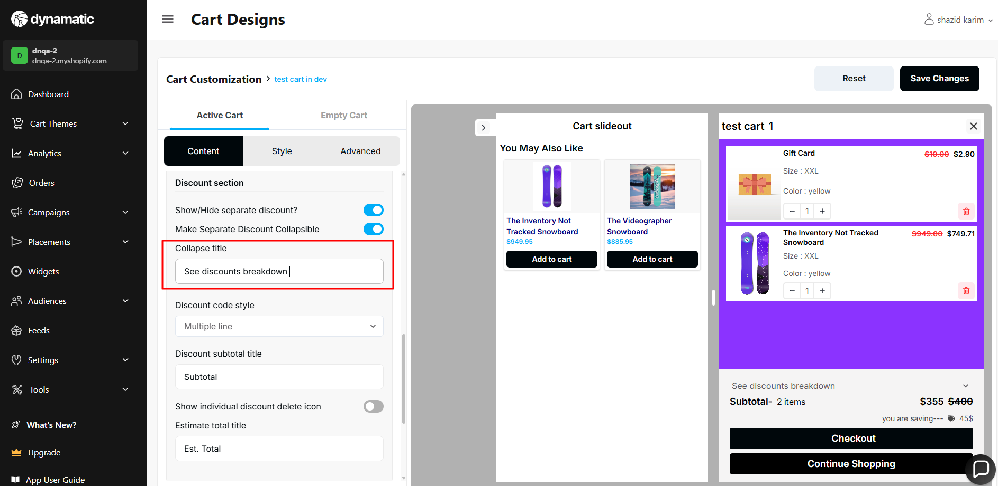

35. Share Cart → The cart is not opening at the beginning after opening the URL.

**Priority-** Medium

**Severity**- Medium

Status- Open

Assigned By- Imran

Steps-

1. Add to cart a product
2. Click the Share icon/text from the cart
3. Paste the link in a different browser.

36. Discount code style => if we set this option in multi line, our cart discount breakdown part is not visible(meaning it's not collapsible ).

**Priority-** Medium

**Severity**- Medium

Status- Open

Assigned By- Imran

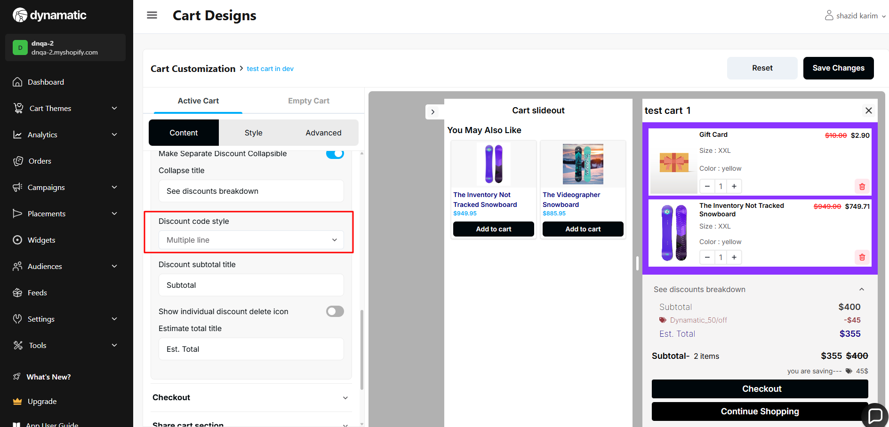

Issue image:

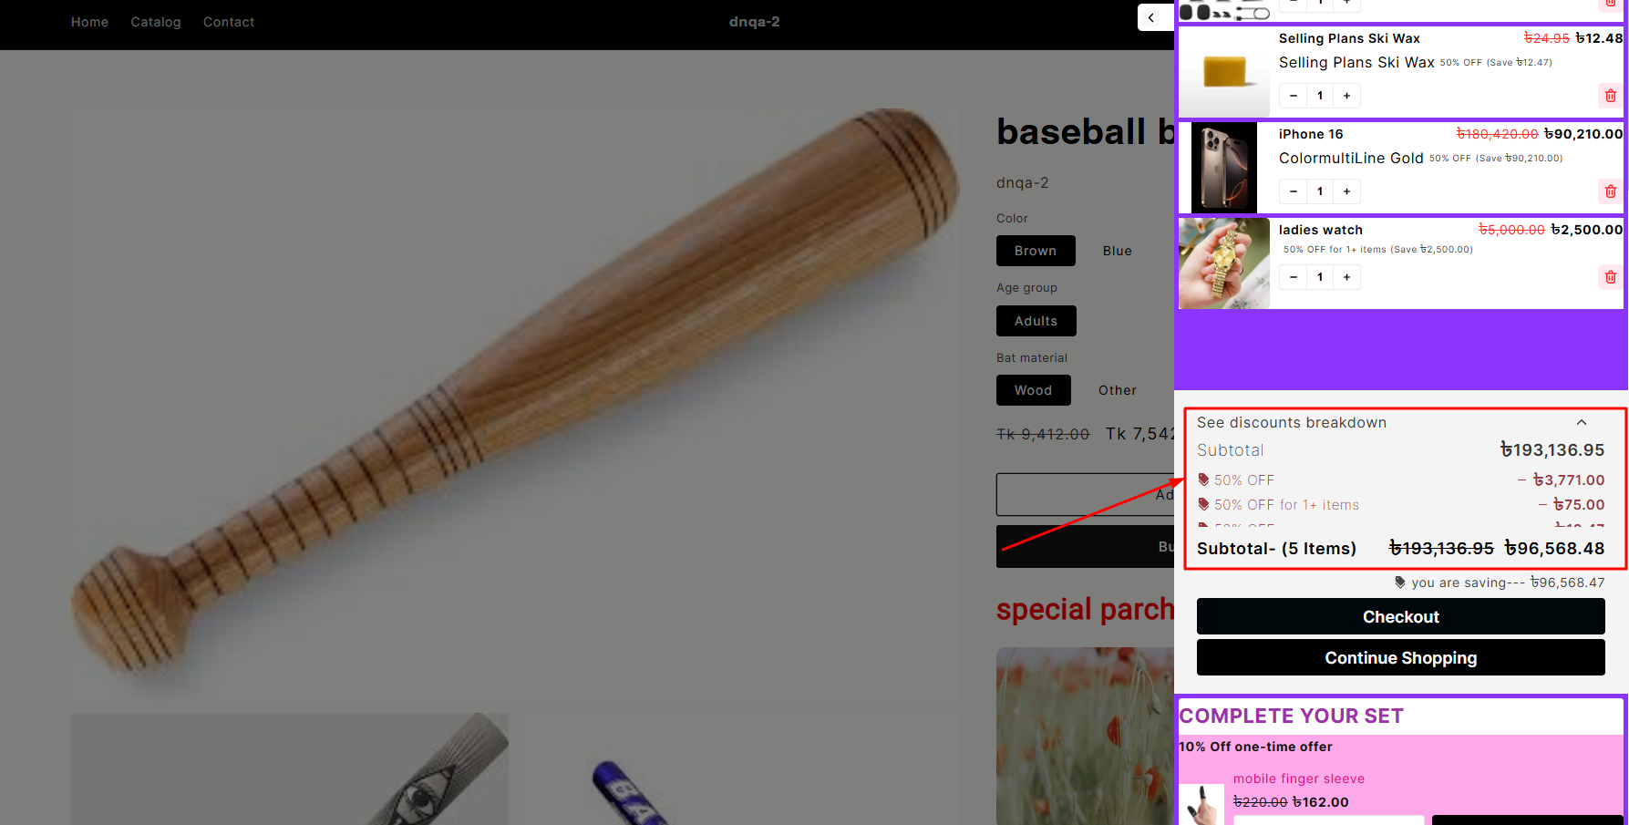

37.Discount subtotal title => there is no maximum text validation.

**Priority-** Medium

**Severity**- Medium

Status- Open

Assigned By- Imran

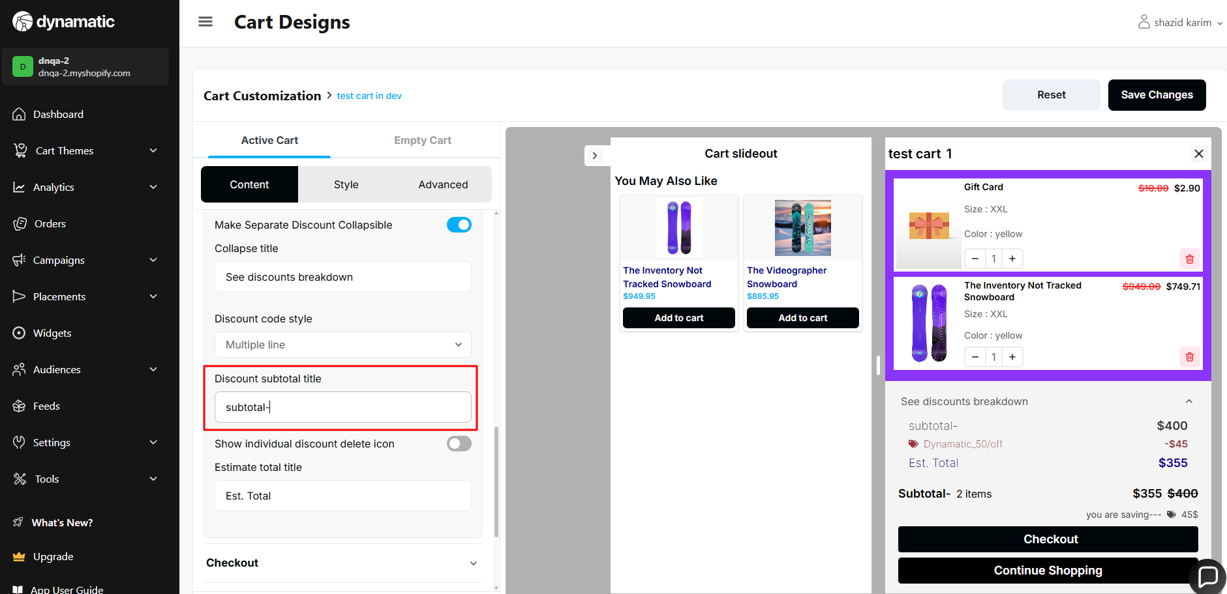

38.Discount subtotal title => this field should not take 0 or negative input.

**Priority-** Medium

**Severity**- Medium

Status- Open

Assigned By- Imran

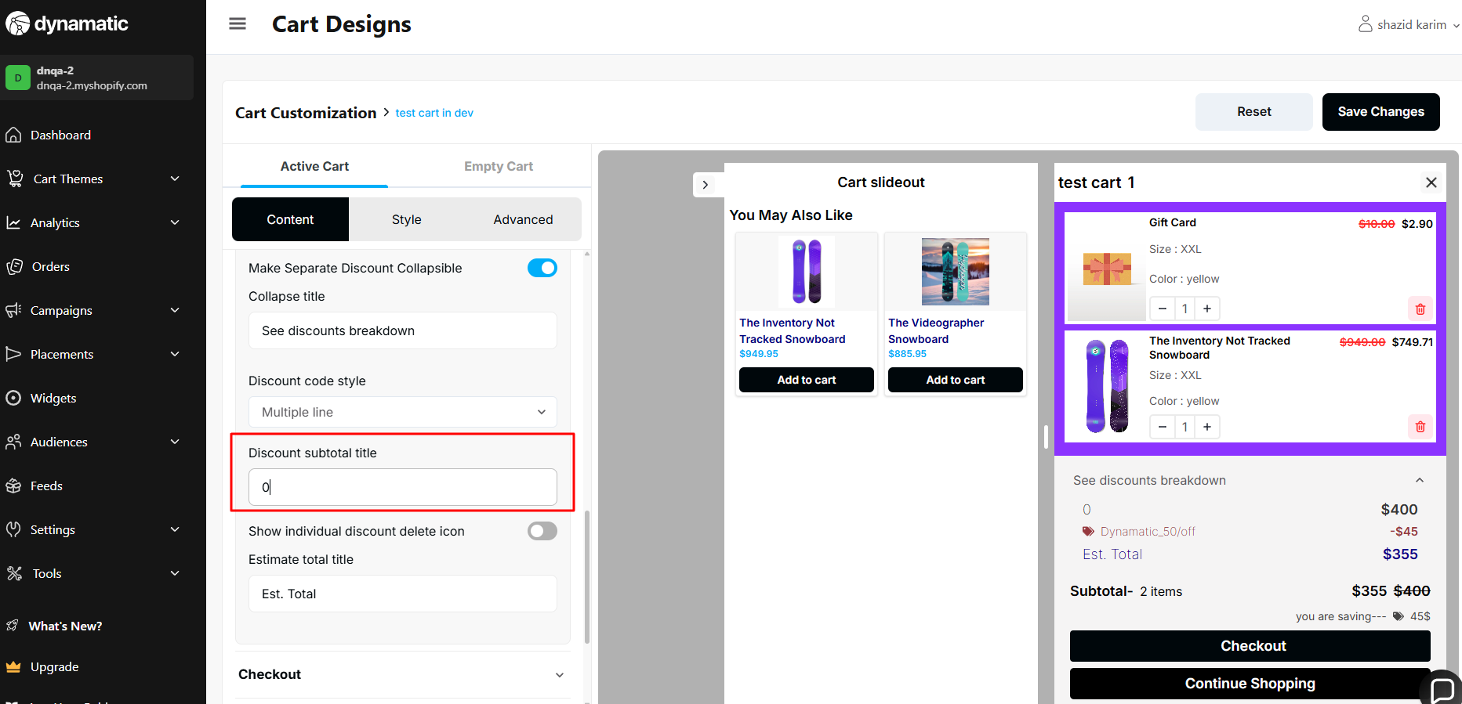

39. Active cart title → There is no max validation for this input field

**Priority-** Medium

**Severity**- Major

Status- Open

Assigned By- Imran

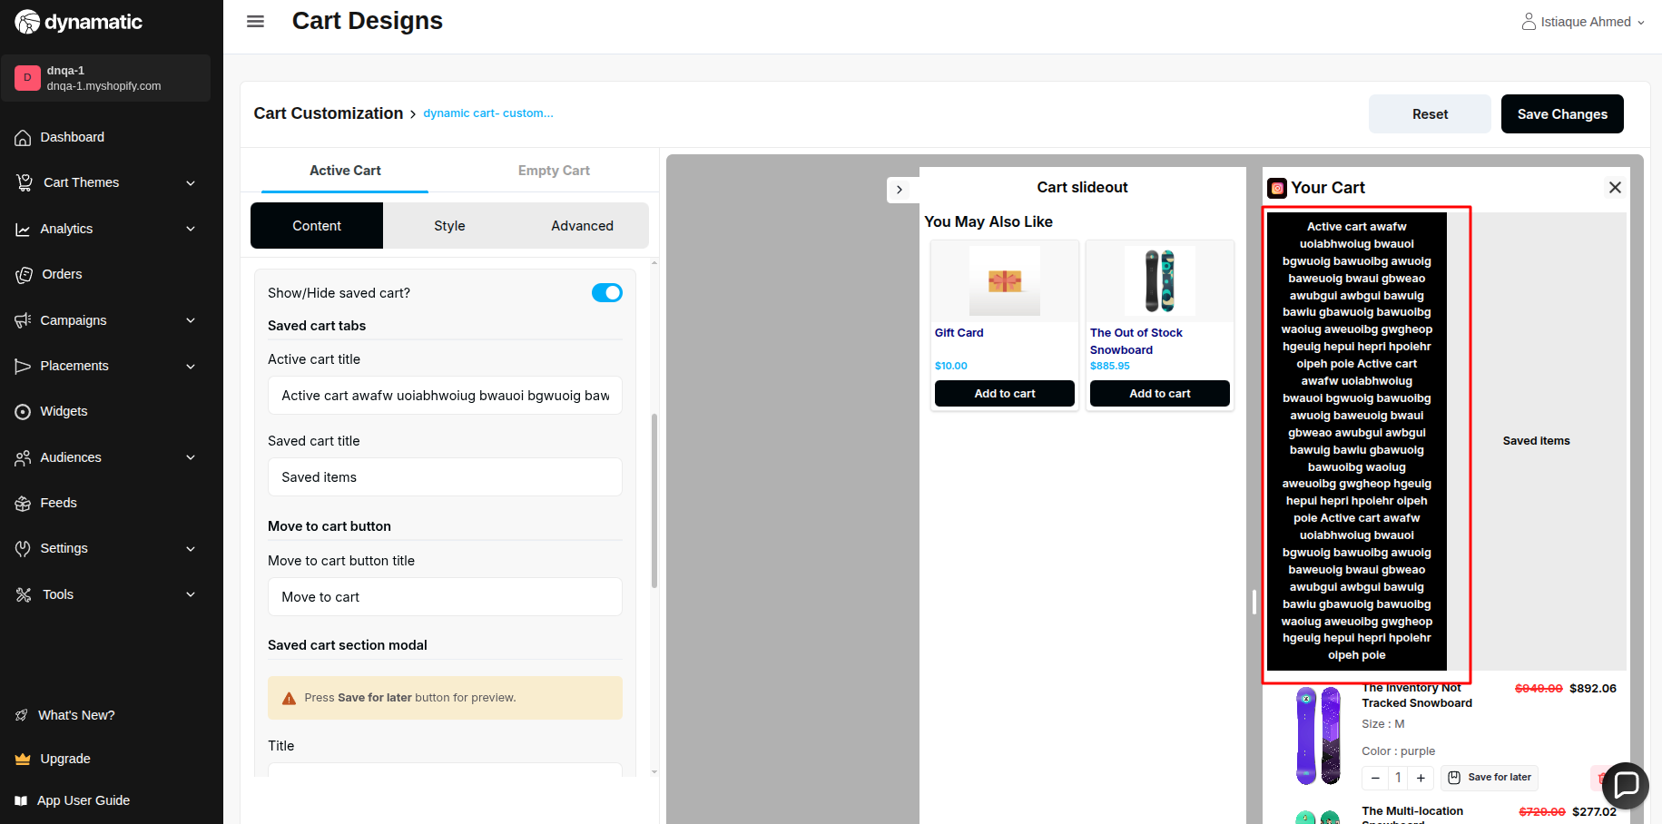

40. Saved cart title → There is no max validation for this input field

**Priority-** Medium

**Severity**- Major

Status- Open

Assigned By- Imran

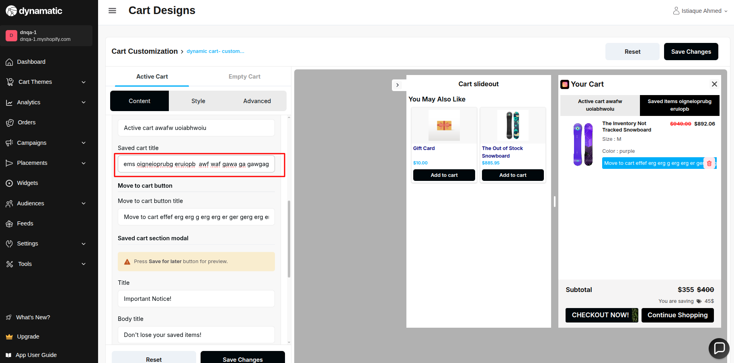

41. Move to cart button title → There is no max character validation for this input field

**Priority-** Medium

**Severity**- Major

Status- Open

Assigned By- Imran

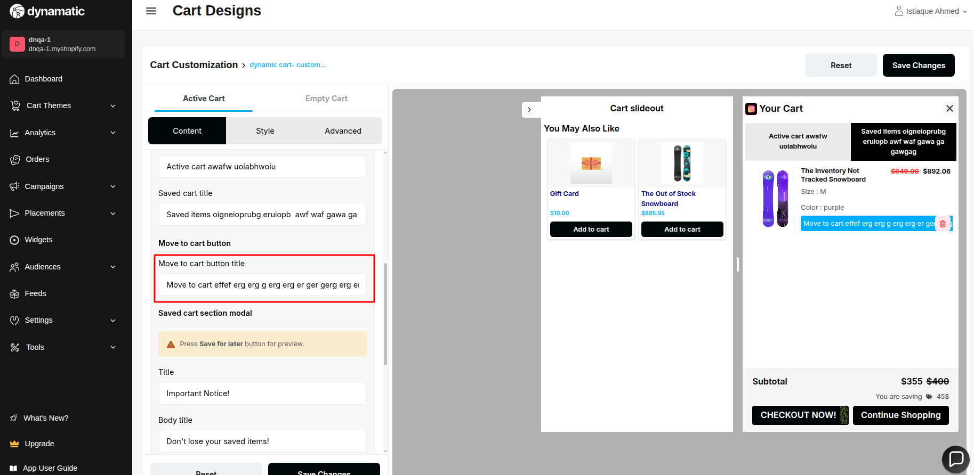

42.Show individual discount delete icon => does not work.

**Priority-** High

**Severity**- Medium

Status- Open

Assigned By- Shazid

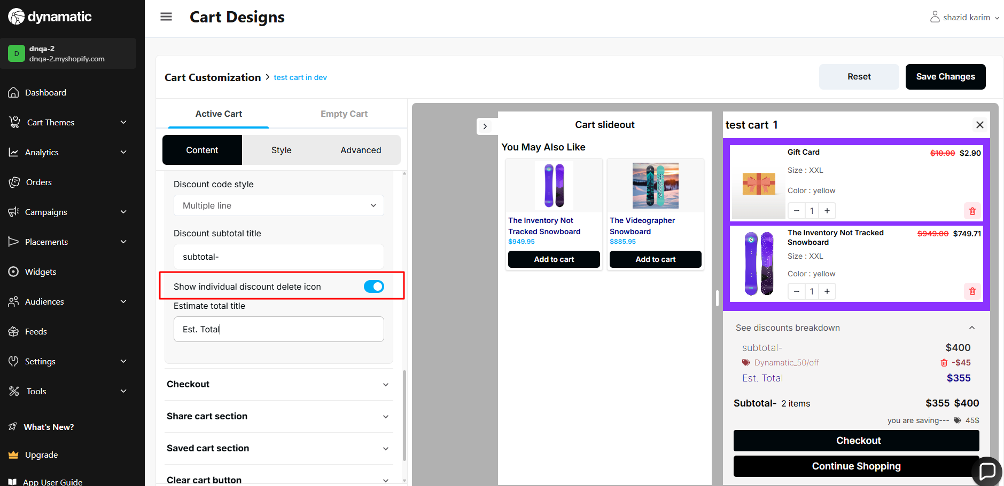

43. Saved Section → Title/Body title/Body description → There is no maximum character validation for these input fields.

**Priority-** Medium

**Severity**- Major

Status- Open

Assigned By- Imran

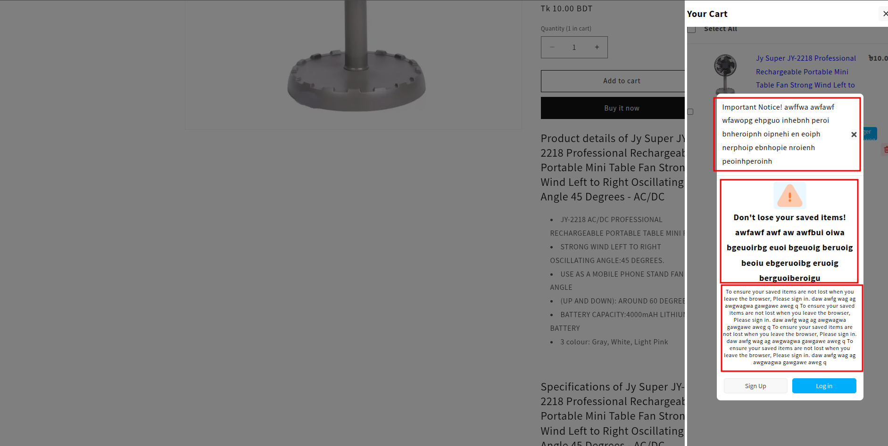

44.Estimate total title => there is no maximum text validation.

**Priority-** High

**Severity**- Medium

Status- Open

Assigned By- Imran

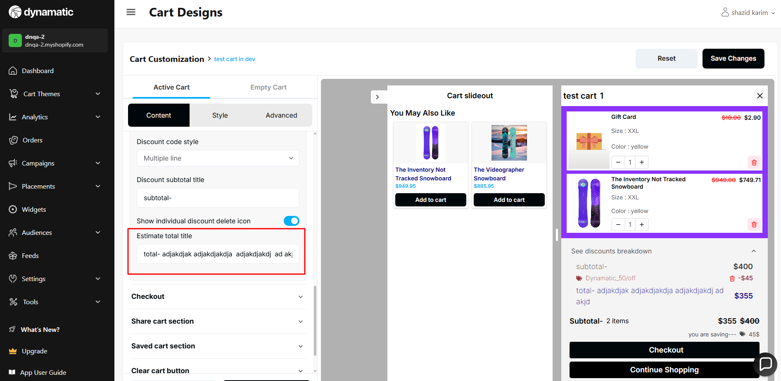

45.Estimate total title =>this field does not take 0 or negative value(text only).

**Priority-** High

**Severity**- Medium

Status- Open

Assigned By- Imran

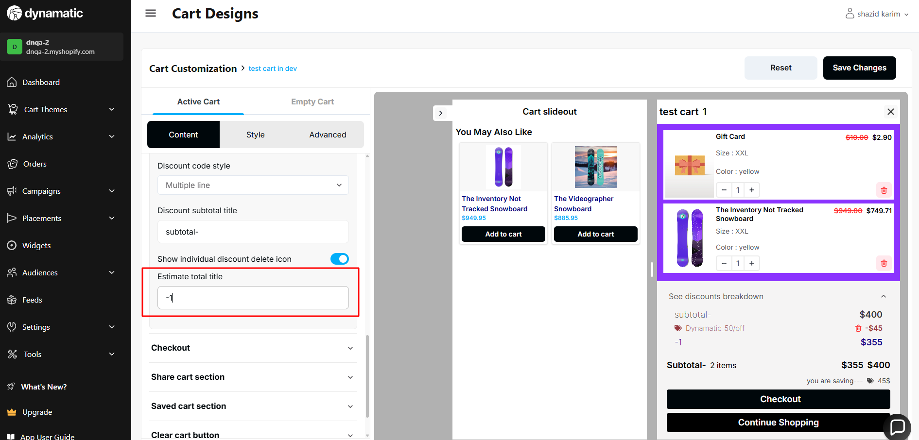

46. Saved Section →Sign up button title/Sign in button title -> These button’s title is

not working.

**Priority-** High

**Severity**- Major

Status- Open

Assigned By- Imran

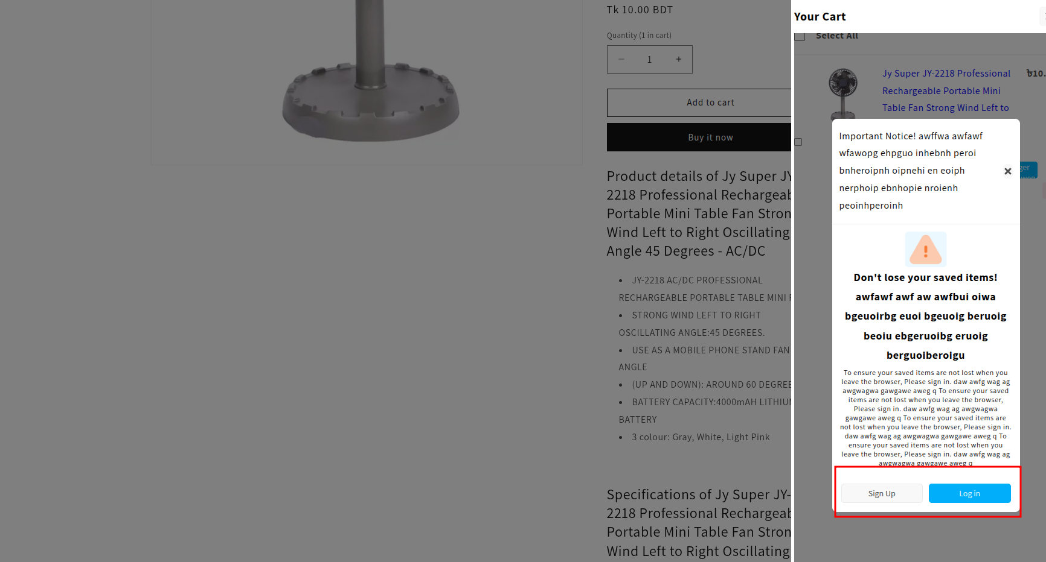

47.The slide-out cart doesn't close automatically after adding all the products.

**Priority-** High

**Severity**- Medium

Status- Open

Assigned By- Imran

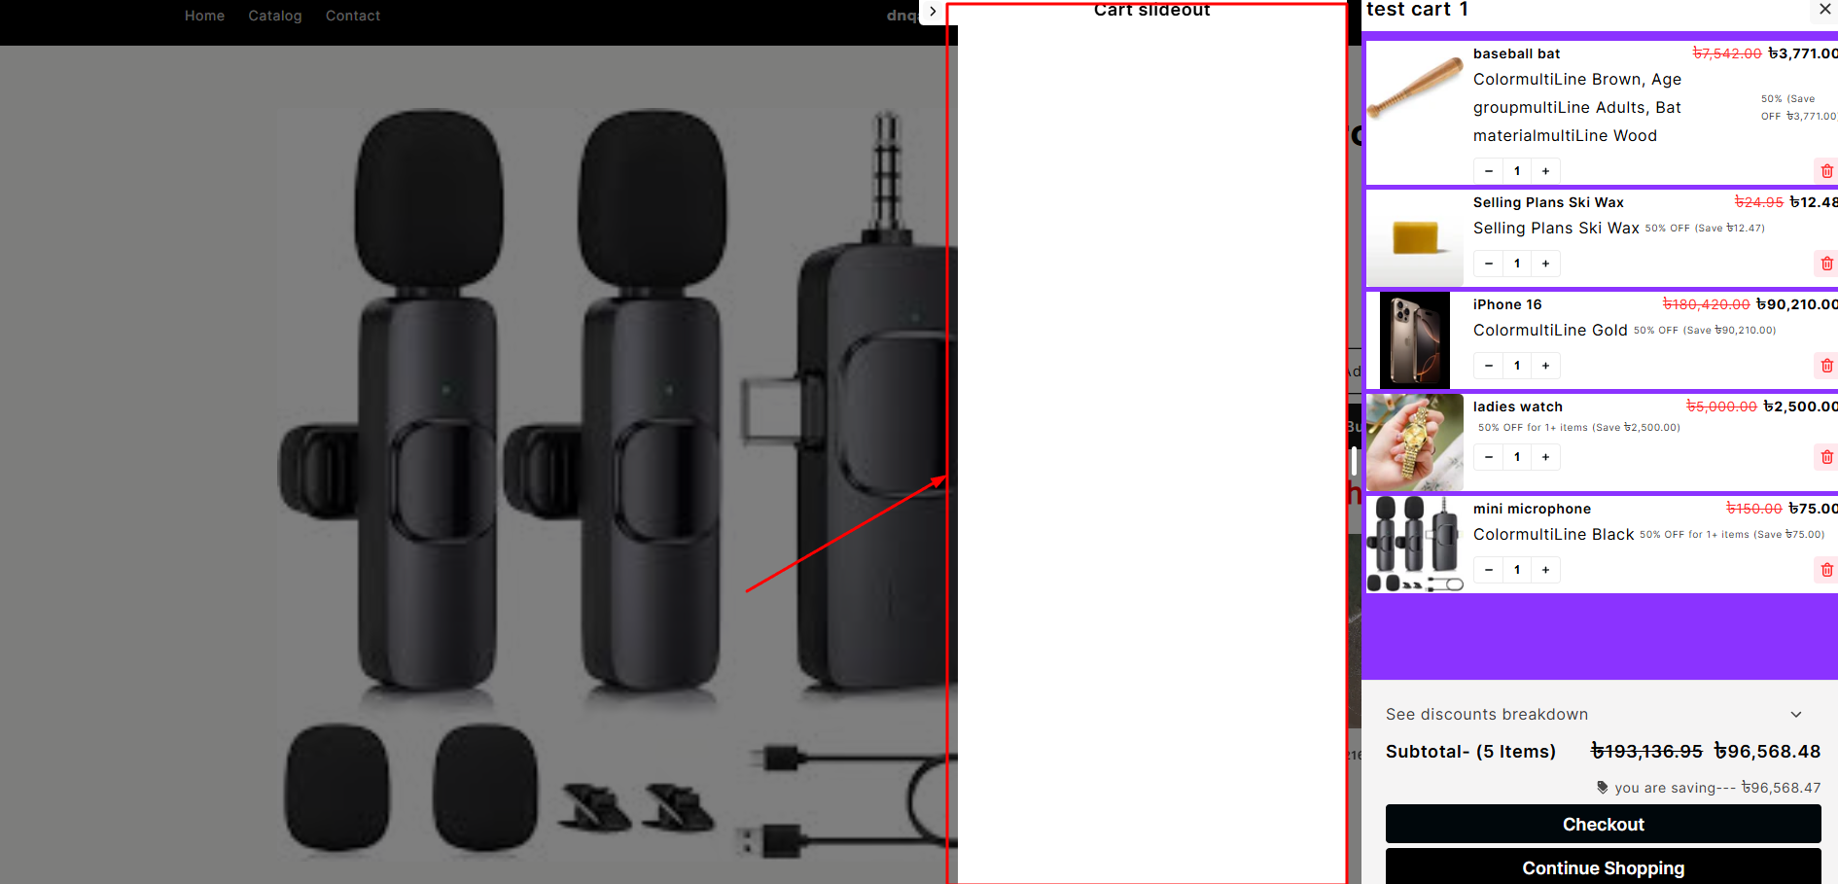

48. Slide-out heading text => there is no maximum text validation.

**Priority-** High

**Severity**- Medium

Status- Open

Assigned By- Imran

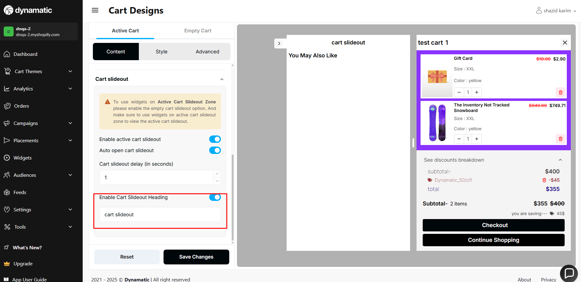

49. Clear cart button → This button’s functionality is not working.

**Priority-** High

**Severity**- Block

Status- Open

Assigned By- Imran

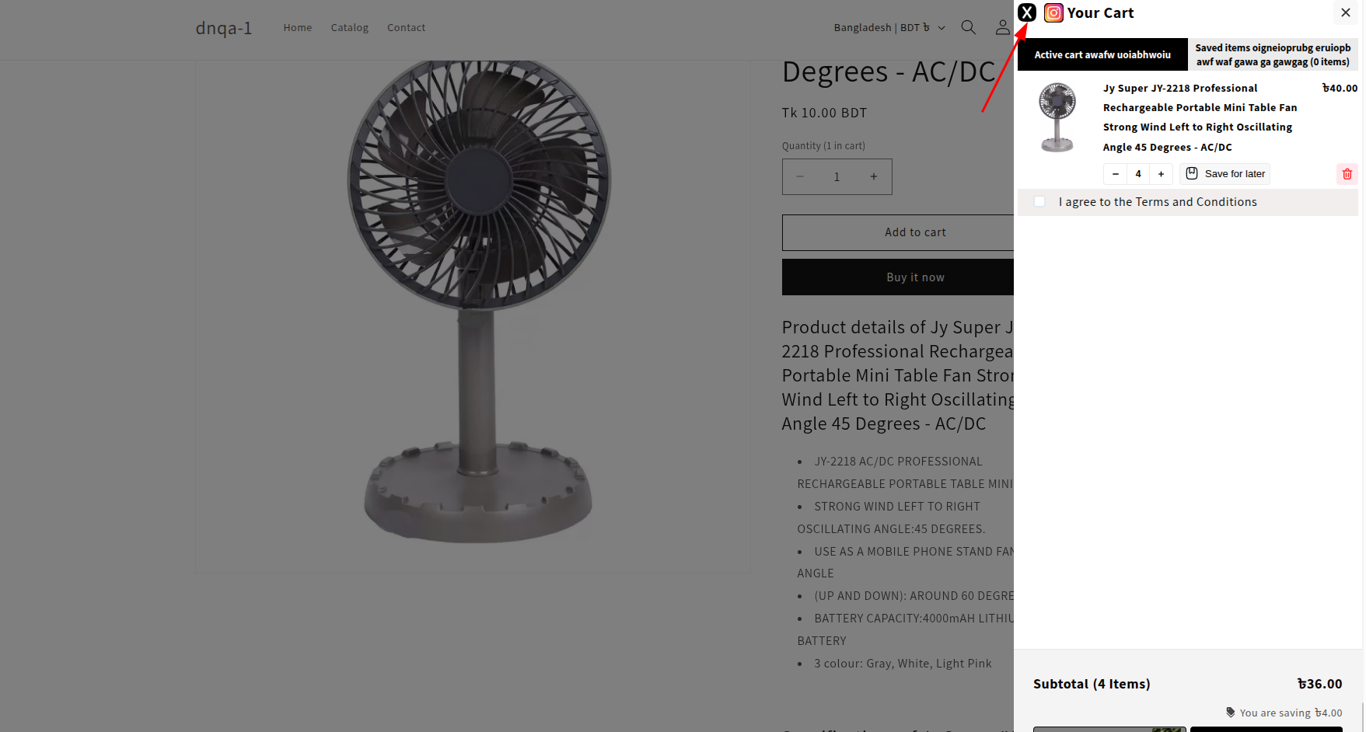

50. Cart slideout delay=> this field must not take negative value.

**Priority-** High

**Severity**- Major

Status- Open

Assigned By- Imran

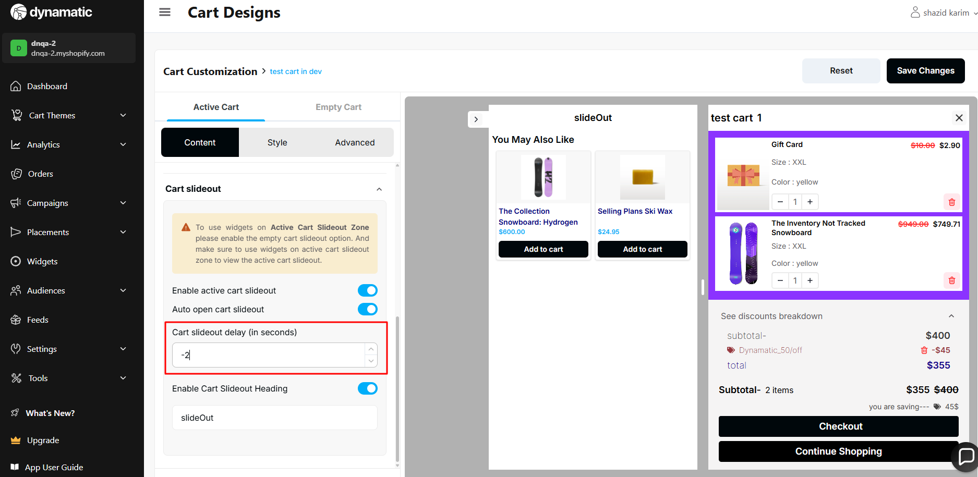

51. Empty Cart → If the saved cart functionality is open, the Empty Cart body functionality is not working

**Priority-** High

**Severity**- Block

Status- Open

Assigned By- Imran

Store Card design

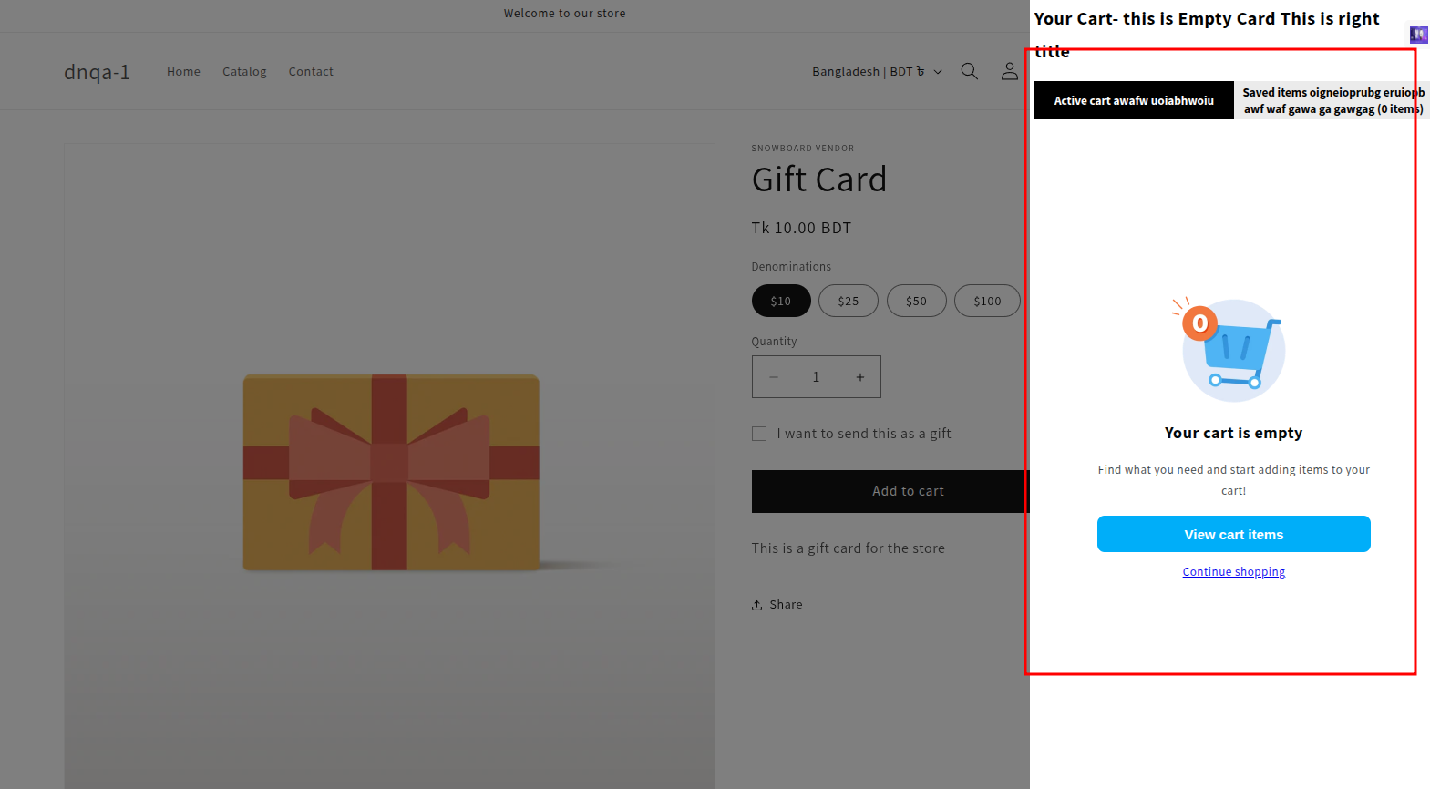

Empty cart design

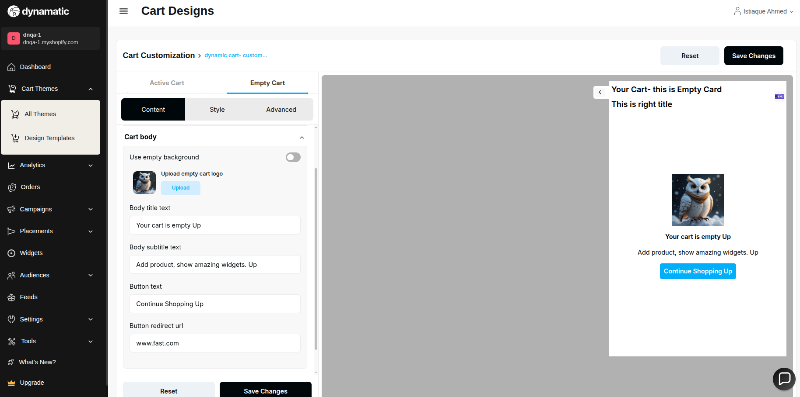

52. The empty cart slide-out remains open even when there are no widgets in the slide-out section.

**Priority-** High

**Severity**- Major

Status- Open

Assigned By- Imran

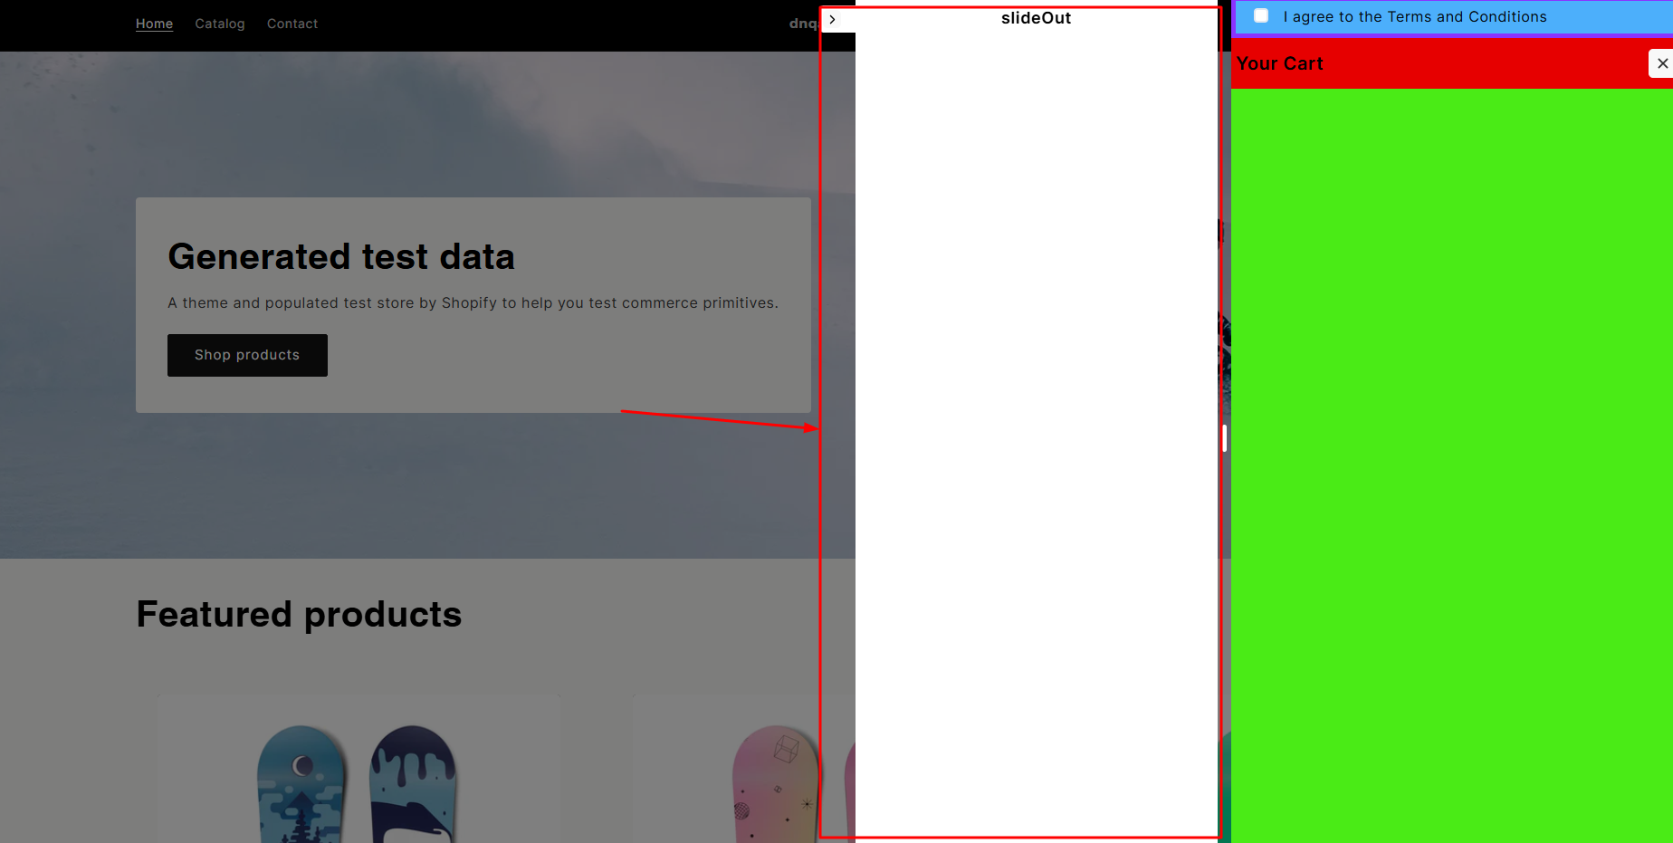

53. Empty cart → Body title/Body Subtitle/Button text -> There is no validation for the maximum character.

**Priority-** Medium

**Severity**- Major

Status- Open

Assigned By- Imran

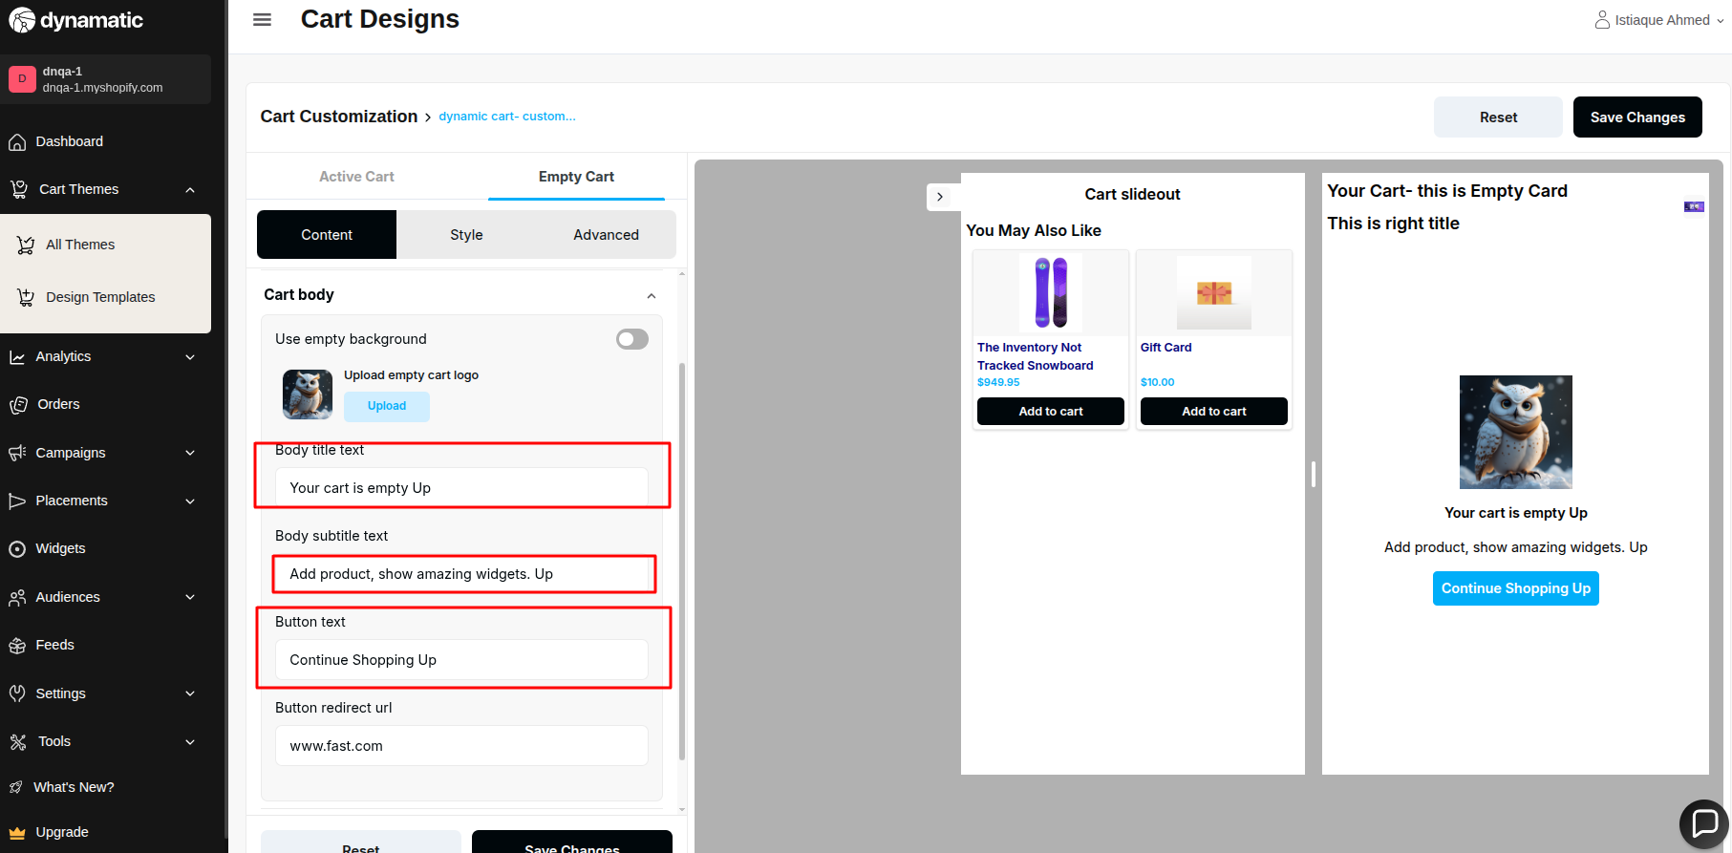

54. Cart width must not be 0 or negative input.

**Priority-** High

**Severity**- Major

Status- Open

Assigned By- Imran

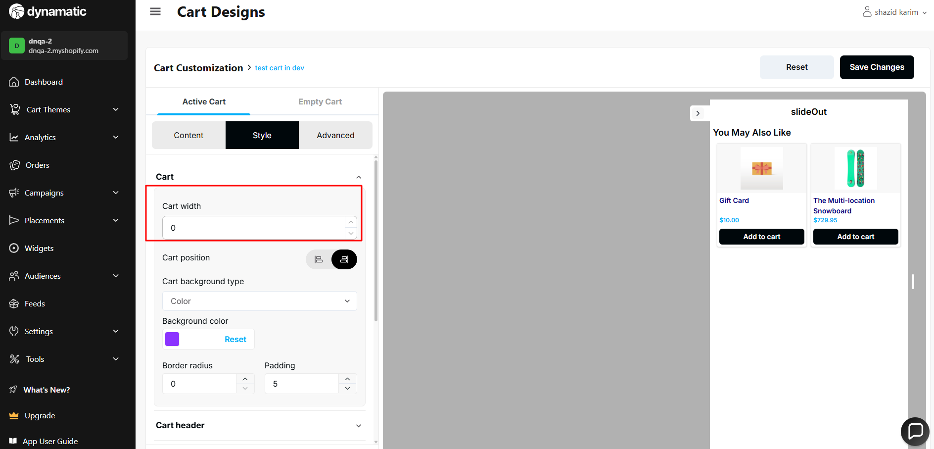

55.The cart width needs to have a minimum value because when I set it to 50px, it becomes invisible on the website.

**Priority-** High

**Severity**- Major

Status- Open

Assigned By- Imran

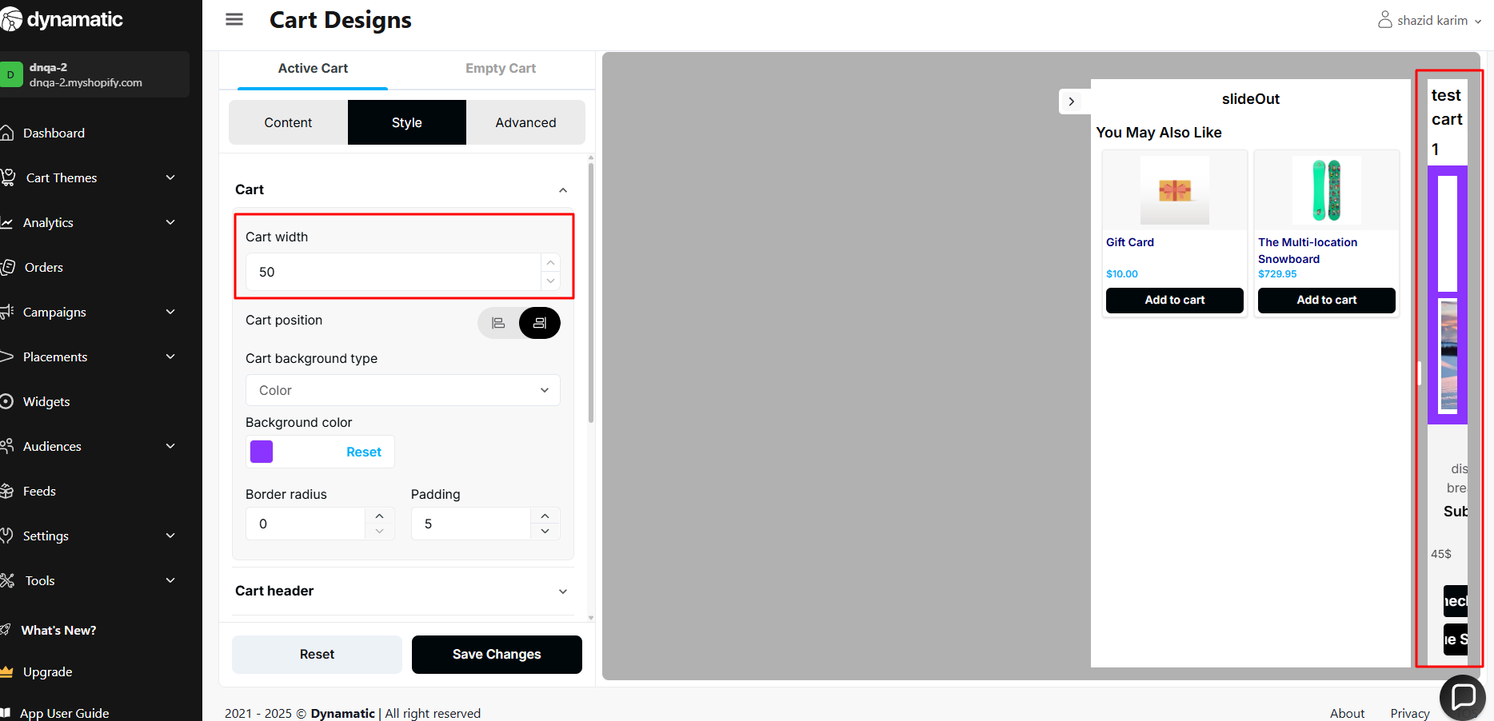

56.cart border radius needs to be validated. It takes so many numbers.

**Priority-** High

**Severity**- Major

Status- Open

Assigned By- Imran

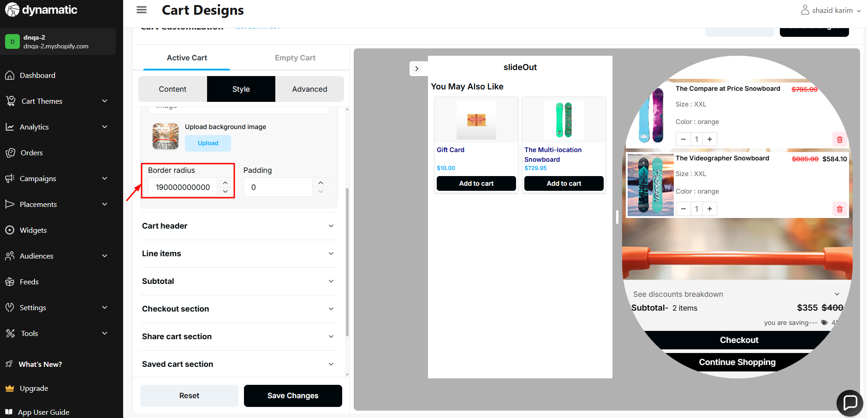

57. Cart padding also needs to be validated, as entering excessively large values breaks the cart's design.

**Priority-** High

**Severity**- Major

Status- Open

Assigned By- Imran

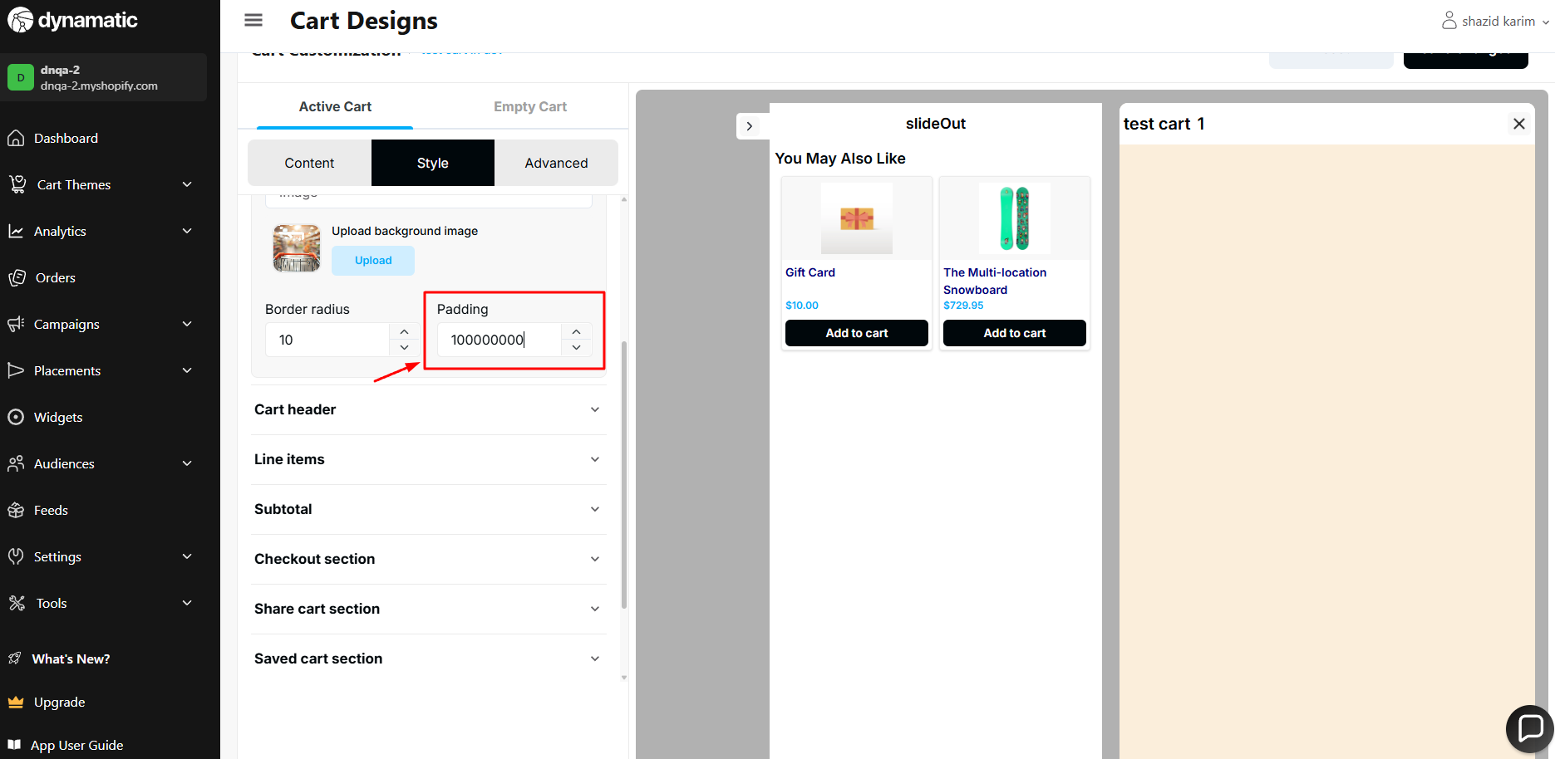

58.Cart header padding also needs to be validated, as entering excessively large values breaks the cart's design.

**Priority-** High

**Severity**- Major

Status- Open

Assigned By- Imran

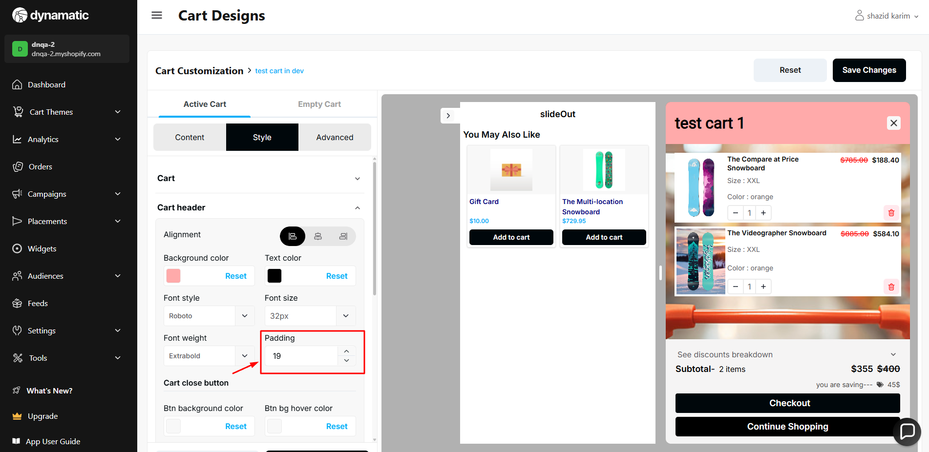

59.Cart close button border radius needs to be validated, it's taking large numbers.

**Priority-** High

**Severity**- Major

Status- Open

Assigned By- Imran

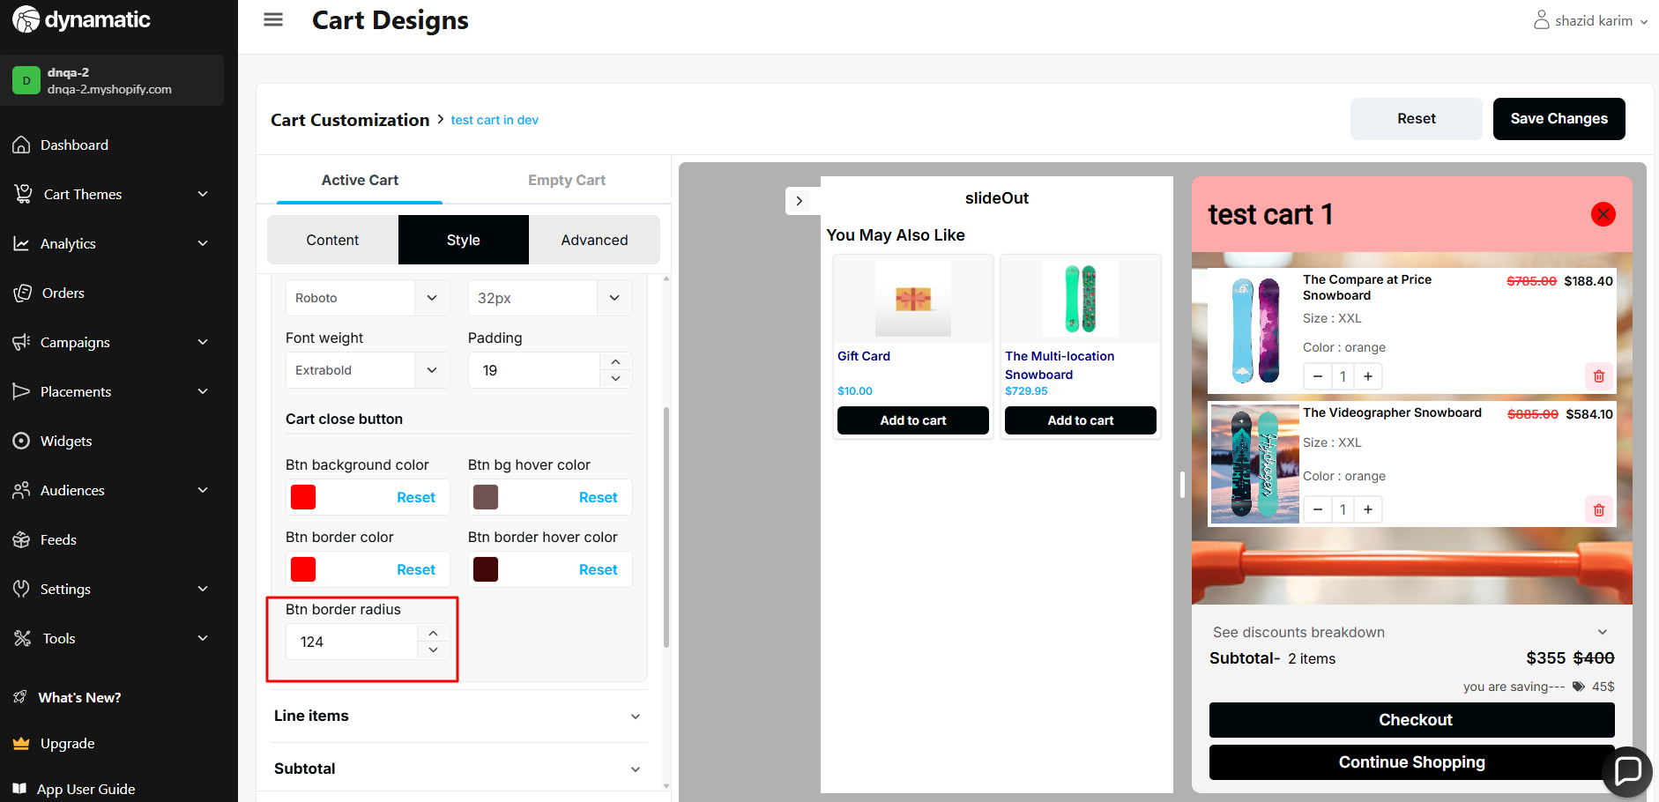

60. Active Cart → Style →Checkout/Continue button → User is able to provide a negative value in the padding.

**Priority-** Medium

**Severity**- Medium

Status- Open

Assigned By- Imran

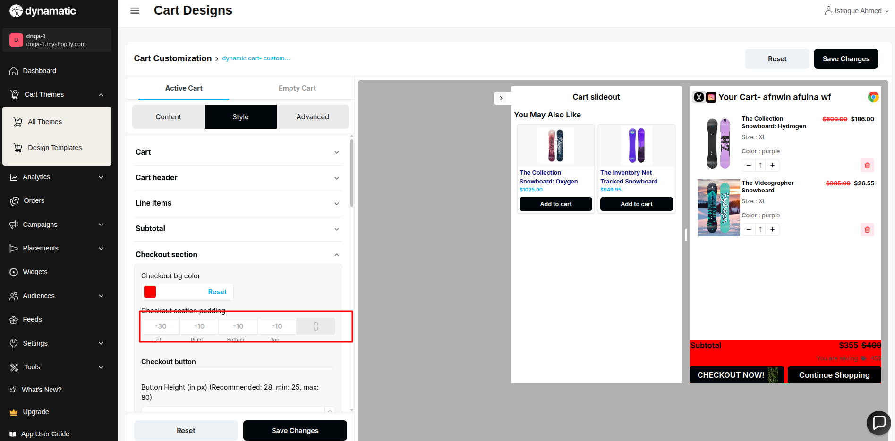

61. Active Cart → Style →Checkout/Continue button → User is able to provide a negative value in the button height.

**Priority-** Medium

**Severity**- Medium

Status- Open

Assigned By- Imran

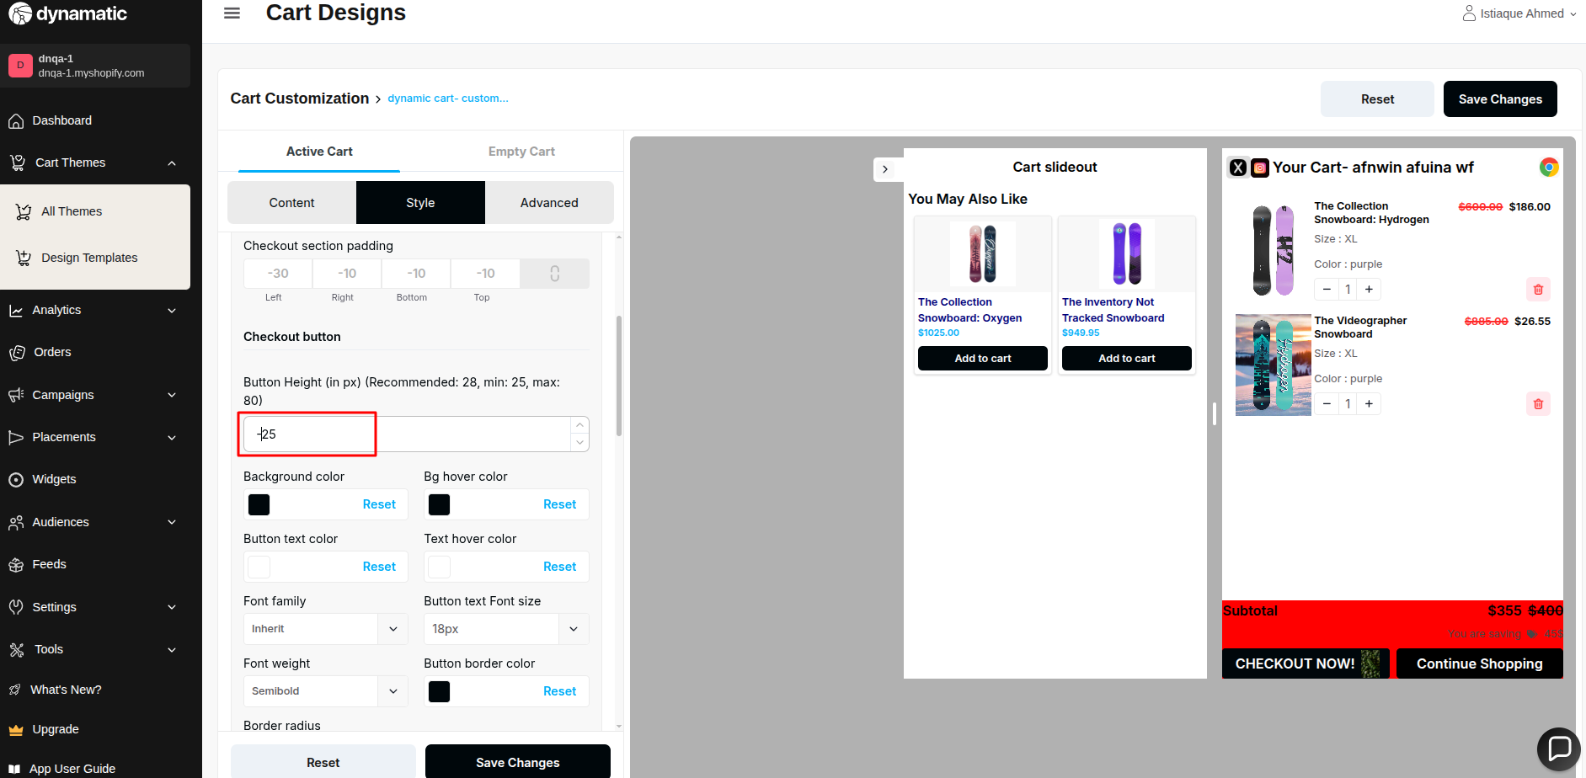

62. Active Cart → Style →Checkout/Continue button →User is able to provide more than the maximum value in the button height.

The max limit is 80px

**Priority-** Medium

**Severity**- Medium

Status- Open

Assigned By- Imran

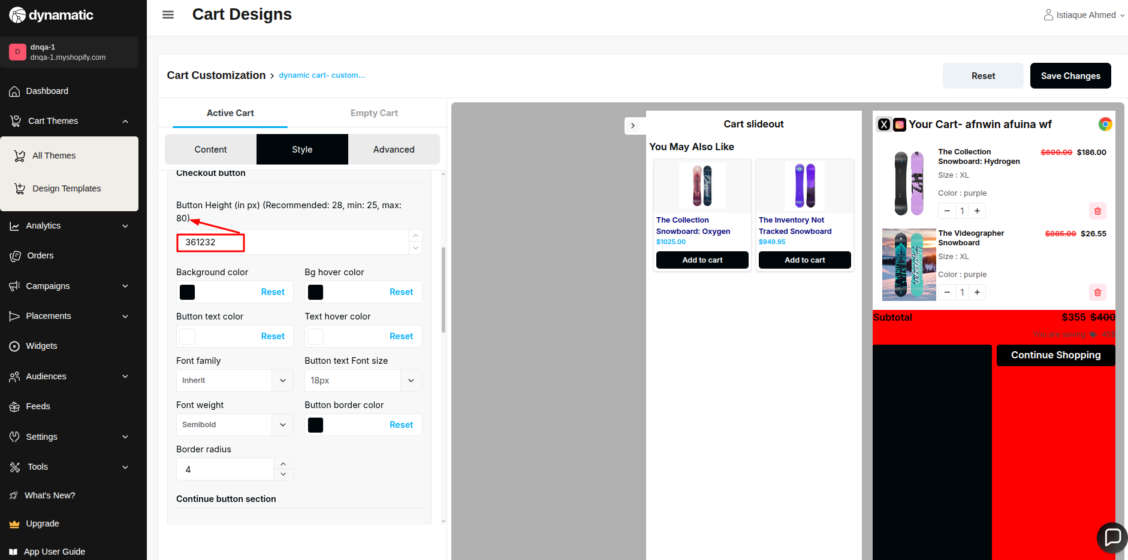

63. Active cart → Style → Store’s Checkout button design doesn’t match with Dynamatic dashboard’s preview

**Priority-** Medium

**Severity**- Medium

Status- Open

Assigned By- Imran

Preview Design-

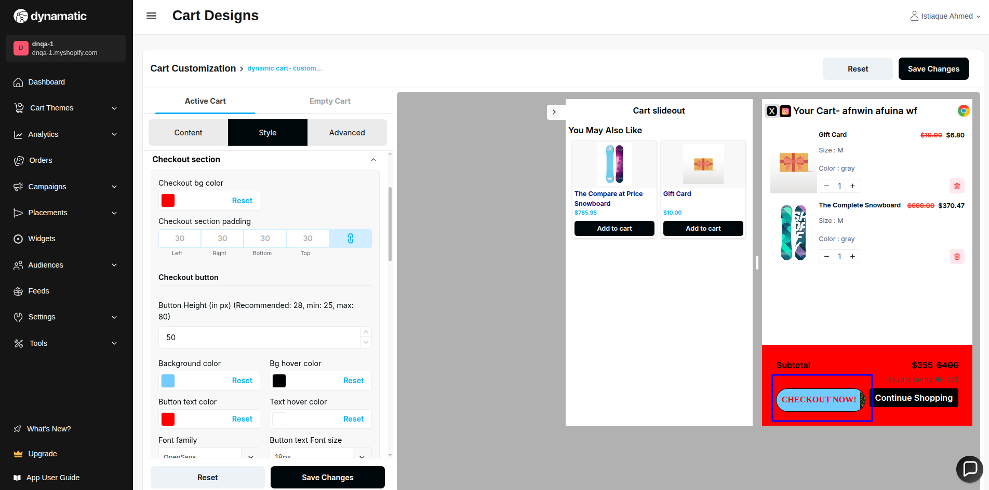

Store design-

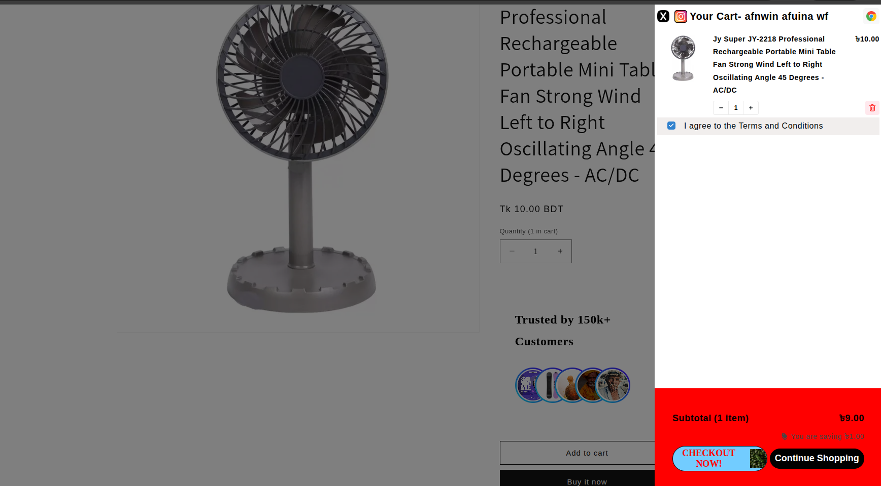

64. Active cart=> styles => line items => border radius need to be validated.

**Priority-** Medium

**Severity**- Medium

Status- Open

Assigned By- Imran

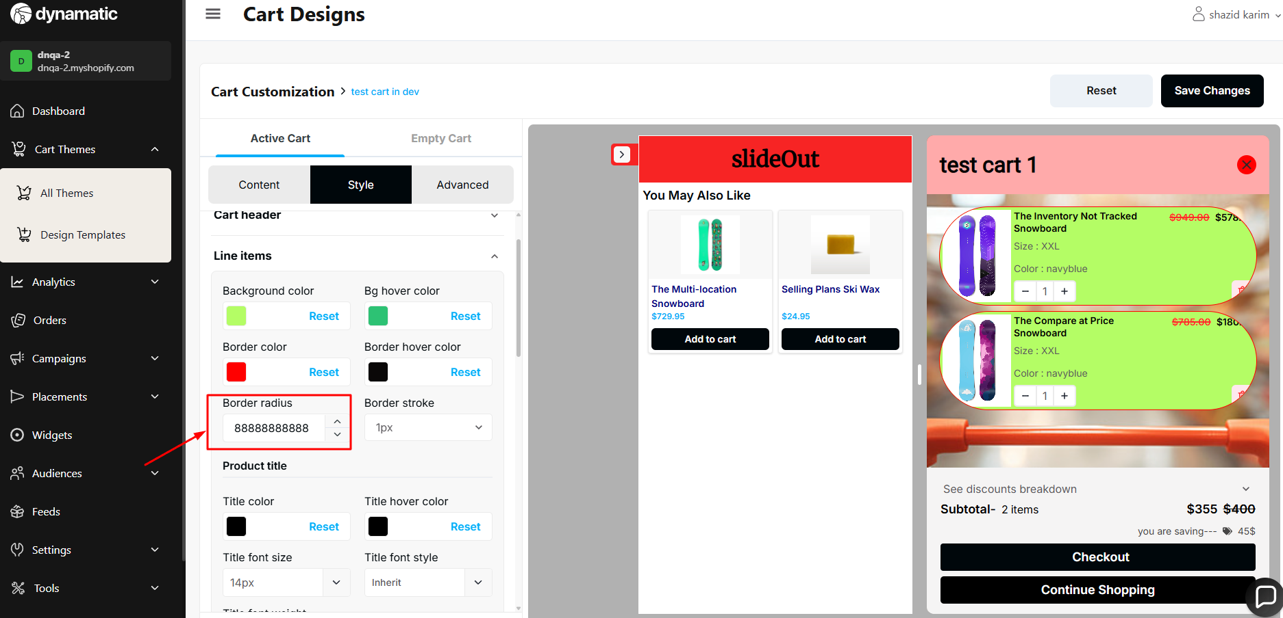

65. Active cart=> styles => subtotal price => price font size and price font weight does not work.

**Priority-** Medium

**Severity**- Medium

Status- Open

Assigned By- Imran

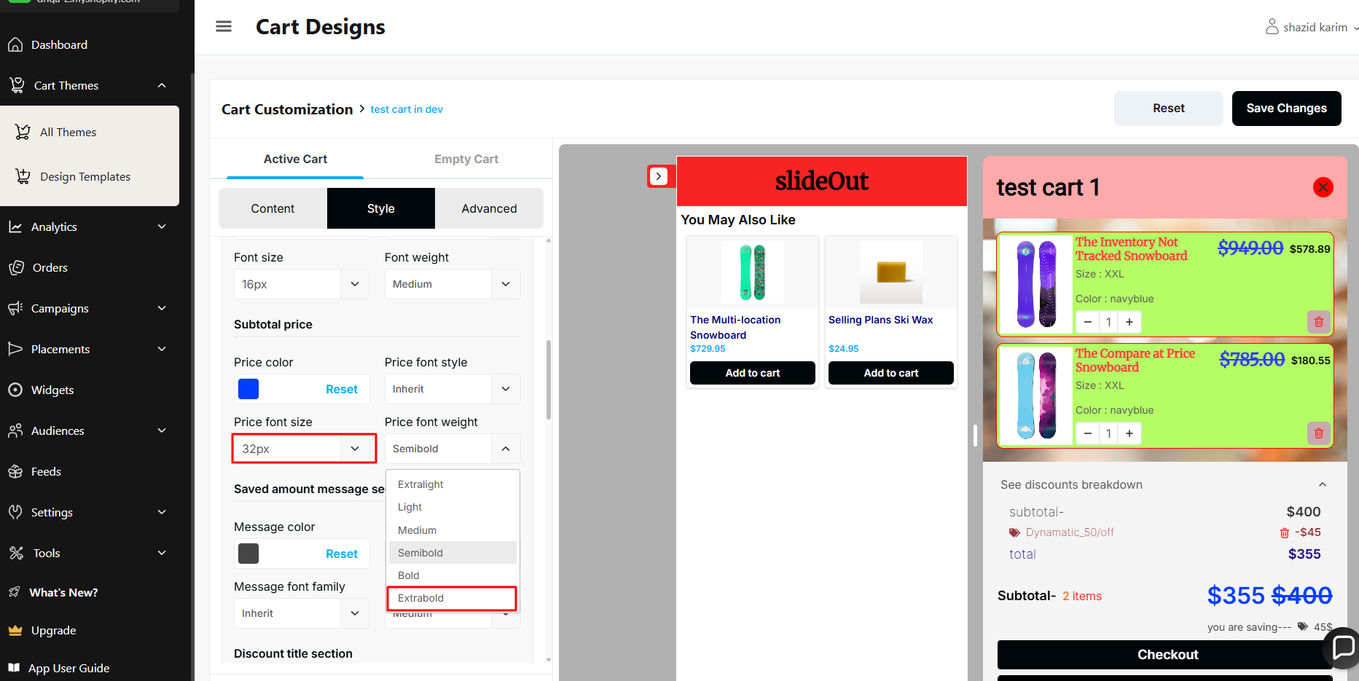

66. Share Cart Section → Style → button height is not working in the store.

**Priority-** Medium

**Severity**- Major

Status- Open

Assigned By- Imran

Dashboard preview -

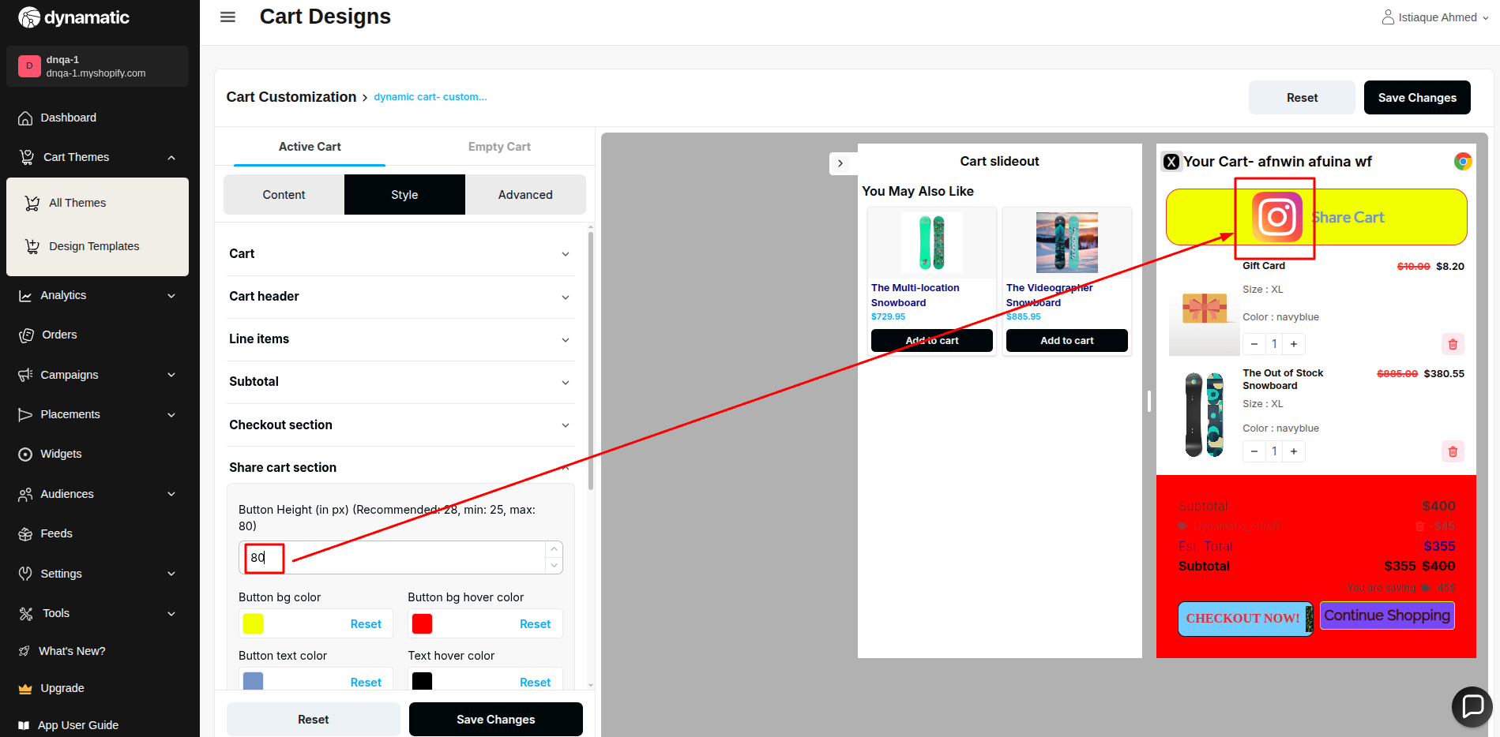

Store design-

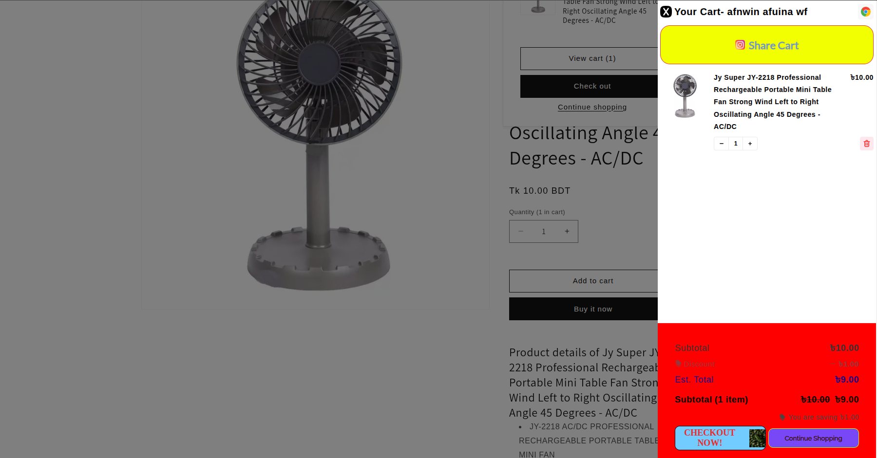

**STATIC CART ISSUE LIST**

1. Cart header (both left and right title) there is no validation for maximum character limit.  
**Priority-** Medium

**Severity**- Medium

Status- Open

Assigned By- Imran  
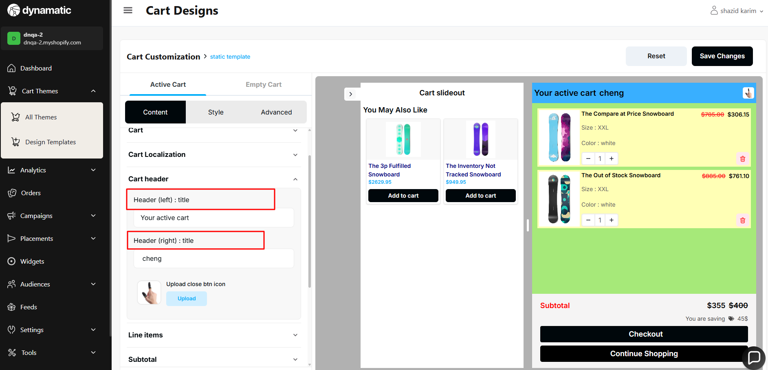

2.Line item image size should not be 0 or negative value.  
**Priority-** Medium

**Severity**- Medium

Status- Open

Assigned By- Imran

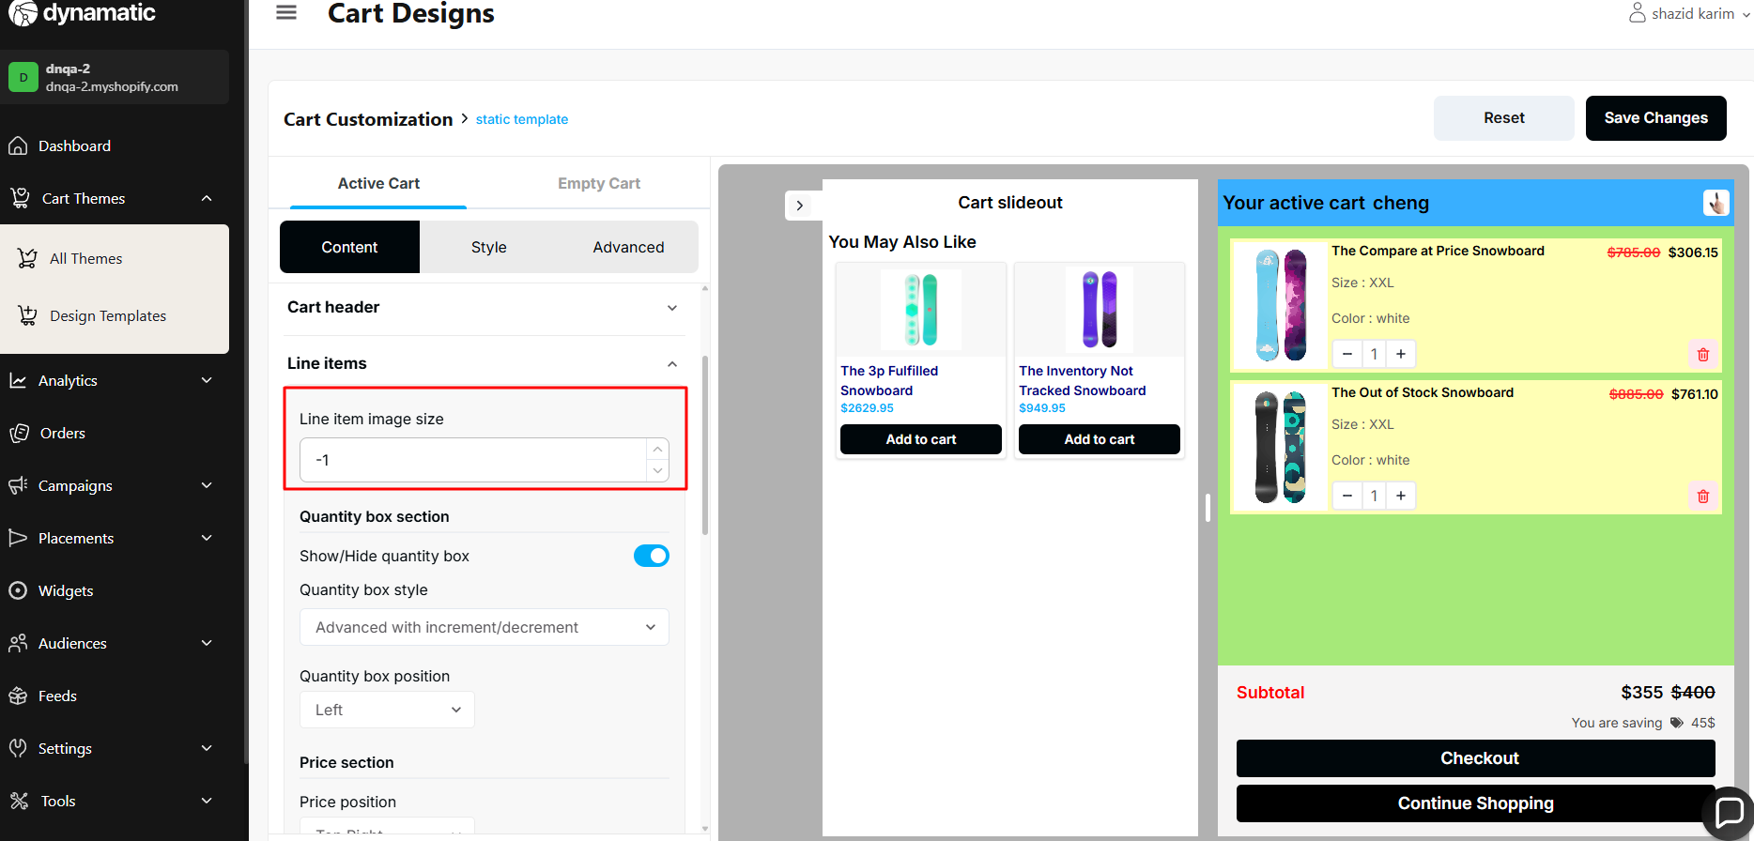

3.show/hide quantity box toggle does not work.  
**Priority-** Medium

**Severity**- Medium

Status- Open

Assigned By- Imran  
  
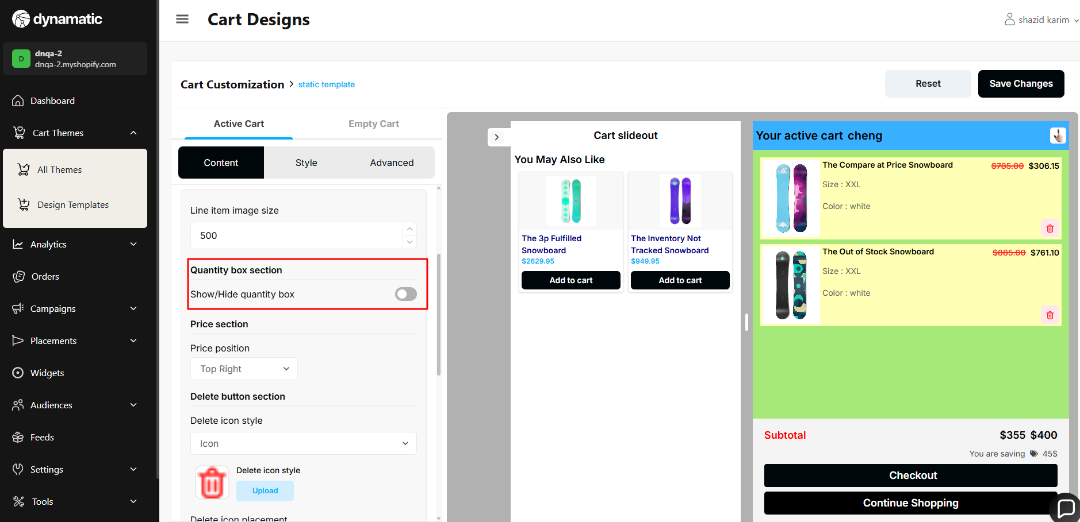

5.quantity box style(basic with dropdown option does not work).  
**Priority-** Medium

**Severity**- Medium

Status- Open

Assigned By- Imran  
  
  
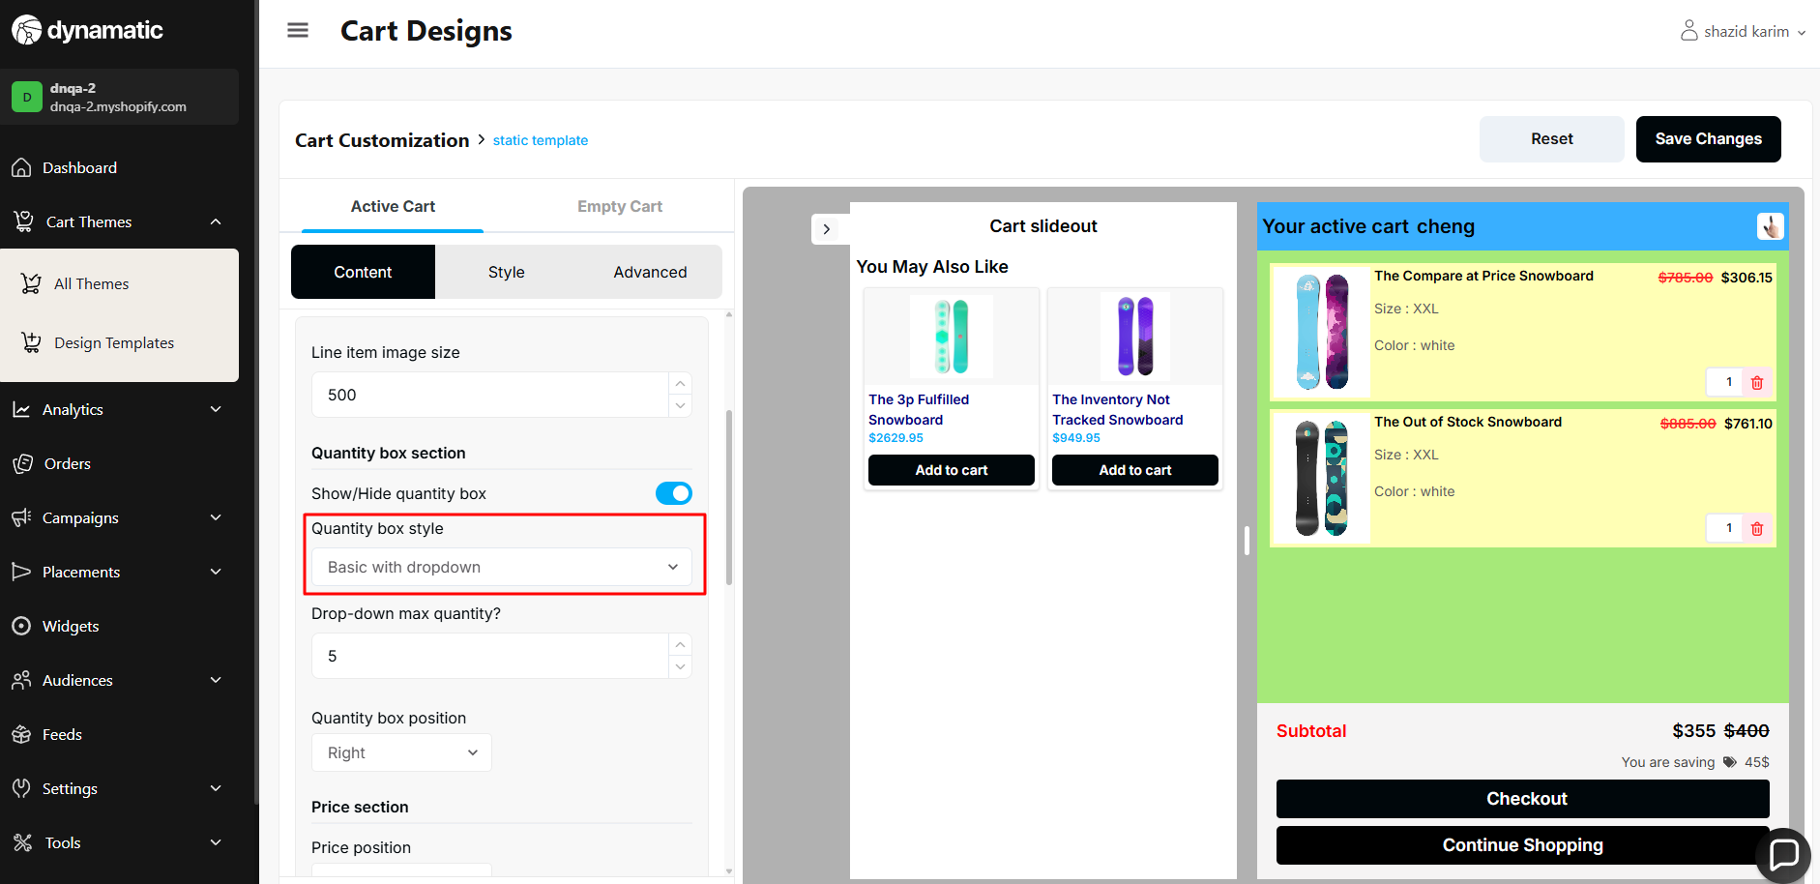

6. Line item properties

steps:

Show line items properties(on) => show properties in (single line) => property separator text => this text field needs to be validated. It takes maximum character.  
**Priority-** Medium

**Severity**- Medium

Status- Open

Assigned By- Imran

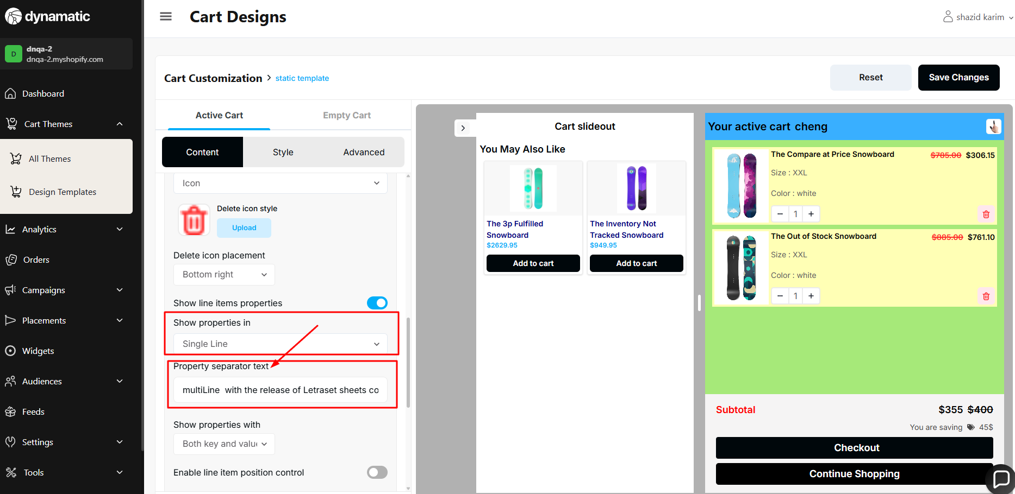

7. Subtotal => full functionality issue. (contact with me when fix)

steps:  
**Priority-** Medium

**Severity**- Medium

Status- Open

Assigned By- Imran

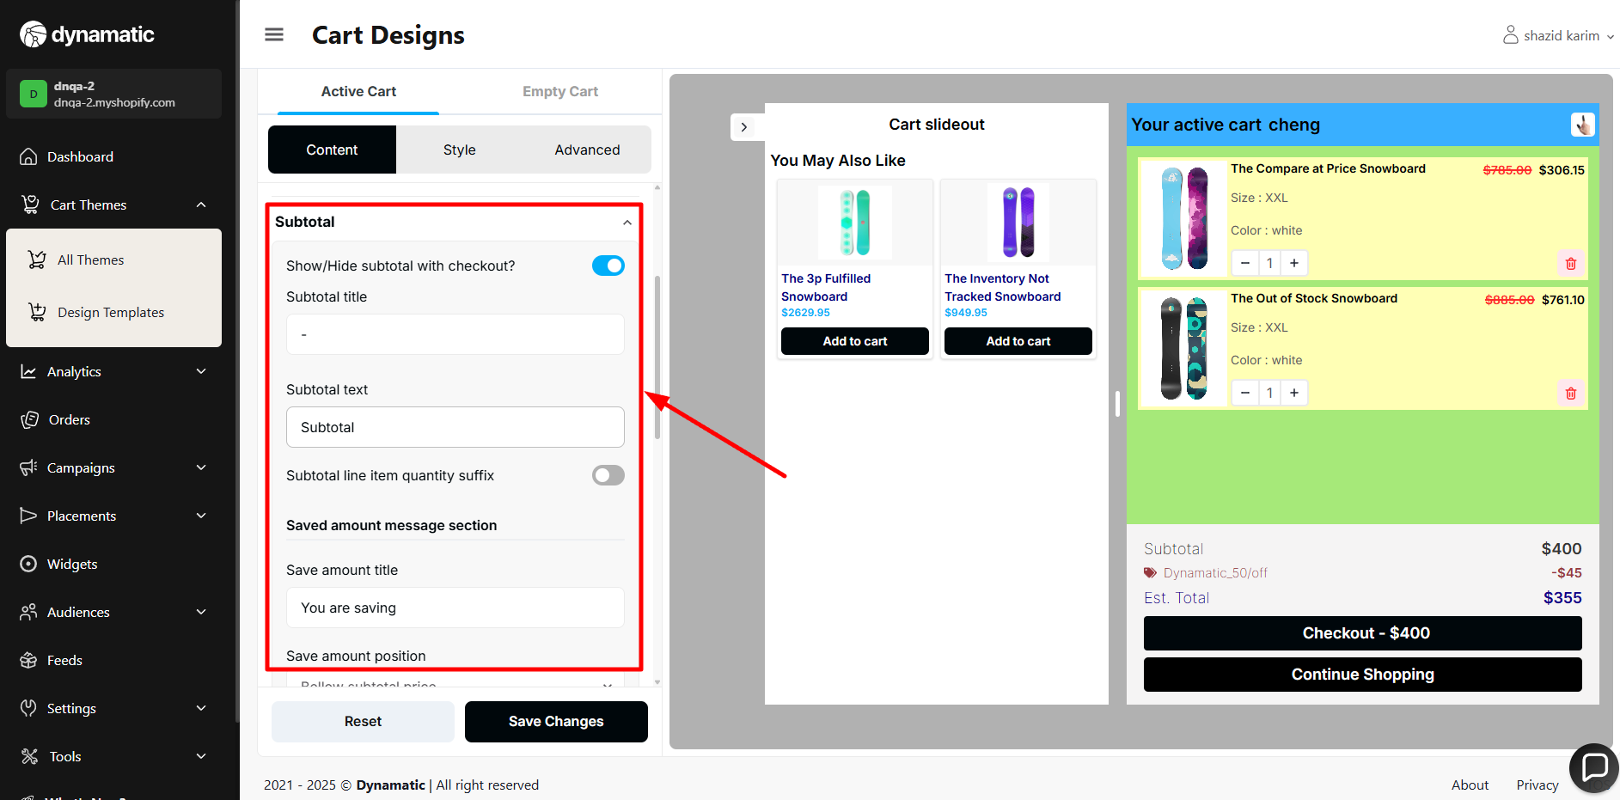

8. Subtotal =>

Show individual discount delete icon=> does not work.  
**Priority-** Medium

**Severity**- Medium

Status- Open

Assigned By- Imran

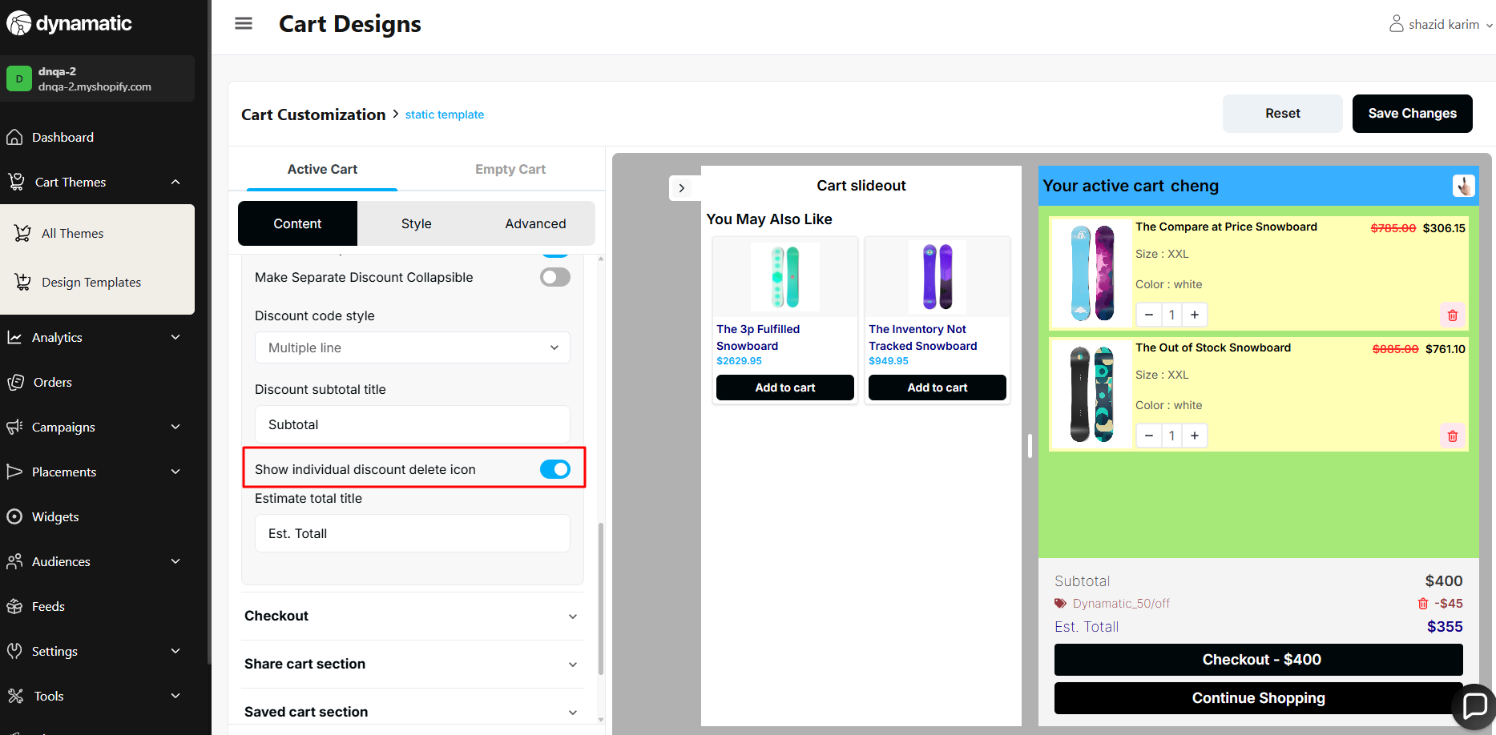

9.checkout   
Checkout btn icon size field => need validation. Maximum limit, 0 and must not take negative value.  
**Priority-** Medium

**Severity**- Medium

Status- Open

Assigned By- Imran  
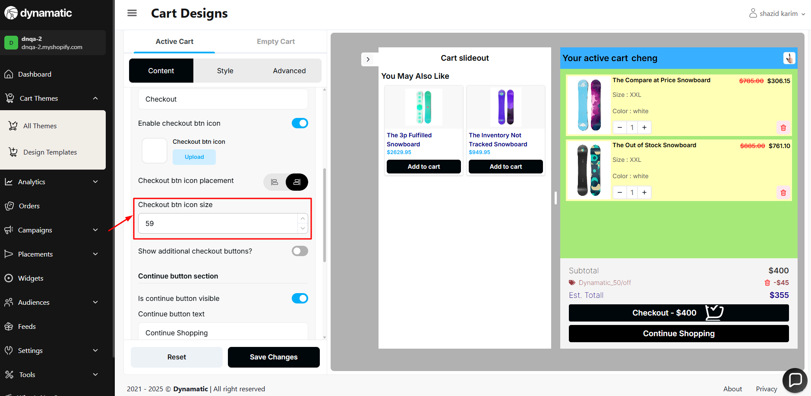

10.align continue and checkout button row.

checkout button design break after changing row.  
not take negative value.  
**Priority-** Medium

**Severity**- Medium

Status- Open

Assigned By- Imran

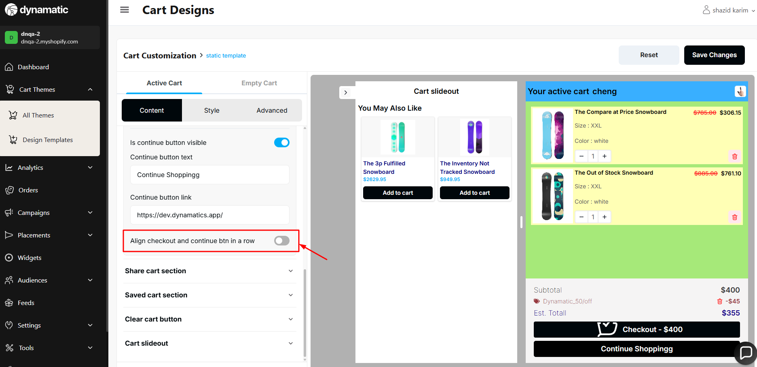

Break design=>

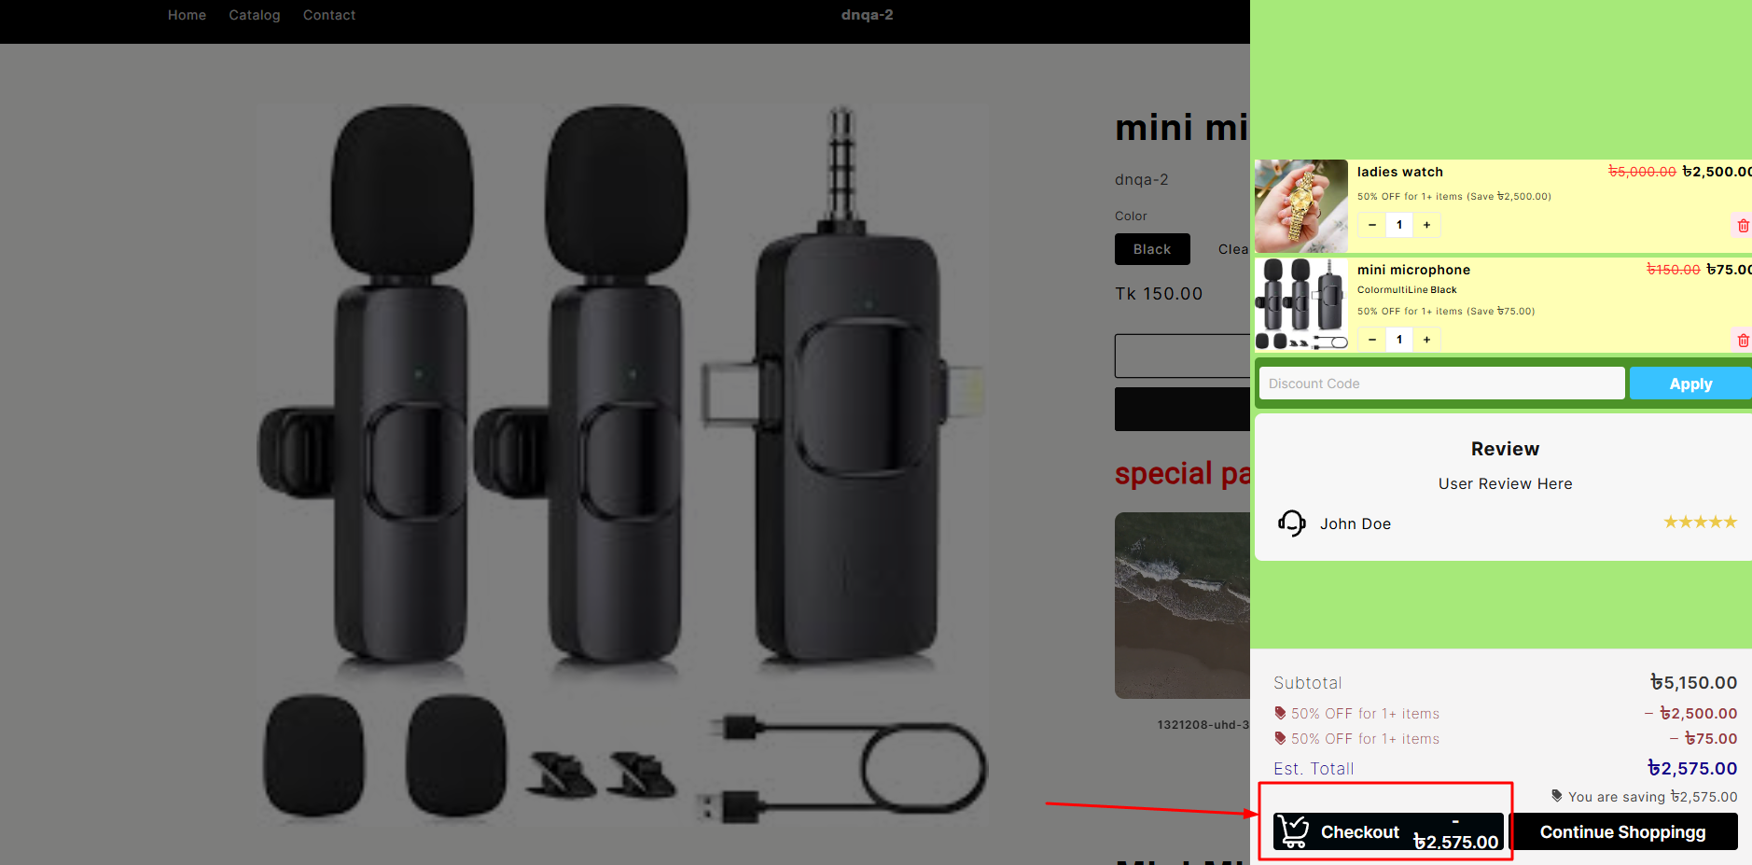

11. Share cart button image upload icon preview not showing.  
**Priority-** Medium

**Severity**- Medium

Status- Open

Assigned By- Imran

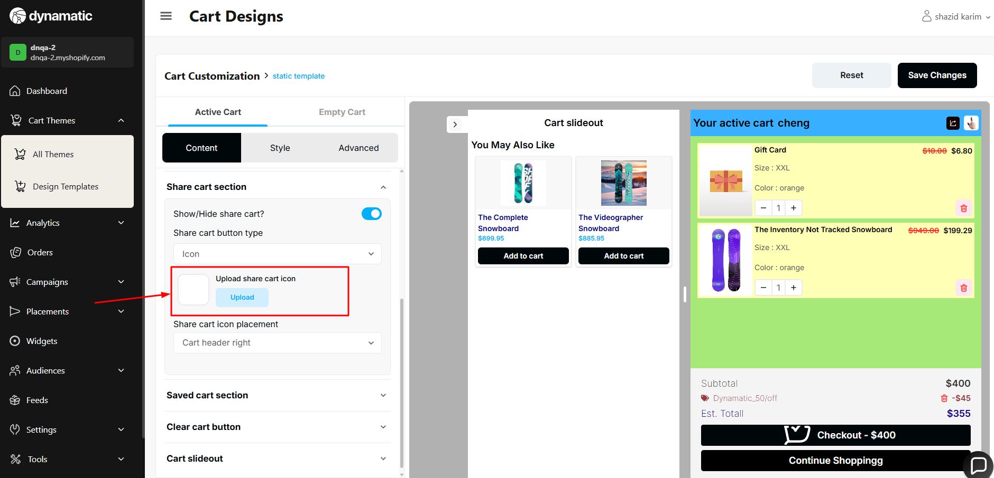

**Cart Theme- All Themes**

1. The continue button is enabled if the user enters only a single space in the title input field (Static/Dynamic)

**Priority-** Medium

**Severity**- Medium

Status- Open

Assigned By- Imran

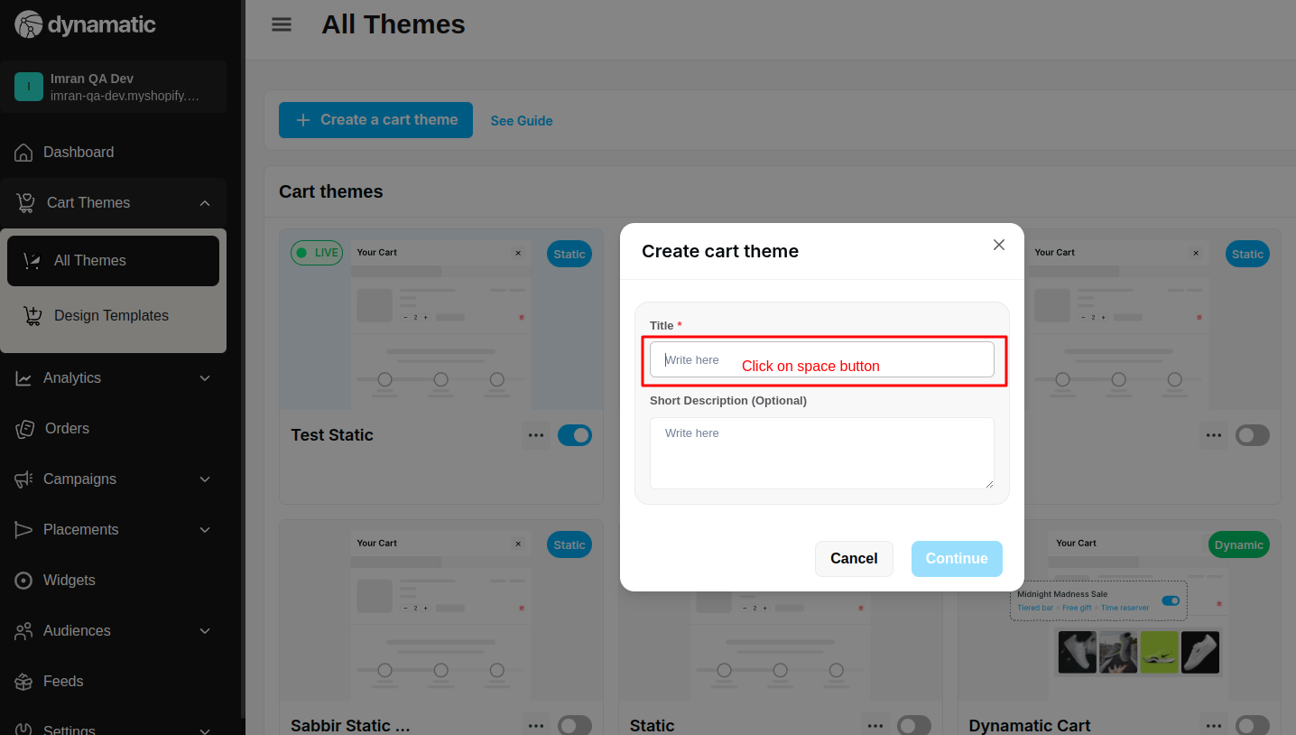

2. The user can enter and save only special characters in the title.

**Priority-** Medium

**Severity**- Medium

Status- Open

Assigned By- Imran

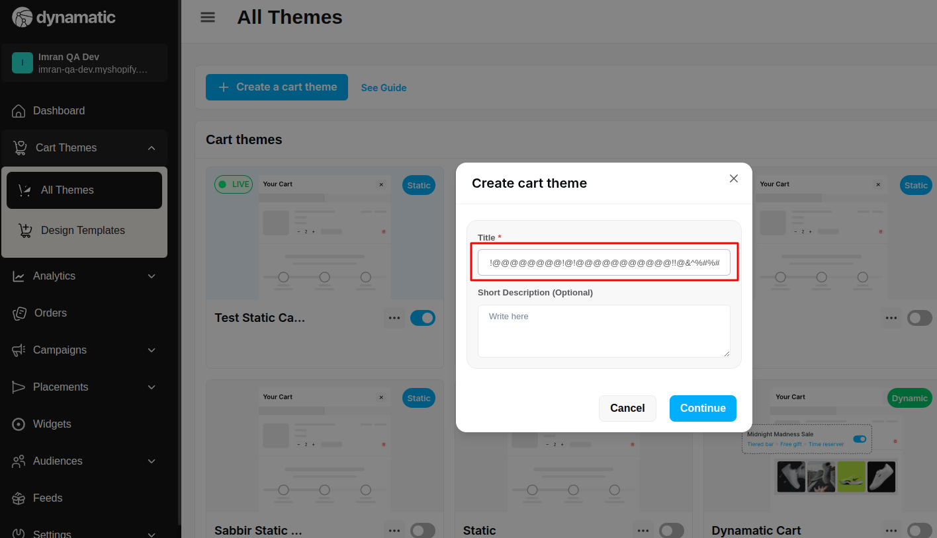

3. When I am adding any audience modal and click on the save button, at that time the audience modal is automatically closed.

**Priority-** High

**Severity**- Major

Status- Open

Assigned By- Imran

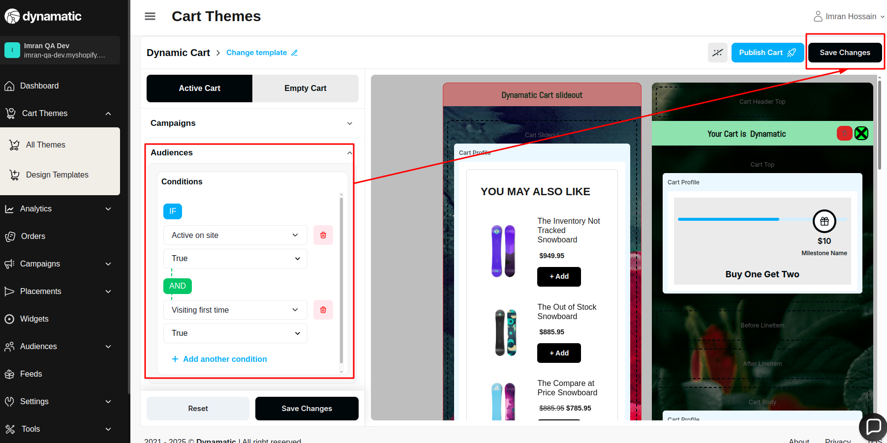

4. When I click change template button, at that time template modal is blinking

**Priority-** High

**Severity**- Major

Status- Open

Assigned By- Imran

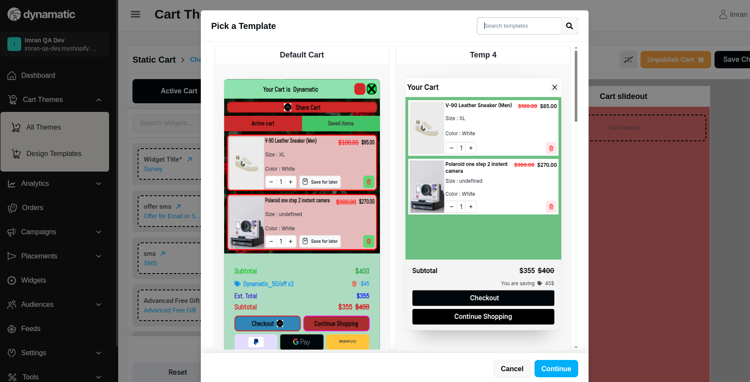

5. After successfully saving the URL, the URL is not properly showing in the URL box.

**Priority-** High

**Severity**- Major

Status- Open

Assigned By- Imran

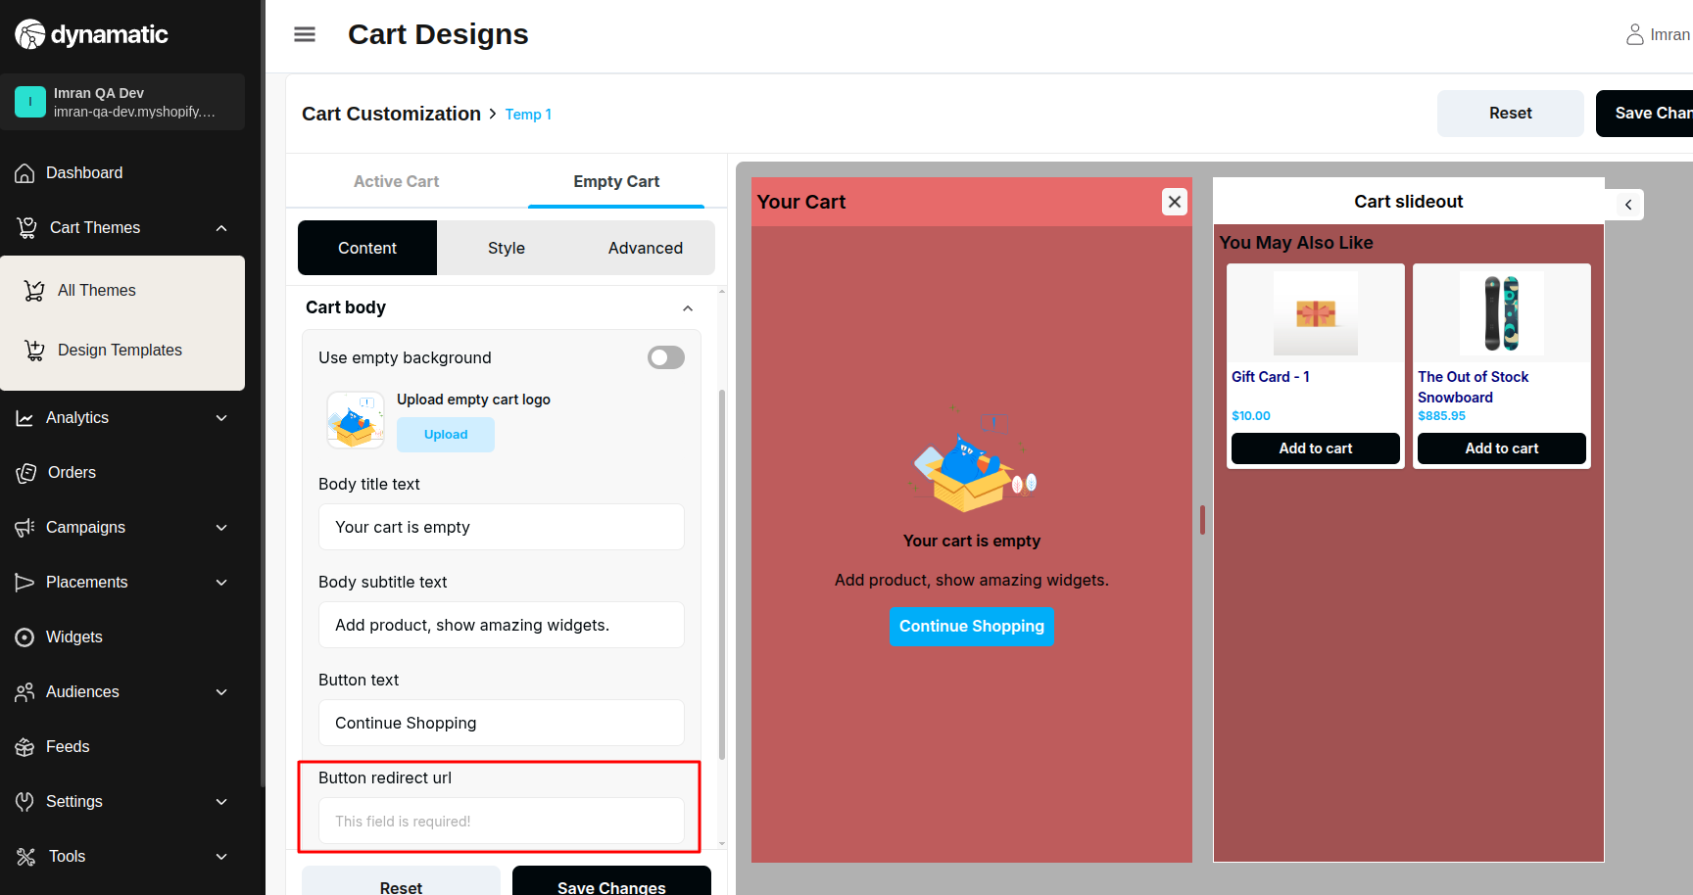

6.if winned dynamic profiles list length is one then return the first valid winner profile.((condtion not properly working)

**Priority-** High

**Severity**- Medium

Status- Open

Assigned By- Imran

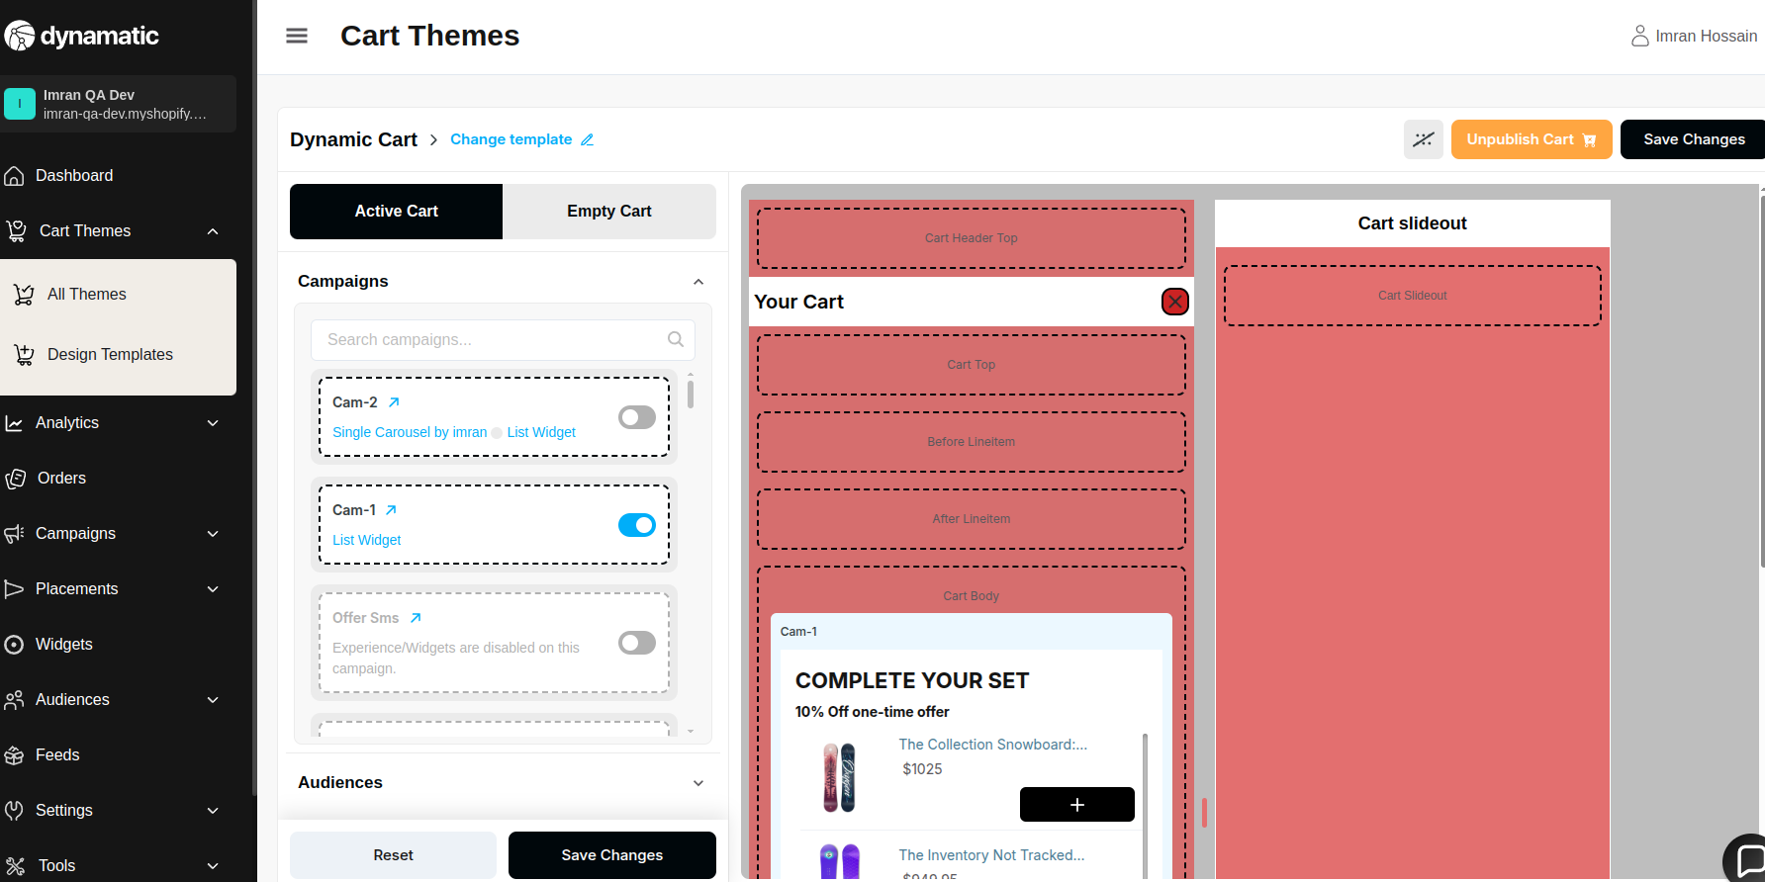

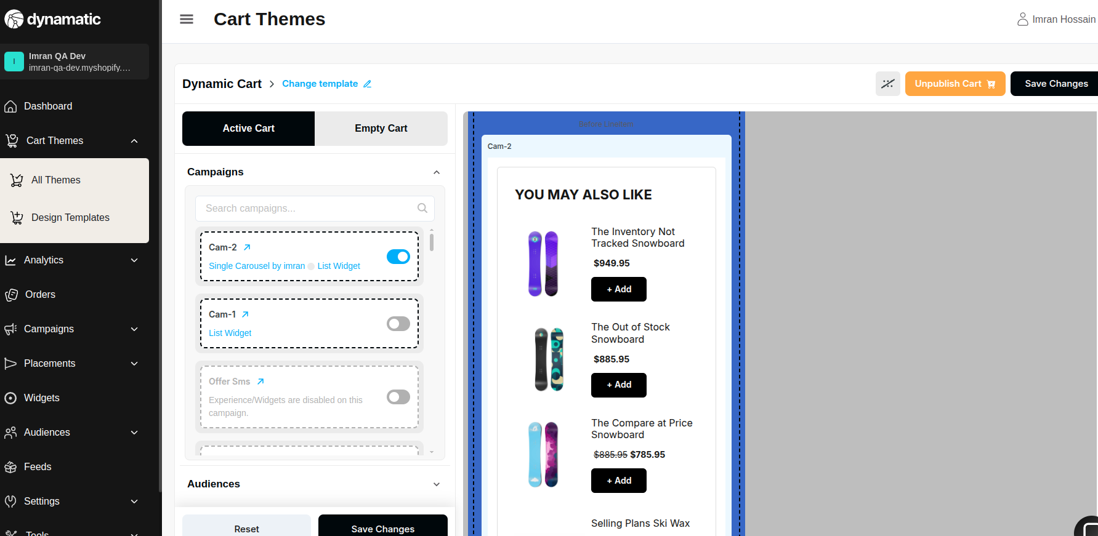

7.if profile contain no segements (dynamic 0 audience or static profile). return most recent profile.(condtion not properly working)

**Priority-** High

**Severity**- Medium

Status- Open

Assigned By- Imran

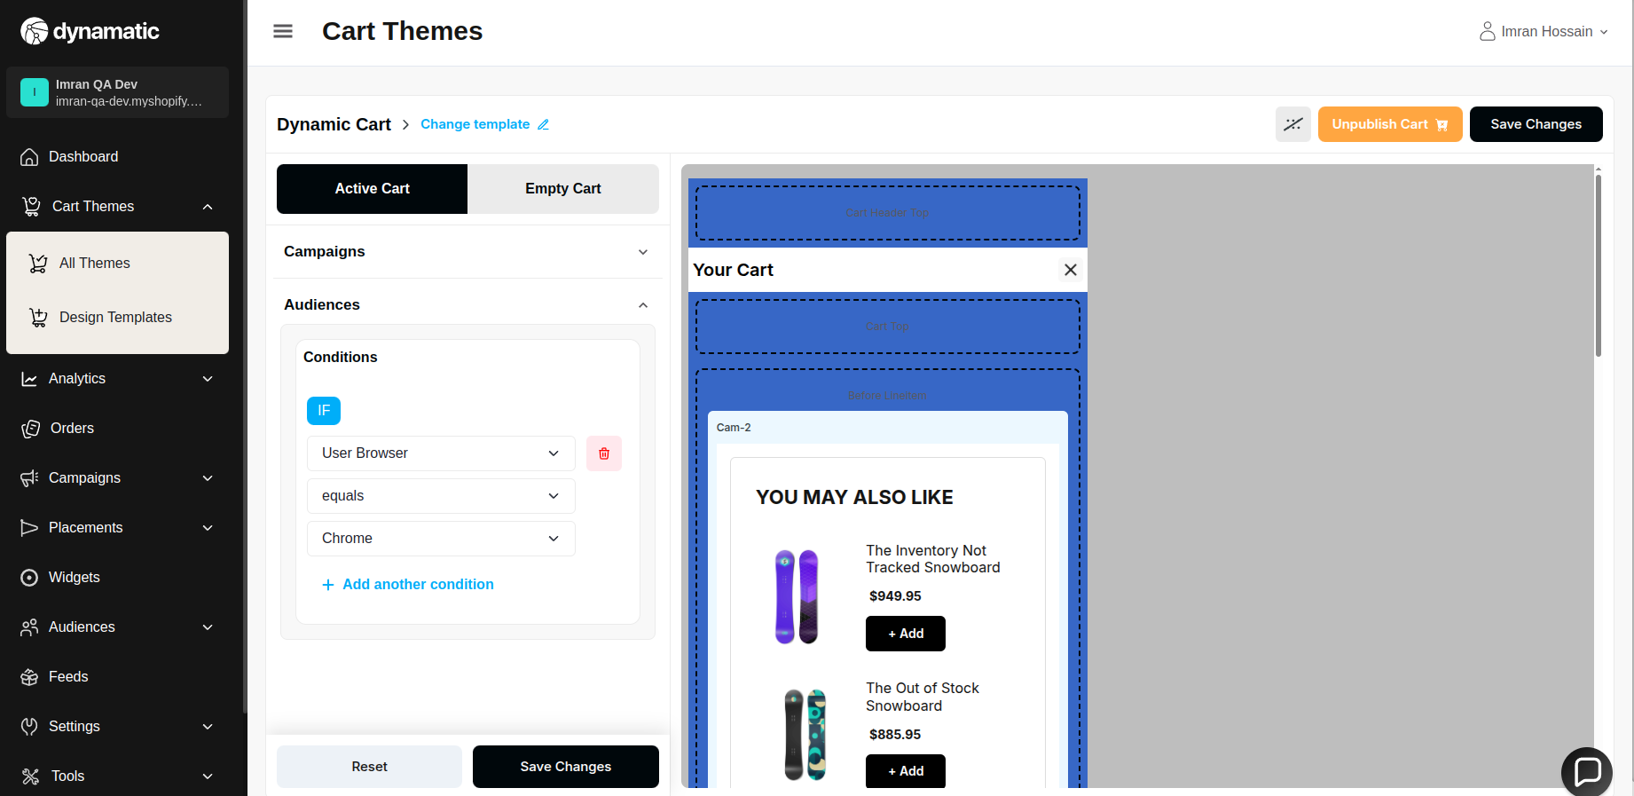

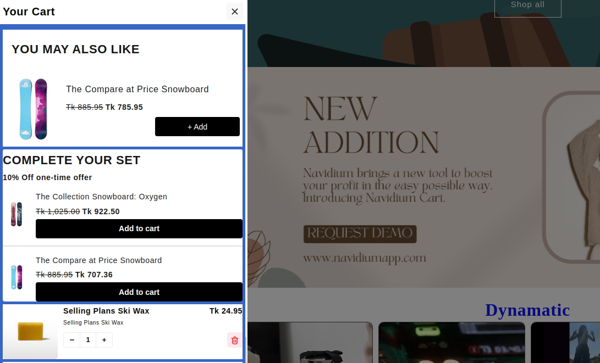

8.if no profile statisfied return default.(condtion not properly working)

